**ANAA: HOTEL AND RESTAURANT MANAGEMENT SYSTEM: HOUSEKEEPING AND MAINTENANCE WITH DIGITAL**

**REQUEST INTEGRATED WITH DOOR LOCK**

**SYSTEM RFID SENSOR AND AUTOMATED**

**INVENTORY MANAGEMENT SYSTEM**

f

Presented to the IT Project Evaluation Committee of

BESTLINK COLLEGE OF THE PHILIPPINES

In Partial Fulfillment

Of the Requirements for the Degree:

Bachelor of Science in Information Technology

By:

JUSTINE JOHN E. ATON

NORHANA O. GANDAROSA

WOWIE N. OLARTE

LHEY JUSTINE G. PATEÑO

WARREN RYO S. PEÑA

**MARCH 202**

# DECLARATION

The researchers of this group certify that this project study does not incorporate, without acknowledgement, any material previously submitted for a degree of Diploma in any University and to the best of our knowledge and belief. It does not contain any material previously published or written by another person or ourselves except where due reference is made in the text. we also hereby give consent for our Project Study. If accepted, to be made available for photocopying and for interlibrary and for the title and summary to be available to outside organizations.

Signature of Group/ Individual: Date: March 2024

JUSTINE JOHN E. ATON NORHANA O. GANDAROSA

WOWIE N. OLARTE

LHEY JUSTINE G. PATEÑO WARREN RYO S. PEÑA

**APPROVAL SHEET**

This capstone entitled **ANAA: HOTEL AND RESTAURANT MANAGEMENT SYSTEM – HOUSEKEEPING AND MAINTENANCE WITH DIGITAL REQUEST INTEGRATED WITH DOOR LOCK SYSTEM USING RFID SENSOR AND AUTOMATED INVENTORY MANAGEMENT SYSTEM** prepared and submitted by **Justine John E. Aton, Norhana O. Gandarosa, Wowie N. Olarte, Lhey Justine G. Pateño and Warren Ryo S. Peña,** in partial fulfilment of the requirements for the degree of Bachelor of Science in Information Technology has been examined and is recommended for acceptance and approval for Final Defense.

**GERALD R. DELA CRUZ**

Adviser

**CAPSTONE REVIEW PANEL**

Approved by the Committee on Oral Examination with a grade of **___1.00___.**

**REYNANTE B. PONAY,CpE** **VINCENT CARLO T. GARADOS**

Member Member

**ROMMEL J. CONSTANTINO, MSIT**

Chairperson

Accepted and approved in partial fulfillment of the requirements for the degree of Bachelor of Science in Information Technology.

**ROSICAR E. ESCOBER, Ph.D**

Dean, College of Computer Studies

Date of Final Defense: March 11, 2024

# CERTIFICATE OF ORIGINALITY

This is to certify that the research work presented in this Project Study entitled ***ANAA HOTEL AND RESTAURANT MANAGEMENT SYSTEM: HOUSEKEEPING AND MAINTENANCE WITH DIGITAL REQUEST INTEGRATED WITH DOOR LOCK SYSTEM USING RFID AND AUTOMATED INVENTORY MANAGEMENT SYSTEM*** for the degree Bachelor of Science in Information Technology at the Bestlink college of the Philippines embodies the result of original and scholarly work carried out by the undersigned. This Project Study does not contain words or ideas for the published sources nor written work that have been accepted as basis for the award of a degree from any higher education institution, except where proper referencing and acknowledgement were made.

ATON, JUSTINE JOHN E.

GANDAROSA, NORHANA O.

OLARTE, WOWIE N.

PATEÑO, LHEY JUSTINE G.

PEÑA, WARRREN RYO S.

Researchers

MARCH 2024

# ACKNOWLEDGEMENT

Our feel privileged and grateful in taking this opportunity to express their profound gratitude to many people who have contributed to the completion of this study:

**Dr. Maria M. Vicente**, President of Bestlink College of the Philippines, we would like to express our extend gratitude to her motivating during the study and valuable guidance.

**Dr. Charlie I. Carino**, Vice President for Academic Affairs of Bestlink College of the Philippines, we extend our gratitude for your unwavering dedication and encouragement.

**Dr. Rosicar Escober**, Dean of College of Computer Studies of Bestlink College of the Philippines, for invaluable support and guidance. Your contributions have been instrumental in our success.

**Mr. Rommel J. Constantino**, Department Head of IT Department of

Bestlink College of the Philippines, for your ongoing oversight and information regarding the project. Also,for your support in getting this project completed.

**Mr. Gerald Dela Cruz**, our Project Study Adviser, for valuable guidance has been the ones that helped us patch this project and make it successful, her suggestions and his instructions has served as the major contributor towards the completion of the project.

Panelists, **Mr. Vincent Carlo T. Garados, Engr. Reynante B. Ponay,** and **Mr. Rommel J. Constantino**, who extended their effort and time to be able to constructively criticize this thesis and share their knowledge with them to deepen and widen their needed information.

**Mr. Enrico B. Pineda**, for your assistance in providing the information needed to complete the project. Thank you for your support in the completion of the project.

To our **parents**, we express our heartfelt gratitude for their enduring love, unwavering support, and invaluable guidance. Their tireless efforts, and boundless wisdom, as well as their faith in us has been a constant source of strength. We are profoundly thankful for everything.

And above all, to our **Almighty God**, constant source of strength, wisdom, love, guidance and inspiration, and for giving immeasurable blessings, for without him this could not be possible

# DEDICATION

The researchers in our group extend a dedicated acknowledgment to the people who have played crucial roles in our journey and express with genuine appreciation and deep gratitude. Then, this humble work is fully devoted to our families, relatives, friends, colleagues, and teachers, whose consistent encouragement has been the source of our strength, inspiration, and compassion. We are grateful for their persistent guidance, which has served as the foundation for our collaborative endeavors.

# ABSTRACT

Title ANAA HOTEL AND RESTAURANT

MANAGEMENT SYSTEM: HOUSEKEEPING AND MAINTENANCE WITH DIGITAL REQUEST INTEGRATED WITH DOOR LOCK SYSTEM USING RFID SENSOR AND AUTOMATED INVENTORY MANAGEMENT SYSTEM

Author Justine John E. Aton

Norhana O. Gandarosa

Wowie N. Olarte

Lhey Justine G. Pateño

Warren Ryo S. Peña

Degree Bachelor of Science and Information

Technology

Majors Information Management, Network

Administrative, Information Security

Date of completion March 2024

I**NTRODUCTION**

Technological innovations are driving the highly competitive hotel and restaurant businesses to a better services and as well to attract and gain guest's interest. Including a Digitalize Inventory management, the Hotel and Restaurant Management System (HRMS) provides integrated features targeted to the industry's unique requirements. Some hotels continue to use outdated methods and techniques in spite of technology advancements, which creates inefficiencies and security hazards. With the use of an RFID sensor for door locking to increase security, an automated inventory management system for effective tracking of hotel supplies, and digital housekeeping and maintenance requests for guests, this project seeks to establish an integrated system that addresses these problems. The objective is to provide an improved, new, and digitalize solution that will benefit both employees and visitors.

**METHODOLOGY**

With the use of AGILE SCRUM METHODOLOGY, Agile methodology will rely on trusting teams and individual to create a collaboration in directly to customers so teams and individuals can understand the needs and give solutions in a timely and progressive approach. Each sprint of the development process will concentrate on a different feature. Frequent scrum meetings will help with adaptability and communication. A project manager oversees the daily operations of the project's scope, in addition to the project team and sponsor. The project manager is prepared to help the project team generate leads for the company. The project manager oversees the Hotel and Restaurant

Management System Project.

**RESULT**

With the fulfillment of housekeeping and maintenance with digital request integrated with door lock system RFID sensor and automated inventory management system the project seeks to optimize Housekeeping and Maintenance in digital form request, RFID's Door locking system and automated inventory management. It improves guest's customer service by giving them digitalize housekeeping and maintenance request, and accessible through mobile device. Giving the hotel a privilege tracking their Inventory reports access in real-time, supplies in the hotel's inventory are monitored through inventory management system. Stakeholders are happily satisfied of the system's Cost reduction because it is more efficient and cost-effective. By the implementation of Digital request form through ANAA's system, it improved guest's request, avoided delays, and improved overall efficiency while causing less difficulty.

**DISCUSSION**

Integrating technologies like an automated inventory management system and an RFID-based door locking system into a seamless digital request system for housekeeping and repair. Also, the need for specific project objectives and a thorough needs analysis are the two most crucial lessons learned from the implementation of this project. To ensure that all points of view are taken into consideration, collaboration is necessary between the project team, stakeholders, scrum master, and end users. User involvement, ongoing feedback loops, and staff training all contribute to effective adoption. A user-friendly, easy to use secure, and efficient system that seamlessly optimizes cleaning and maintenance procedures is created by developing a mobile and web-based Housekeeping and maintenance with digital request integrated with door lock system using rfid sensor and automated inventory management system.

Lastly, it is also essential to prioritize cybersecurity measures, address integration challenges, and put in place comprehensive data accuracy checks. The adaptability and long-term efficacy of the system are guaranteed by scalability, securing, and frequent system reviews.

**TABLE OF CONTENTS**

TITLE….………………………………………………………………………i

DECLARATION ……………………………………………………………..ii APPROVAL SHEET ….……………… ………………….……………. …iii

CERTIFICATE OF ORIGINALITY……..….………….…………………...iv ACKNOWLEDGEMENT.….…………………….……….…………………v

DEDICATION……...…………………………………….………….……...vii

ABSTRACT ….………………………………………….…………...…….viii TABLE OF CONTENTS ….…………………………….………………....xii

LIST OF TABLES ….………………………………….…………………...xx LIST OF FIGURES…..…..……………………………….………….……xxii LIST OF APPENDICES …..…………………………….……………….xxiv

1. Introduction:

Background of the Capstone Project ...…………….………………..1

Context and Scope …………………………………………..………..1 Problem Statement ...……………………………………………..…..2

Objectives and Goals …………………………………………………3

Significance and Relevance ...……………………….………………4

Structure of the Document ...………………………………...............4

1. Literature Review

Agile Scrum Methodology Overview ….………………………….....5

Enterprise Architecture Concepts ….………………..……..............6

Relevant Studies and Research ….………………………………....6

Integration of Information Systems in Enterprise Environments

…………………………..……………………………..……..…………8

1. Methodology

Agile Scrum Methodology in the Project …………………………..12

Roles (e.g., Scrum Master, Product Owner, Development Team) ……………………………………………………………….….……..13

Sprint Cycles (e.g., Sprint Planning, Daily Standups, Sprint

Review) ...…………………………………………………………….16

Scrum Artifacts (e.g., Product Backlog, Sprint Backlog)……..…..19

Integration Approach for Information Systems…….....…….……..83

Introduction to TOGAF and the Four Architectural Domains

…………………………………………………………………...........84

1. Requirements Analysis

Stakeholder Identification ...………………………………………...85

Requirements Gathering Technique…...…………………………..90 User Stories and Use Cases …….……………………..….……….92

Functional Requirements for Integration …….…………………….96

1. Business Process Architecture:

Identification of Business Processes.………..……….……………98

Business Process Diagrams ….…………………………………….99

Alignment of Integrated System with Business Processes.........100

Business Process Improvements ….……………………….........102

1. Application Architecture

Components of Application Architecture.………..……………….106

Application Architecture Diagrams…………………..……………107

Integration of Software Modules ...………...…….………….…....109 Communication and Interaction Patterns ….…….……………....111

1. Data Architecture:

Data Sources and Types ...………………...………. ………….…113

Data Flow Diagrams ………………………………..…..………….116

Data Storage and Management.…………………….…. ………..118

Data Synchronization Across Systems ….……...…………….…119

1. Technology Architecture:

Technology Stack and Infrastructure ………………………….…119

Network Topology and Configuration ..……………… ……….….120

Software Technologies ..……………………….………………….122 Scalability and Performance Considerations …………………....128

1. Development Process:

Agile Scrum Roles and Responsibilities ……………...............…129

Sprint Planning and Backlog Management ….…………………..131

Sprint Execution and Deliverables ...…………………………..…134

Challenges Faced in the Development Process ….…………..…136

1. Implementation:

Technical Implementation Details …………………………….….136

Tools and Technologies Used …………………...…………….…137

Code Integration and Interoperability ….…………………..……..139 Integration Testing and Debugging …..……………...…………...140

1. Testing and Quality Assurance:

Testing Strategies and Methodologies ...………………………...141

Test Cases and Test Data ……..………………………………….141

Test Results and Bug Reports ...………………………… ………142

Quality Assurance Measures ……….…………………………….143

1. Results and Evaluation:

Project Outcomes and Deliverables …..………………………….144

Alignment with Project Objectives ….…………………………….145

Stakeholder and User Feedback ….………………………….…..147 Lessons Learned ….……………………………………………….150

1. Conclusion:

Key Takeaways and Summary …..……………………………….151

Project Achievements and Contributions ….…………………….151

Future Work and Enhancements …...…………………………….152

Closing Remarks ……………………………………………..……153

1. References:

List of Cited Sources and References ……………………………153

1. Appendices:

Appendices …………………………………………………………154

Supplementary Material ……………………………...……………177

Scrum Artifacts (e.g., Burndown Charts, Sprint Backlogs)……..177

1. Technical Documentation

16.1 System Architecture:

Overview of the overall system architecture……..……..………..197 Detailed diagrams illustrating system components and their

interactions...………………………………………………… …….198

Explanation of Component responsibilities and Relationships…199

16.2 Information Systems Integration:

Description of how the class's information systems were

integrated ………………………….………………………….…….199

Diagrams showing the integration points and data flows...........200

Data transformation and mapping processes ….……….............201

16.3 Application Design and Development:

Detailed information about the software modules and

components …………………………...…………………………...203

Code snippets and code structure …….………………………….204

Algorithms and data structures used ….…..……………………..216

Libraries and frameworks utilized …..………………………….…218

16.4 Database Schema and Data Management:

Database schema design ...……………………………………….219

Entity-relationship diagrams (ERDs) ...…………………………..222

Data modeling and normalization……..….……………………….222 CRUD (Create, Read, Update, Delete) operations ….………….223

16.5 Network Configuration:

Network topology and configuration details ….………………….223

Security measures (e.g., firewalls, encryption) ………………….225

Protocols and communication methods used ……….…………..227

Load balancing and failover mechanisms ...……………………..227

16.6 Deployment and Infrastructure:

Deployment strategies (e.g., cloud, on-premises).…..………….229

Hardware specifications and server configurations……..….......230 Configuration management (e.g., scripts, automation tools)

………………………………………………………………………..232

Scalability and resource optimization ….…………….…………..233

16.7 Security Measures:

Security protocols and measures implemented ….…….……….233

Authentication and authorization mechanisms …………............233

Encryption and data protection …..……………………………….233 Incident response and mitigation procedures ….………………..234

16.8 Testing and Quality Assurance:

Detailed test cases and scenarios …..…………………………....235

Test data and expected outcomes …..…………………………...234

Test results and validation against requirements ……………….235 Performance testing and optimization efforts …..…………….…236

16.9 System Monitoring and Maintenance:

Tools and techniques for monitoring system health ……............237

Logging and error handling mechanisms …...…………………...238

Scheduled maintenance and updates …………………………...238

Disaster recovery and backup procedures …..………………..…242

16.10 APIs and Integration Points:

Documentation of APIs used for integration …………….............243

API endpoints, methods, and data formats ..………..…………...243

How external systems interact with your project…………………246

16.11 User Documentation:

User manuals and guides (if applicable) ……………….………...247

Instructions for system users ...………………………….….247 Troubleshooting and FAQs ………………………………………..247

16.12 Known Issues and Troubleshooting:

List of known issues and their status ...…………………………...252

Troubleshooting steps for common problems ...………………...253

Contact information for technical support ...……………………...255

16.13 Version Control and Source Code Repository

Description of version control system (e.g., Git) …….…………..256

Repository location and access details ...………………………..256

Branching and merging strategies ………………………………..257

16.14 DevOps and Continuous Integration/Continuous Deployment (CI/CD):

CI/CD pipeline setup and configurations ………….……………..258

Automation scripts and tools used ………………………………..259 Deployment strategies and rollback procedures ………………..260

16.15 Licensing and Open-Source Libraries:

Information about licenses for software and libraries

used………………………………………………………….………261

Credits and attributions for open-source components……….....263

16.16 Performance Metrics and Monitoring:

Metrics collected and monitored…………………………………..264

Tools and dashboards used for performance analysis………….265

Actions taken based on performance data…………. ….………..266

**LIST OF TABLES**

Table 1: Business Goals and Objectives

Table 2: Roles (e,g., Scrum Master, Product Owner, Development Team)

Table 3: Daily Standups

Table 4: Product Backlog

Table 5: Product Backlog for EIS Information Security

Table 6: Product Backlog for EIS Standards

Table 7: Product Backlog for Integration

Table 8: Application System Analytics

Table 9: EIS Analytics

Table 10: Sprint Backlog

Table 11: Sprint Backlog Information Security

Table 12: Sprint Backlog EIS Standards

Table 13: Sprint Backlog EIS Integration

Table 14: Sprint Backlog Analytics

Table 15: Stakeholder Analysis

Table 16: Housekeeping Management Data Source and Types

Table 17: Maintenance Management Data Source and Types

Table 18: Inventory Management Data Source and Types

Table 19: Door Lock Management Data Source and Types

Table 20: Software Technologies

Table 21: Supplementary Material User Stories

Table 22: Housekeeping Database Schema and Database Management

Table 23: Maintenance Database Schema and Database Management

Table 24: Inventory Database Schema and Database Management

Table 25: Door Lock Database Schema and Database Management

Table 26: Security Measures

Table 27: Hardware Specification

Table 28: Contact Information for Technical Support

**LIST OF FIGURES**

Figure 1: Stakeholder Analysist Chart

Figure 2: Business Process Diagram Top Level 1

Figure 3: Business Process Diagram Top Level 2

Figure 4: Components of Application Architecture

Figure 5: High Level Architecture

Figure 6: Housekeeping Management Application Architecture

Figure 7: Maintenance Management Application Architecture

Figure 8: Inventory Management Application Architecture

Figure 9: Housekeeping Management Data Flow Diagram

Figure 10: Inventory Management Data Flow Diagram

Figure 11: Maintenance Management Data Flow Diagram

Figure 12: Door Lock Management Data Flow Diagram

Figure 13: Network Topology

Figure 14: Appendix A Process Diagram

Figure 15: Appendix D Sample Data

Figure 16: Appendix H Mobile Application Prototype

Figure 17: Appendix J Panel Evaluation and Signature

Figure 18: System Architecture

Figure 19: Detailed Diagrams Illustrating System Components and Their Interaction

Figure 20: Diagrams Showing Integration Points and Data Flows

Figure 21: Entity Relation Diagrams

Figure 22: Network Topologyand Configuration Details

Figure 23: Login System

Figure 24: System Modules

Figure 25: Housekeeping Modules

Figure 26: Housekeeper Selection

Figure 27: Items Selection

Figure 28: Task Progress Page

Figure 29: Staff Mobile Application

Figure 30: Mobile Application Task Progress

Figure 31: Completion Alert

Figure 32: Completed Task

Figure 33: Dashboard

**LIST OF APPENDICES**

Appendix A: Process Diagram

Appendix B: User Surveys

Appendix C: User Stories and Use Cases

Appendix D: Sample Data

Appendix E: Stakeholder Interview Transcripts

Appendix F: System Performance Test Results

Appendix G: Data Security Measures

Appendix H: Mobile Application Prototype

Appendix I: Adviser Acceptance (Functional)

Appendix J: Panel Evaluation and Signature (plus photo ops during defense)

Appendix K: Capacity Planning (Estimates on Storage Consumption –

5 years)

Appendix L: Pilot Companies’ Background with proofs of interviews

Appendix M: Cloud Copy of the Codes (1 year validity) Appendix N: IMRAD Format Summary

Appendix O: Comparison of the EIS to existing EIS’s

**1. INTRODUCTION**

**BACKGROUND OF THE CAPSTONE PROJECT**

The hospitality sector is a highly competitive industry, where businesses are constantly looking for ways to improve their services and attract new customers. One way to do this is to invest in technology that can help to streamline operations, maximize productivity, and enhance the guest experience. The Hotel and Restaurant Management System (HRMS) with integrated features is a comprehensive solution that has been designed to meet the specific needs of the hospitality sector. It includes a range of automated features, such as inventory.

**CONTEXT AND SCOPE**

Due to continuous advancement of technology, some hotels

practices stick on traditional way where housekeeping practices such

as scheduling and room assignments, cleaning rooms and maintenance often rely on paper logbooks or verbal communication using telephone and inventory items such as cleaning supplies are manually tracked, leading to potential inefficiencies and overstocking/understocking issues while door lock still use physical keys for guest room access when duplicate keys can be made, and if a guest loses their key, it poses a security risk.

The goal of this project is to develop an integrated hotel and restaurant management system that will benefit both staff and guest through creating a digital housekeeping and maintenance request where guest can request a housekeeping and maintenance for their rooms that can access through digital form and will direct to the hotel admin system and also develop an RFID sensor for door locking system in order to enhance security and convenient access. In addition, the project team also will develop an automated inventory management for tracking hotel supplies and amenities.

**PROBLEM STATEMENT**

In the rapidly evolving hospitality industry, the challenges in managing efficient hotel and restaurant operations includes housekeeping and maintenance are manual and paper-based

processes that result in inefficiencies and slower response time. The inventory management struggles to maintain accurate inventory levels due to paper records that causes error such as miscalculation and misplacement. Other than that, the traditional lock and key systems are less secure and less convenient.

**OBJECTIVE AND GOALS**

The Project team’s objective is to develop a user- friendly system to manage guest maintenance and housekeeping request through a digital form that can access through a mobile device or website and will receive by the admin system accurately, also to develop a RFID Door lock system in order to enhance guest security and record the door access date and time. Apart from that project team also develop an automated inventory management where efficiently managing the procurement, tracking and usage of supplies and materials in a hotel. For restocking supplies project team also will create vendor portal to connect and collaborate on supplier.

|  |  |
| --- | --- |
| **Business**  **Goal/Objective** | **Description** |
| Digital Maintenance and  Housekeeping  Request | Enable guest to make digital request for services, such as housekeeping, and room maintenance. |
| RFID Door Lock  System Implementation | Enhance guest security and access control, also track door access through door logs |
| Automated Inventory  Management | Optimize inventory levels, reduce in overstocking and supplies shortage, and also provide automatic reordering when supplies is low. |
| Security and  Compliance | Regularly update and enhance security measures to protect guest, staff and property data. |
| Enhance Guest  Experience | Provide guests with a convenient experience through digital guest request and secure access control for using RFID Door Locks |

*Table 1: Business Goals and Objectives*

# SIGNIFICANCE AND RELEVANCE

The Housekeeping Management, Maintenance

Management, Door Lock Management, Inventory Management or a request from other modules, that manages guest request. The Anaa Hotel and Management System will enhance the operational

efficiency, guest experience and security in the hotel and restaurant industry.

# STRUCTURE OF THE DOCUMENT

In line with this project plan and its subsidiary management plans, the project manager, Warren Peña, is in responsibility of managing and bringing out this Capstone project. Personnel from the coding group, quality control/assurance group, technical writing group, and testing group will make up the project team. Personnel from the coding group, quality control/assurance group, technical writing group, and testing group will make up the project team. The project leader will handle the project document using all tools at their disposal. The project leader will manage the Capstone project by using all their available resources. Each project's and subsidiary management plan will be reviewed and approved by the client. All funding decisions will be made by the client. Any documented information, and the authority to approve by the project manager should be signed by both the client and the project manager. The project leader is in charge of informing organizational management on the development and effectiveness of each information resource.

**2. LITERATURE REVIEW**

**AGILE SCRUM METHODOLOGY OVERVIEW**

The Agile scrum methodology will relies on trusting employees and teams to work directly with customers to understand the goals and provide solutions in a fast and incremental way.

**ENTERPRISE ARCHITECTURE CONCEPTS**

The design of the system will follow business architectural requirements to ensure that it is in line with business goals, maximizes the use of available resources, and enhances scalability.

**RELEVANT STUDIES AND RESEARCH**

1. According to Global Research Intellect (2023) The Hotel Housekeeping Management Software Market has grown significantly in recent years, with an upward trend driven by escalating consumer demand and technical developments. The Hotel Housekeeping Management Software Market has experienced a spike in product offers, catering to a variety of demands and interests as sectors embrace innovation. Global expansion has also been aided by favorable economic conditions and strategic alliances. With the projected integration of cutting-edge technologies and changing Market dynamics, the view for the future is still positive. With a focus on continual improvement and client centricity, the Hotel Housekeeping Management Software Market is well-positioned to continue growing and establish itself as a major force in the world economy.
2. Alexis Janmarie Diaz et al. (2021) emphasized the manual recordkeeping and delayed reporting due to the absence of an automated inventory system. The accounting department manages all inventory processes, causing operational bottlenecks. To address these issues, the researchers propose developing a hotel inventory system. The system aims to enhance accuracy, eliminate bottlenecks, and provide real-time visibility into product quantities. It will prevent overstocking and understocking, monitor returnable and consumable products, and secure data access for authorized personnel. Adopting the Agile methodology ensures continuous client collaboration, with prototypes presented at the end of each sprint for feedback and improvement.
3. Guntur, J., Raju, S.S., Niranjan, T. et al SN COMPUT. SCI. 4, 209 (2023) Addressed the project introduces an advanced smart door locking system using RFID tags and Arduino technology. Unlike traditional keypad-based systems, this solution eliminates the need for physical touch on shared keypads amid ongoing COVID concerns. The RFID card reader verifies user access by recognizing the radiofrequency of the card, triggering key sounds, LCD display, and LED blinking. A sensor enhances nighttime operation, and the system can further integrate face recognition and SMS alert features for heightened security. With low construction costs, advanced capabilities, and a user-friendly interface, this system can serve as both a lock and a fire alarm, offering enhanced security and convenience for various applications, including homes, hotels, banks, classrooms, and more.

**INTEGRATION OF INFORMATION SYSTEMS IN ENTERPRISE ENVIRONMENTS**

Integrated Manufacturing Management System Implementation

**Preliminary Phase**

**Business Goals and Objectives**

A manufacturing company aims to improve operational efficiency, product quality, and machine uptime through the integration of core processes such as audit management, product execution, and maintenance. The objectives include streamlining workflows, enhancing real-time decision-making, and optimizing task prioritization to ensure the smooth execution of production activities with minimal downtime.

**Integration Need:**

The company recognizes the necessity of integrating audit management, product execution, and maintenance processes into a cohesive system. This integration will incorporate dynamic task prioritization, intelligent scheduling algorithms, and real-time monitoring tools. The goal is to improve resource allocation, reduce operational delays, and create a continuous feedback loop between audit, production, and maintenance teams.

**Phase A - Architecture Vision:**

**Architecture Vision:**

The architecture envisions a unified platform that brings together audit management, product execution, and maintenance activities. The system will dynamically prioritize tasks based on urgency and available resources, allowing for intelligent scheduling that optimizes production workflows and minimizes machine downtime. The result is a more agile manufacturing environment that responds quickly to both planned and unplanned events.

**Stakeholders:**

Stakeholders include production managers, audit teams, maintenance personnel, IT departments, and senior management. Concerns span from system usability and data accuracy to regulatory compliance and maintaining operational continuity during implementation.

**Phase B - Business Architecture:**

**Business Processes:**

Define the end-to-end processes that link audit management, production execution, and maintenance activities. The system will handle task prioritization by evaluating real-time data from production lines and machines, ensuring that critical tasks such as audits or repairs are attended to promptly without interrupting the flow of production.

**Data Entities:**

Key data entities include production schedules, audit findings, maintenance logs, and machine status reports. Define data relationships to enable efficient data exchange and synchronization between departments, allowing for real-time visibility into both operational status and future requirements.

**Business Services:**

Provide services for real-time production monitoring, predictive maintenance scheduling, and dynamic task assignment. The system should ensure that audit results trigger appropriate maintenance actions and that production schedules are adjusted according to machine availability and maintenance requirements.

**Phase C - Information Systems Architecture:**

**Systems Design:**

Design an integrated information system capable of supporting dynamic task prioritization, real-time scheduling, and cross-functional communication. The system will draw data from IoT sensors, audit reports, and machine logs to create a real-time overview of the manufacturing floor and make intelligent decisions about task execution.

**Technology Selection:**

Select advanced scheduling software that leverages artificial intelligence (AI) and machine learning (ML) to forecast maintenance needs and prioritize tasks. Integrate IoT sensors on production machines to feed real-time data into the system, enabling proactive decision-making.

**Phase D - Technology Architecture:**

**Technology Standards:**

Define standards for integrating IoT devices, task management software, and audit systems. Ensure these components are compatible with existing IT infrastructure and can scale to support future growth. Standardize communication protocols for real-time data exchange between audit, product execution, and maintenance modules.

**Security Protocols:**

Implement stringent security measures to protect sensitive production data, audit reports, and machine logs. Ensure data integrity through encrypted communications and role-based access control (RBAC) to restrict access based on user roles and responsibilities.

**Phase E - Opportunities & Solutions:**

**Integration Solutions:**

Identify potential solutions for integrating audit management, product execution, and maintenance processes. Evaluate existing systems for gaps and opportunities for optimization. Look for opportunities to automate routine tasks such as task assignment and reporting, freeing up human resources for higher-level decision-making.

**Opportunities:**

Leverage predictive analytics to anticipate machine failures and schedule maintenance ahead of time. Utilize AI-driven task prioritization to ensure that high-priority tasks are executed without disrupting production. This approach creates opportunities for cost savings, increased productivity, and reduced downtime.

**Phase F - Migration Planning:**

**Migration Plan:**

Develop a detailed migration plan to transition from disconnected systems to an integrated platform. Start by implementing the new system in a pilot phase with a single department or production line. Gradually scale the implementation to the entire manufacturing facility, ensuring minimal disruptions to production during the transition.

**Phase G - Architecture Change Management:**

**Change Management Processes:**

Implement processes for managing system updates and responding to evolving business needs. Regularly review system performance and adjust task prioritization algorithms as necessary to improve overall efficiency. Establish feedback loops with stakeholders to gather insights and ensure that the system meets both current and future operational requirements.

Throughout the implementation, the manufacturing company will prioritize operational efficiency, system reliability, and data security. By integrating audit management, product execution, and maintenance with dynamic task prioritization and intelligent scheduling, the company aims to create a more responsive, data-driven manufacturing environment that maximizes productivity and minimizes downtime.

**3. METHODOLOGY**

**AGILE SCRUM METHODOLOGY IN THE PROJECT**

The development process will be divided into sprints, each focusing on specific features. Regular scrum meetings will facilitate communication and adaptability. The Hotel and Restaurant Management System Project has a Project Manager who is in charge of the day-to-day operations of the project's scope, as well as the project team members and project sponsor, and who is ready to assist the project manager as well as the project team in delivering leads to the company. The table below defines the roles and duties for the Hotel and Restaurant Management System Project's scope management

**ROLES (e,g., Scrum Master, Product Owner, Development Team)**

|  |  |  |
| --- | --- | --- |
| Name | Role | Responsibilities |
| Mr. Ronald  Roldan | Sponsor | * starting and securing the project's success * making significant choices * Create the project charter and the first scope. |

|  |  |  |  |
| --- | --- | --- | --- |
|  |  | - | authorized and determined  the project's criteria |
| Warren Peña | Project  Manager | - | Analyze project results to make sure stakeholders are  satisfied |
|  |  | - | validate the project's scope |
|  |  | - | Organize discussions, meetings with the team members. |
|  |  | - | outline the procedure for change management |
|  |  | - | set deadlines and promoter of progress |
| Lhey Justine  Pateño    Norhanna  Gandarosa | Document | -  -  - | Identify strengths among team members and coordinate team's project. determining the project's goals and objectives inform team organizer about scope requests for changes |

|  |  |  |
| --- | --- | --- |
| Warren Peña | Programmer | Troubleshoots every system errors.   * Maintains a good working performance in the operating systems. * The programmer determines and assesses the solutions and modifications to the project's scope. * Communicates with the project manager and team members on how the flow of the coding goes |
| Wowie  Nastor  Olarte | Designing | * determines the needs of the website * Determines and assesses the project's conclusions and adjustments to its scope. * Communicates with the project manager and team members |
| Justine John  Ejorcadas | Testing | * the method of testing a program * Make sure it functions exactly as intended. * Assemble the criteria for the test. |
|  |  | * Outlines the project's scope's change resolutions. * Communicates with the project manager and team members |

*Table 2: ROLES (e,g., Scrum Master, Product Owner, Development Team)*

# SPRINT CYCLES

Planning meetings, daily stand-ups to report progress, and sprint reviews to assess and modify the system will all be a part of the sprint cycle.

* **Sprint Planning** – Developing a user interface for the Digital Request Integration Module, implementing RFID sensor integration with the Door

Lock System, and creating the Automated Inventory Management System Module. Over the course of days, the project team will focus on tasks such as designing the flow for the Digital Request Integration module, developing UI components for submitting and tracking housekeeping and maintenance requests, implementing user authentication, and

authorization for access to the Digital Request Module. In the subsequent days, the project team will conduct research to identify RIFD sensor technology suitable for door lock integration. Moving on, the tasks will involve also designing the database schema for the Inventory Management

System, developing backend logic for managing inventory levels, restocking, and tracking usage and implementing frontend components for viewing and managing inventory.

* **Daily Standups** - Each team member would share a similar update during the daily stand-up meeting, fostering communication, collaboration, and transparency within the team. The daily stand up meeting update will be shown below:

|  |  |
| --- | --- |
| **Daily Stand-up Update** | **Description** |
| Introduction | The project team will briefly greet the team and set the stage for the update. |
| What I did Yesterday | The project team will provide a summary of the tasks or activities that worked on the previous day. |
| Challenges | Each member of the project team will discuss any obstacles and challenges that has been encountered while working on each tasks. |
| What will I do today | This section will allow the project team to understand the priorities and focus areas of the day. |

*Table 3: Daily Standups*

* **Sprint Review** - The project team presented the completed features,

including as demonstration of the user interface for submitting and tracking housekeeping and maintenance requests, the RFID sensor integration with the Door Lock System will be showcased, emphasizing its seamless

integration and highlighting access control functionalities. Additionally, the project team will present the Automated Inventory Management System that will provide an overview of the database schema, backend logic and frontend components along with a detailed explanation of inventory tracking, restocking and usage monitoring.

**SCRUM ARTIFACTS**

**PRODUCT BACKLOG**

**Product Backlog (User Stories)**

|  |  |  |  |  |  |  |  |
| --- | --- | --- | --- | --- | --- | --- | --- |
| **User**  **Story**  **Number** | **User Stories** | **User**  **Story**  **Priority** | **Requirements Reference** | **Revise d**  **Priority** | |  | **Status** |
|  | **Housekeeping Management** | | | | |  | |
| 1 | As a  Housekeeping  Manager, I can login my  account to the system in  order to gain access. | 1 | Figure 23 | | 3 | Done | |
| 2 | As a  Housekeeping  Manager, I am able to see the dashboard. | 2 | Figure 33 | | 2 | Done | |
|  | As a  Housekeeping  Manager, I want to view  the list of my housekeeping staff. | 2 |  | | 2 | Done | |
| 3 | As a  Housekeeping  Manager, I want to view the list of all available  rooms so that I can efficiently assign  cleaning task to my staff. | 2 |  | | 1 | Done | |
| 4 | As a  Housekeeping  Manager, I want to issue  maintenance if my staff  encounter any broken things. | 2 |  | | 1 | Don | |

|  |  |  |  |  |  |
| --- | --- | --- | --- | --- | --- |
| 5 | As a  Housekeeping  Manager, I can view all the  housekeeping request of  each room in  order to assign  cleaning task to my staff. | 1 | Figure 25 | 1 | Done |
| 6 | As a  Housekeeping  Manager, I want  to schedule room inspections to ensure that cleaning  Standard are consistently met. | 1 |  | 2 | Done |
| 7 | As a  Housekeeping  Manager, I want to create  Housekeeping  Task to specify required  materials and estimated time for completion. | 1 | Figure 26 | 1 | Done |
| 9 | As a  Housekeeping  Manager, I want to track  progress of  housekeeping tasks in real-  time and ensure  they |  | Figure 28 |  | Done |

|  |  |  |  |  |  |
| --- | --- | --- | --- | --- | --- |
|  | are completed  on schedule. |  |  |  |  |
| 10 | As a  Housekeeping  Manager, I want to view  all the room status  depending on its condition. | 2 |  | 2 | Done |
| 11 | As a  Housekeeping  Manager, I want to track the  inventory of cleaning  amenities and supplies to  ensure stocks  are available. | 1 | Figure 27 | 2 | Done |
| 12 | As a  Housekeeping  Manager, I can logout my account in the  system if my job is finish. | 2 |  | 3 | Done |
| **Maintenance Management** | | | | | |
| 13 | As a  Maintenance  Manager, I want to see the dashboard | 2 |  | 3 | Done |
|  | As a  Maintenance  Manager, I want to see  the list of my  Maintenance  staff and their specialties. |  |  |  | Done |

|  |  |  |  |  |  |
| --- | --- | --- | --- | --- | --- |
| 14 | As a  Maintenance  Manager, I want to assign room  maintenance tasks to  specific staff or technician. | 1 |  | 1 | Done |
| 15 | As a  Maintenance  Manager, I want  to  schedule  maintenance for every rooms. | 1 |  | 2 |  |
| 16 | As a  Maintenance  Manager, I want to track progress of  maintenance  tasks in realtime and  ensure they  are completed on schedule. | 2 |  | 2 | Done |
| 17 | As a  Maintenance  Manager, I want to track the inventory  of spare parts  and equipment to ensure we have the  necessary  supplies for repairs and maintenance. | 1 |  | 1 | Done |

|  |  |  |  |  |  |
| --- | --- | --- | --- | --- | --- |
|  | **Inventory and Sto** | | **ck Management** | |  |
| 18 | As a  Inventory  Manager, I can login my  account to the system to gain access. | 2 |  | 3 | Done |
| 19 | As a  Inventory Manager, I am able to see the dashboard. | 2 |  | 2 | Done |
| 20 | As a  Inventory  Manager, I want to create item categories | 2 |  | 2 | Done |
| 21 | As a  Inventory  Manager, I want to view all the  list of inventory items | 1 |  | 1 | Done |
| 22 | As a  Inventory  Manager, I am able to add products on inventory items. | 1 |  | 2 | Done |

|  |  |  |  |  |  |
| --- | --- | --- | --- | --- | --- |
| 23 | As a  Inventory  Manager, I can manage to  update and  delete in real time if the  products are used or received. | 1 |  | 2 | Done |

|  |  |  |  |  |  |
| --- | --- | --- | --- | --- | --- |
| 24 | As a  Inventory  Manager, I want to receive  notification and  alerts when  inventory  supplies are low stock level. | 1 |  | 2 | Done |
| 25 | As a  Inventory  Manager, I must update and monitor  stock levels for each item on inventory. | 2 |  | 2 | Done |
| 26 | As a  Inventory  Manager, I am able to logout  my account if my job is done. | 3 |  | 3 | Done |
| **Door Lock Management** | | | | | |
| 27 | As a  Housekeeping  Manager, I can access  door lock for cleaning purposes. | 2 |  | 2 |  |
| 28 | As a  Maintenance  Manager, I can access  door lock for  maintenance services. | 2 |  | 2 |  |

*Table 4: Product Backlog*

**Product Backlog for EIS Information Security**

|  |  |  |  |  |  |
| --- | --- | --- | --- | --- | --- |
| **User**  **Story**  **Number** | **User Stories** | **User**  **Story**  **Priority** | **Requirements**  **Reference** | **Revised**  **Priority** | **Status** |
| 1 | As a System  Developer, I am able to get  logged in to the system by  providing my email and password. | 1 |  | 1 | Done |
| 2 | As a System  Developer, I want the  password to be encrypted. | 1 |  | 1 | Done |
| 3 | As a System  Developer, I want the  password to be masked when a user enter their password. | 1 |  | 1 | Done |
| 4 | As a System  Developer, I am able to limit user  access depending on their role. | 1 |  | 1 | Done |

*Table 5:* *Product Backlog for EIS Information Security*

**Product Backlog for EIS Standards**

|  |  |  |  |  |  |
| --- | --- | --- | --- | --- | --- |
| **User**  **Story**  **Number** | **User Stories** | **User**  **Story**  **Priority** | **Requirements**  **Reference** | **Revised**  **Priority** | **Status** |
| 1 | As a Product  Owner, I want the login page to have its logo | 1 | Figure 18 | 1 | Done |
| 2 | As a Product  Owner, I want the system to  have presentable icons. | 1 |  | 2 | Done |
| 3 | As a Product  Owner, I want the system to  have clear font  and font size, so it can be  readable towards users. | 1 |  | 2 | Done |
| 4 | As a Product  Owner, I want the system to  have an overall  color scheme to  produce a UI that is aesthetically pleasing to users. | 1 |  | 1 | Done |
| 5 | As a Product  Owner, I want the interface  should be simple to use, with choices and  buttons that are easy to navigate. | 2 |  | 2 | Done |
| 6 | As a Product  Owner, I want the system to be  responsive, to ensure a  consistent  experience  across different devices. | 1 |  | 2 | Done |
| 7 | As a Product  Owner, I want to improve overall  usability and user experience of the system. | 1 |  | 1 | Done |

*Table 6: Product Backlog for EIS Standards*

**Product Backlog for Integration**

|  |  |  |  |  |  |
| --- | --- | --- | --- | --- | --- |
| **User**  **Story**  **Number** | **User Stories** | **User**  **Story**  **Priority** | **Requirements**  **Reference** | **Revised**  **Priority** | **Status** |
| 1 | As a  Housekeeping  Manager, I want to integrate with  Report Module for real-time monitoring. | 1 |  | 1 | Done |
| 2 | As a  Housekeeping Manager, I want to Integrate with | 1 |  | 1 | Done |

|  |  |  |  |  |  |
| --- | --- | --- | --- | --- | --- |
|  | Room Service Module for  Housekeeping Request. |  |  |  | Done |
| 3 | As a  Housekeeping  Manager, I want to integrate with  Front-Desk  Module | 2 |  | 2 | Done |
| 4 | As a  Housekeeping  Manager, I want to integrate with  Door Lock  System for managing rooms. | 2 |  | 2 | Done |
| 5 | As a  Maintenance  Manager, I want to integrate with  Room Service  Module for  Maintenance  Request | 1 |  | 1 | Done |
| 6 | As a  Maintenance  Manager, I want to integrate with | 2 |  | 2 | Done |
|  | Front-Desk  Module |  |  |  | Done |
| 7 | As a  Maintenance  Manager, I want to integrate with  Door Lock  System | 2 |  | 2 | Done |
| 8 | As a  Maintenance  Manager, I want to integrate with  Report Module. | 1 |  | 1 | Done |

*Table 7: Product Backlog for Integration*

**Product Backlog Analytics**

**Application System Analytics**

|  |  |  |  |  |  |
| --- | --- | --- | --- | --- | --- |
| **User**  **Story**  **Number** | **User Stories** | **User**  **Story**  **Priority** | **Requirements**  **Reference** | **Revised**  **Priority** | **Status** |

|  |  |  |  |  |  |
| --- | --- | --- | --- | --- | --- |
| 1 | As a  Housekeeping  Manager, I am able to see all  Housekeeping  Request List. | 1 |  | 2 | Done |
| 2 | As a  Housekeeping  Manager, I am able to see all room status  depending on their conditions. | 2 |  | 2 | Done |
| 3 | As a  Housekeeping  Manager, I can see all inventory cleaning  amenities and supplies. | 1 |  | 1 | Done |
| 4 | As a  Housekeeping  Manager, I can manage  Housekeeping Task, and assign cleaning supplies to staff. | 1 |  | 1 | Done |

|  |  |  |  |  |  |
| --- | --- | --- | --- | --- | --- |
| 5 | As a  Maintenance  Manager, I can see all | 1 |  | 1 | Done |
|  | Maintenance Request List. |  |  |  |  |
| 6 | As a  Maintenance  Manager, I can see Room status depending on their conditions | 2 |  | 2 | Done |
| 7 | As a  Maintenance  Manager, I can see all inventory for maintenance services. | 1 |  | 1 | Done |
| 8 | As a  Maintenance  Manager, I can manage  maintenance task and assign staff for services. | 1 |  | 1 | Done |
| 9 | As an Inventory  Manager, I am able to see all inventory item | 1 |  | 1 | Done |
|  | lists. |  |  |  |  |
| 10 | As an Inventory  Manager, I can see all the item’s quantity labelled  with in-stock, low stock and out of stock. | 2 |  | 1 | Done |

*Table 8: Application System Analytics*

**EIS Analytics**

|  |  |  |  |  |  |
| --- | --- | --- | --- | --- | --- |
| **User**  **Story**  **Number** | **User Stories** | **User Story**  **Priority** | **Requirements**  **Reference** | **Revised**  **Priority** | **Status** |

|  |  |  |  |  |  |
| --- | --- | --- | --- | --- | --- |
| 1 | As a  Housekeeping  Manager, I want to redirect from dashboard to  Housekeeping  Request List page if I clicked  the total  number  of Housekeeping request. | 1 |  | 1 | Done |
| 2 | As a  Housekeeping  Manager, I want to redirect from  dashboard to  Room  Assignment List page if I press the  total number of pending room assignments. | 1 |  | 1 | Done |
| 3 | As a  Housekeeping  Manager, I want to redirect from dashboard to  Room Status page if I press  the total number  Occupied,  Available,  Reserved, and  Under  Maintenance. | 2 |  | 1 | Done |

|  |  |  |  |  |  |
| --- | --- | --- | --- | --- | --- |
| 4 | As a  Housekeeping  Manager, I want to redirect from dashboard to  Housekeeping  Task page if I clicked the total number of  Housekeeping Task. | 1 |  | 2 | Done |
| 5 | As a  Housekeeping  Manager, I want to redirect from Inventory. | 2 |  | 2 | Done |

|  |  |  |  |  |  |
| --- | --- | --- | --- | --- | --- |
| 6 | As a  Maintenance  Manager, I want to redirect from dashboard to Maintenance Request List if I clicked the total number of  Maintenance Request. | 1 |  | 1 | Done |
| 7 | As a  Maintenance  Manager, I want to redirect to  Maintenance  Schedule | 2 |  | 2 | Done |
| 8 | As a  Maintenance  Manager, I want to redirect from  Assignment List page | 2 |  | 2 | Done |
| 9 | As a  Maintenance  Manager, I want to redirect to  Inventory | 2 |  | 2 | Done |
| 10 | As a  Maintenance  Manager, I want to redirect to  Maintenance Task. | 1 |  | 1 | Done |
| 11 | As a Inventory  Manager, I want to redirect to  Product List if I press the total number of  Products/Supplies on dashboard. | 1 |  | 1 | Done |

*Table 9: EIS Analytics*

**SPRINT BACKLOG**

**User Stories**

|  |  |  |  |  |
| --- | --- | --- | --- | --- |
| **User**  **Story**  **Number** | **User Stories** | **Tasks** | **User**  **Story**  **Point s(Hours)** | **Responsib**  **le**  **Team**  **Member** |
| **Sprint 1** | | | | |
| **Housekeeping Management** | | | | |
| 1 | As a Housekeeping  Admin, I want to create a Dashboard        To create a  Dashboard | Planning | 2 | Warren  Pena |
| Designing | 2 | Warren  Pena,  Wowie  Olarte |
| Coding | 5 | Warren  Pena |
| Testing | 1 | Justine  Ejorcada  s |
| Documenting | 3 | Norhana  Gandaro sa, Lhey  Pateno |
| 2 | As a Housekeeping  Admin, I want to create Housekeepers  Lists        To create a table for  Housekeepers | Planning | 2 | Warren  Pena |
| Designing | 2 | Warren  Pena,  Wowie  Olarte |
| Coding | 5 | Warren  Pena |
| Testing | 1 | Justine  Ejorcada  s |
| Documenting | 3 | Norhana  Gandarosa,  Lhey  Pateno |

|  |  |  |  |  |
| --- | --- | --- | --- | --- |
| 3 | As a Housekeeping  Admin, I want to create Available Rooms | Planning | 2 | Warren  Pena |
| Designing | 2 | Warren  Pena,  Wowie  Olarte |
| Coding | 5 | Warren  Pena |
| Testing | 1 | Justine  Ejorcada  s |
|  | To create a table for Available Rooms Lists | Documenting | 3 | Norhana  Gandaro sa, Lhey  Pateno |
| 4 | As a Housekeeping  Admin, I want to create Housekeeping  Requests to show the  list of guest’s  housekeeping request      To create a table for  Housekeeping  Requests Lists | Planning | 2 | Warren  Pena |
| Designing | 6 | Warren  Pena,  Wowie  Olarte |
| Coding | 6 | Warren  Pena |
| Testing | 1 | Justine  Ejorcada  s |
| Documenting | 3 | Norhana  Gandaro sa, Lhey  Pateno |
| 5 | As a Housekeeping Admin, I want to create Schedule Room  Inspection | Planning | 2 | Warren  Pena |
| Designing | 3 | Warren  Pena,  Wowie  Olarte |

|  |  |  |  |  |
| --- | --- | --- | --- | --- |
|  | To create a table for  Schedule Room  Inspection | Coding | 5 | Warren  Pena |
| Testing | 1 | Justine  Ejorcada  s |
| Documenting | 3 | Norhana  Gandaro sa, Lhey  Pateno |
| 6 | As a Housekeeping  Admin, I want to create Room Status Lists      To create a table for  Room Status  lists | Planning | 2 | Warren  Pena |
| Designing |  | Warren  Pena,  Wowie  Olarte |
| Coding | 6 | Warren  Pena |
| Testing | 1 | Justine  Ejorcada  s |

|  |  |  |  |  |
| --- | --- | --- | --- | --- |
|  |  | Documenting | 3 | Norhana  Gandaro sa, Lhey  Pateno |
| **Sprint 2** | | | | |
| **Housekeeping Management** | | | | |
| 7 | As a Housekeeping  Admin, I want to create  Housekeeping Task      To create a table for  Housekeeping Task  Lists | Planning | 2 | Warren  Pena |
| Designing | 3 | Warren  Pena,  Wowie  Olarte |
| Coding | 7 | Warren  Pena |
| Testing | 1 | Justine  Ejorcada  s |
| Documenting | 3 | Norhana  Gandaros a, Lhey Pateno |

|  |  |  |  |  |
| --- | --- | --- | --- | --- |
| 8 | As a Housekeeping  Admin, I want to create  Housekeeping Progress  To create a table for  Housekeeping Progress  Lists | Planning | 2 | Warren  Pena |
| Designing | 3 | Warren  Pena,  Wowie  Olarte |
| Coding | 7 | Warren  Pena |
| Testing | 1 | Justine  Ejorcada  s |
| Documenting | 3 | Norhana  Gandaro sa, Lhey  Pateno |
| 9 | As a Housekeeping  Admin, I want to create  Housekeeping Inventory  Lists  To create a table for | Planning | 2 | Warren  Pena |
| Designing | 3 | Warren  Pena,  Wowie  Olarte |
| Coding | 5 | Warren  Pena |
| Testing | 1 | Justine  Ejorcada  s |
|  | Housekeeping Inventory  Lists | Documenting | 3 | Norhana  Gandaro sa, Lhey  Pateno |
| **Sprint 2** | | |  |  |
| **Maintenance Management** | | |  |  |
|  |  | Planning | 3 | Warren  Pena |

|  |  |  |  |  |
| --- | --- | --- | --- | --- |
| 10 | As a Maintenance  Admin, I want to create Dashboard    To create an admin  Dashboard | Designing | 3 | Warren  Pena,  Wowie  Olarte |
| Coding | 5 | Warren  Pena |
| Testing | 1 | Justine  Ejorcada  s |
| Documenting | 3 | Norhana  Gandaro sa, Lhey  Pateno |
| 11 |  | Planning | 3 | Warren  Pena |
| Designing | 3 | Warren  Pena,  Wowie |
|  | As a Maintenance  Admin, I want to create Maintenance Staff    To create a table for  Maintenance staff Lists |  |  | Olarte |
| Coding | 5 | Warren  Pena |
| Testing | 1 | Justine  Ejorcada  s |
| Documenting | 3 | Norhana  Gandaro sa, Lhey  Pateno |
| 12 | As a Maintenance  Admin, I want to create  Maintenance Requests      To create a table for  Maintenance Requests  Lists | Planning | 3 | Warren  Pena |
| Designing | 3 | Warren  Pena,  Wowie  Olarte |
| Coding | 3 | Warren  Pena |
| Testing | 1 | Justine  Ejorcada  s |
| Documenting | 3 | Norhana  Gandaro sa, Lhey  Pateno |

|  |  |  |  |  |
| --- | --- | --- | --- | --- |
| 13 | As a Maintenance  Admin, I want to create  Schedule Room Maintenance    To create a table for  Schedule  Maintenance Lists | Planning | 3 | Warren  Pena |
| Designing | 3 | Warren  Pena,  Wowie  Olarte |
| Coding | 5 | Warren  Pena |
| Testing | 1 | Justine  Ejorcada  s |
| Documenting | 3 | Norhana  Gandaro sa, Lhey  Pateno |
| 14 | As a Maintenance  Admin, I want to create Maintenance Task    To create a table for  Maintenance Task Lists | Planning | 3 | Warren  Pena |
| Designing | 3 | Warren  Pena,  Wowie  Olarte |
| Coding | 6 | Warren  Pena |
| Testing | 1 | Justine  Ejorcada  s |
|  |  | Documenting | 3 | Norhana  Gandaro sa, Lhey  Pateno |
|  |  | Planning | 3 | Warren  Pena |

|  |  |  |  |  |
| --- | --- | --- | --- | --- |
| 15 | As a Maintenance  Admin, I want to create  Maintenance Progress    To create a table for  Maintenance Progress  Lists | Designing | 3 | Warren  Pena,  Wowie  Olarte |
| Coding | 5 | Warren  Pena |
| Testing | 1 | Justine  Ejorcada  s |
| Documenting | 3 | Norhana  Gandaro sa, Lhey  Pateno |
| 16 | As a Maintenance  Admin, I want to create  Maintenance Inventory | Planning | 3 | Warren  Pena |
| Designing | 3 | Warren  Pena,  Wowie  Olarte |
|  | Lists    To create a table for  Maintenance Inventory  Lists | Coding | 5 | Warren  Pena |
| Testing | 1 | Justine  Ejorcada  s |
| Documenting | 3 | Norhana  Gandaro sa, Lhey  Pateno |
|  | **Sprint 3** | | |  |
|  | **Inventory and Stock Management** | | |  |
| 17 | As a Inventory Admin, I want to create Dashboard    To create an Inventory  Dashboard | Planning | 3 | Warren  Pena |
| Designing | 3 | Warren  Pena,  Wowie  Olarte |
| Coding | 3 | Warren  Pena |

|  |  |  |  |  |
| --- | --- | --- | --- | --- |
|  |  | Testing | 1 | Justine  Ejorcada  s |
| Documenting | 3 | Norhana  Gandaro sa, Lhey  Pateno |

|  |  |  |  |  |
| --- | --- | --- | --- | --- |
| 18 | As a Inventory Admin, I want to create Categories    To create a Category  Lists | Planning | 3 | Warren  Pena |
| Designing | 3 | Warren  Pena,  Wowie  Olarte |
| Coding | 3 | Warren  Pena |
| Testing | 1 | Justine  Ejorcada  s |
| Documenting | 3 | Norhana  Gandaro sa, Lhey  Pateno |
| 19 | As a Inventory Admin, I want to create Inventory Items    To create a table for  Inventory Items Lists | Planning | 3 | Warren  Pena |
| Designing | 3 | Warren  Pena,  Wowie  Olarte |
| Coding | 5 | Warren  Pena |
| Testing | 1 | Justine  Ejorcada  s |
|  |  | Documenting | 3 | Norhana  Gandaro sa, Lhey  Pateno |

|  |  |  |  |  |
| --- | --- | --- | --- | --- |
| 20 | As a Inventory Admin, I want to create add items on inventory    To add an items to inventory | Planning | 3 | Warren  Pena |
| Designing | 3 | Warren  Pena,  Wowie  Olarte |
| Coding | 5 | Warren  Pena |
| Testing | 1 | Justine  Ejorcada  s |
| Documenting | 3 | Norhana  Gandaro sa, Lhey  Pateno |
| 21 | As a Inventory Admin, I want to update and | Planning | 3 | Warren  Pena |
| Designing | 3 | Warren  Pena,  Wowie  Olarte |
|  | delete items on inventory    To update and delete items on inventory | Coding | 5 | Warren  Pena |
| Testing | 1 | Justine  Ejorcada  s |
| Documenting | 3 | Norhana  Gandaro sa, Lhey  Pateno |
| 22 | As a Inventory Admin, I want to create  notifications for low stock items | Planning | 3 | Warren  Pena |
| Designing | 3 | Warren  Pena,  Wowie  Olarte |
| Coding | 5 | Warren  Pena |

|  |  |  |  |  |
| --- | --- | --- | --- | --- |
|  | To create a notification when item quantity is running low | Testing | 1 | Justine  Ejorcada  s |
| Documenting | 3 | Norhana  Gandaro sa, Lhey  Pateno |
|  |  | Planning | 3 | Warren  Pena |

|  |  |  |  |  |
| --- | --- | --- | --- | --- |
| 23 | As a Inventory Admin, I want to update items  quantity on inventory    To update stock levels on inventory | Designing | 3 | Warren  Pena,  Wowie  Olarte |
| Coding | 5 | Warren  Pena |
| Testing | 1 | Justine  Ejorcada  s |
| Documenting | 3 | Norhana  Gandaro sa, Lhey  Pateno |
| **Sprint 4** | | | | |
| **Door Lock Management** | | | | |
| 24 | As a Door Lock  Manager, I want to | Planning | 3 | Warren  Pena |
| Designing | 3 | Warren  Pena,  Wowie  Olarte |
|  | create access records for door access.    To create a table for  Door Access | Coding | 5 | Warren  Pena |
| Testing | 1 | Justine  Ejorcada  s |
| Documenting | 3 | Norhana  Gandaro sa, Lhey  Pateno |

*Table 10: Sprint Backlog*

**Information Security**

|  |  |  |  |  |
| --- | --- | --- | --- | --- |
| **User**  **Story**  **Number** | **IS Description** | **Task** | **User**  **Story**  **Point s(Hours)** | **Responsible**  **Team**  **Member** |
| **Sprint 1** | | |  | |
| 1 | As a System  Developer, I am able to get logged in to the  system by providing my email and password. | Planning | 2 | Warren  Pena |
| Designing | 2 | Warren  Pena,  Wowie  Olarte |
| Coding | 4 | Warren Pena |
| Testing | 1 | Justine  Ejorcada  s |
| Documenting | 3 | Norhana  Gandaro sa, Lhey  Pateno |
|  |  | Planning | 2 | Warren  Pena |

|  |  |  |  |  |
| --- | --- | --- | --- | --- |
| 2 | As a System  Developer, I want the password to be encrypted. | Designing | 2 | Warren  Pena,  Wowie  Olarte |
| Coding | 2 | Warren Pena |
|  |  | Testing | 1 | Justine  Ejorcada  s |
| Documenting | 3 | Norhana  Gandaro sa, Lhey  Pateno |
| 3 | As a System  Developer, I want the password to be  masked when a user enter their password. | Planning | 2 | Warren Pena |
| Designing | 2 | Warren  Pena,  Wowie  Olarte |
| Coding | 2 | Warren Pena |
| Testing | 1 | Justine  Ejorcada  s |
| Documenting | 3 | Norhana  Gandaro sa, Lhey  Pateno |
| 4 | As a System  Developer, I am able to limit user access  depending on their role. | Planning | 2 | Warren Pena |
| Designing | 2 | Warren  Pena,  Wowie  Olarte |
| Coding | 5 | Warren Pena |
| Testing | 1 | Justine  Ejorcada  s |
| Documenting | 3 | Norhana  Gandaro sa, Lhey  Pateno |

*Table 11: Sprint Backlog Information Security*

**EIS Standards**

|  |  |  |  |  |
| --- | --- | --- | --- | --- |
| **Standard Number** | **Standard**  **Description** | **Tasks** | **User**  **Story**  **Point s(Hours)** | **Responsible**  **Team**  **Member** |
| **Sprint 1** | | |  | |
| 1 | As a Product Owner, I want the login page to have its logo | Planning | 2 | Warren Pena |
| Designing | 2 | Warren  Pena,  Wowie  Olarte |
| Coding | 1 | Warren Pena |
| Testing | 1 | Justine  Ejorcada  s |
| Documenting | 3 | Norhana  Gandaro sa, Lhey  Pateno |
|  |  | Planning | 2 | Warren Pena |
| 2 | As a Product Owner, I want the system to have presentable icons. | Designing | 2 | Warren  Pena,  Wowie  Olarte |
| Coding | 1 | Warren Pena |
| Testing | 1 | Justine  Ejorcada  s |

|  |  |  |  |  |
| --- | --- | --- | --- | --- |
|  |  | Documenting | 3 | Norhana  Gandaro sa, Lhey  Pateno |
| 3 | As a Product Owner, I want the system to have  clear font and font size, so it can be readable towards users. | Planning | 2 | Warren Pena |
| Designing | 2 | Warren  Pena,  Wowie  Olarte |
| Coding | 1 | Warren  Pena |
| Testing | 1 | Justine  Ejorcada  s |
| Documenting | 3 | Norhana  Gandaro sa, Lhey  Pateno |
| 4 | As a Product Owner, I want the system to have an overall color scheme to produce a UI that is  aesthetically pleasing to users. | Planning | 2 | Warren Pena |
| Designing | 2 | Warren  Pena,  Wowie  Olarte |
| Coding | 3 | Warren  Pena |
| Testing | 1 | Justine  Ejorcada  s |
| Documenting | 3 | Norhana  Gandaro sa, Lhey  Pateno |
|  |  | Planning | 2 | Warren  Pena |

|  |  |  |  |  |
| --- | --- | --- | --- | --- |
| 5 | As a Product Owner, I want the interface  should be simple to use,  with choices and buttons that are easy to navigate. | Designing | 2 | Warren  Pena,  Wowie  Olarte |
| Coding | 2 | Warren  Pena |
| Testing | 1 | Justine  Ejorcada  s |

|  |  |  |  |  |
| --- | --- | --- | --- | --- |
|  |  | Documenting | 3 | Norhana  Gandaro sa, Lhey  Pateno |
| 6 | As a Product Owner, I want the system to be responsive, to  ensure a consistent experience across different devices. | Planning | 2 | Warren Pena |
| Designing | 2 | Warren  Pena,  Wowie  Olarte |
| Coding | 4 | Warren  Pena |
| Testing | 1 | Justine  Ejorcada  s |
| Documenting | 3 | Norhana  Gandaro sa, Lhey  Pateno |
| 7 | As a Product Owner, I want to improve overall usability and user experience of the system. | Planning | 2 | Warren Pena |
| Designing | 2 | Warren  Pena,  Wowie  Olarte |
| Coding | 5 | Warren  Pena |
|  |  | Testing | 1 | Justine  Ejorcada  s |
|  |  | Documenting | 3 | Norhana  Gandaro sa, Lhey  Pateno |

*Table 12: Sprint Backlog EIS Standards*

**EIS Integration**

|  |  |  |  |  |  |
| --- | --- | --- | --- | --- | --- |
| **Integr ation**  **Numb**  **er** | **Integration Description** |  | **Tasks** | **User**  **Story**  **Point s(Hours)** | **Responsible**  **Team**  **Member** |
| **Sprint 1** | | |  |  | |
| 1 | As a Housekeeping  Admin, I want to integrate with Analytics |  | Planning | 2 | Warren Pena |
|  | Designing | 2 | Warren  Pena,  Wowie  Olarte |
|  | Coding | 4 | Warren Pena |
|  | and reporting for realtime monitoring. | Testing | | 1 | Justine  Ejorcada  s |
| Documenting | | 3 | Norhana  Gandaro sa, Lhey  Pateno |
| 2 | As a Housekeeping  Admin, I want to  Integrate with Room  Service | Planning | | 2 | Warren Pena |
| Designing | | 2 | Warren Pena, |

|  |  |  |  |  |
| --- | --- | --- | --- | --- |
|  | Module for Guest  Maintenance Request. |  |  | Wowie  Olarte |
| Coding | 4 | Warren  Pena |
| Testing | 1 | Justine  Ejorcada  s |
| Documenting | 3 | Norhana  Gandaro sa, Lhey  Pateno |
| 3 | As a Housekeeping  Admin, I want to integrate with Frontdesk  Module for door lock access records. | Planning | 2 | Warren Pena |
| Designing | 2 | Warren  Pena,  Wowie  Olarte |
| Coding | 4 | Warren  Pena |
| Testing | 1 | Justine  Ejorcada  s |
| Documenting | 3 | Norhana  Gandaro sa, Lhey  Pateno |
| 4 | As a Housekeeping  Admin, I want to integrate with Door Lock  System for managing rooms. | Planning | 2 | Warren Pena |
| Designing | 2 | Warren  Pena,  Wowie  Olarte |
| Coding | 4 | Warren  Pena |
| Testing | 1 | Justine  Ejorcada  s |

|  |  |  |  |  |
| --- | --- | --- | --- | --- |
|  |  | Documenting | 3 | Norhana  Gandaro sa, Lhey  Pateno |
| 5 | As a Maintenance  Admin, I want to integrate with Room Service  Module for  Maintenance Request | Planning | 2 | Warren Pena |
| Designing | 2 | Warren  Pena,  Wowie  Olarte |
| Coding | 4 | Warren  Pena |
| Testing | 1 | Justine  Ejorcada  s |
| Documenting | 3 | Norhana  Gandaro sa, Lhey  Pateno |
| 6 | As a Maintenance  Admin, I want to integrate with FrontDesk  Module | Planning | 2 | Warren Pena |
| Designing | 2 | Warren  Pena,  Wowie  Olarte |
| Coding | 4 | Warren  Pena |
|  |  | Testing | 1 | Justine  Ejorcada  s |
| Documenting | 3 | Norhana  Gandaro sa, Lhey  Pateno |
|  |  | Planning | 2 | Warren  Pena |
| 7 | As a Maintenance  Admin, I want to integrate with Door Lock  System | Designing | 2 | Warren  Pena,  Wowie  Olarte |
| Coding | 4 | Warren  Pena |
| Testing | 1 | Justine  Ejorcada  s |
| Documenting | 3 | Norhana  Gandaro sa, Lhey  Pateno |

*Table 13: Sprint Backlog EIS Integration*

# Analytics

|  |  |  |  |  |
| --- | --- | --- | --- | --- |
| **Analytics Number** | **Analytics**  **Description** | **Tasks** | **User**  **Story**  **Point s(Hour**  **s)** | **Responsibl**  **e**  **Team**  **Member** |
|  | **Sprint 1** | |  |  |
| 1 | As a Housekeeping  Manager, I want to  see all  Housekeeping  Request Lists | Planning | 2 | Warren Pena |
| Designing | 2 | Warren  Pena,  Wowie  Olarte |
| Coding | 4 | Warren  Pena |
| Testing | 1 | Justine  Ejorcada  s |

|  |  |  |  |  |
| --- | --- | --- | --- | --- |
|  |  | Documenting | 3 | Norhana  Gandaro sa, Lhey  Pateno |

|  |  |  |  |  |
| --- | --- | --- | --- | --- |
| 2 | As a Housekeeping  Manager, I want to see all Room Status | Planning | 2 | Warren Pena |
| Designing | 2 | Warren  Pena,  Wowie  Olarte |
| Coding | 4 | Warren  Pena |
| Testing | 1 | Justine  Ejorcada  s |
| Documenting | 3 | Norhana  Gandaro sa, Lhey  Pateno |
| 3 | As a Housekeeping  Manager, I am able to see all  housekeeping inventory | Planning | 2 | Warren Pena |
| Designing | 2 | Warren  Pena,  Wowie  Olarte |
| Coding | 4 | Warren  Pena |
| Testing | 1 | Justine  Ejorcada  s |
|  |  | Documenting | 3 | Norhana  Gandaro sa, Lhey  Pateno |
|  |  | Planning | 2 | Warren  Pena |

|  |  |  |  |  |
| --- | --- | --- | --- | --- |
| 6 | As a Housekeeping  Manager, I can manage  housekeeping task | Designing | 2 | Warren  Pena,  Wowie  Olarte |
| Coding | 4 | Warren Pena |
| Testing | 1 | Justine  Ejorcada  s |
| Documenting | 3 | Norhana  Gandaro sa, Lhey  Pateno |
| 7 | As a Maintenance  Manager, I want to | Planning | 2 | Warren Pena |
| Designing | 2 | Warren  Pena,  Wowie  Olarte |
|  | see all Maintenance Request Lists. | Coding | 4 | Warren Pena |
| Testing | 1 | Justine  Ejorcada  s |
| Documenting | 3 | Norhana  Gandaro sa, Lhey  Pateno |
|  | **Sprint 2** | |  |  |
| 8 | As a Maintenance  Manager, I want to see Room status | Planning | 2 | Warren Pena |
| Designing | 2 | Warren  Pena,  Wowie  Olarte |
| Coding | 4 | Warren Pena |

|  |  |  |  |  |
| --- | --- | --- | --- | --- |
|  |  | Testing | 1 | Justine  Ejorcada  s |
| Documenting | 3 | Norhana  Gandaro sa, Lhey  Pateno |

|  |  |  |  |  |
| --- | --- | --- | --- | --- |
| 9 | As a Maintenance  Manager, I want to see all Maintenance  task | Planning | 2 | Warren Pena |
| Designing | 2 | Warren  Pena,  Wowie  Olarte |
| Coding | 4 | Warren  Pena |
| Testing | 1 | Justine  Ejorcada  s |
| Documenting | 3 | Norhana  Gandaro sa, Lhey  Pateno |
| 10 | As a Maintenance  Manager, I want to see all Maintenance Inventory. | Planning | 2 | Warren Pena |
| Designing | 2 | Warren  Pena,  Wowie  Olarte |
| Coding | 4 | Warren  Pena |
| Testing | 1 | Justine  Ejorcada  s |

|  |  |  |  |  |
| --- | --- | --- | --- | --- |
|  |  | Documenting | 3 | Norhana  Gandaro sa, Lhey  Pateno |
| **Sprint 3** | | | | |
| 11 | As a Inventory  Manager, I want to see all Inventory items lists | Planning | 2 | Warren  Pena |
| Designing | 2 | Warren  Pena,  Wowie  Olarte |
| Coding | 4 | Warren  Pena |
| Testing | 1 | Justine  Ejorcada s |
| Documenting | 3 | Norhana  Gandaro sa, Lhey  Pateno |
| 12 | As a Inventory  Manager, I want to see all item’s | Planning | 2 | Warren  Pena |
| Designing | 2 | Warren  Pena,  Wowie  Olarte |
|  | quantity labelled with in-stock, low-stock and out of stock. | Coding | 4 | Warren  Pena |
| Testing | 1 | Justine Ejorcadas |
| Documenting | 3 | Gandarosa,  Pateno |

*Table 14: Sprint Backlog Analytics*

**INTEGRATION APPROACH FOR INFORMATION SYSTEMS**

The system project will enable seamless data flow and communication between disparate systems, ensuring that the system work together efficiently. Here are some integration approach that will be shown below:

* **Identify Integration Points** – determine data flows and dependencies to establish a comprehensive understanding of how information will be exchanged.
* **Data Mapping and Transformation** – implement data mapping and

transformation processes to ensure data consistency and integrity across integrated systems.

* **API Specification** – the project team will develop a clear and standardized APIs for each module to enable communication and data exchange.
* **Middleware Integration** – the project team will evaluate and implement middleware solutions in order to facilitate communication and data transfer between different modules.

**INTRODUCTION TO TOGAF AND THE FOUR ARCHITECTURAL DOMAINS**

The TOGAF provides a comprehensive and widely adopted

framework for enterprise architecture, offering guidance on the creation, management and evolution of an organization’s architecture. In the context

of Hotel and Restaurant Management System: Housekeeping,

Maintenance, RFID Door Lock system and Automated Inventory Management System the TOGAF serves as a valuable tool.

Within TOGAF, architecture is structured across four key domains, each representing a specific perspective on the enterprise:

* **Business Architecture** – define and align business strategy, organization structure and core processes for the effective management of hotels and restaurant.
* **Data Architecture** – the data architecture addresses the structured organization of data, covering areas such as housekeeping and maintenance requests, door lock activity logs, and inventory management in the hotel and restaurant domain.
* **Application Architecture** – focuses on designing and integrating software applications that streamline operations, such as digital request, door lock activity logs and automated inventory management.
* **Technology Architecture** – ensures that the underlying technology infrastructure, including servers, programming tools such as IDEs, programming language used and databases to support the applications and data needed for efficient hotel housekeeping and maintenance management.

**4. REQUIREMENTS ANALYSIS**

**STAKEHOLDER IDENTIFICATION**

The ANAA Hotel and Restaurant Management System is a comprehensive system that integrates housekeeping, maintenance, and inventory management. The system is designed to help hotels operate more efficiently and effectively, while also improving the guest experience.

The system's digital request feature allows guests to submit requests for housekeeping and maintenance services directly from their room or from the hotel lobby. This feature can be accessed through a mobile app or through a kiosk located in the lobby. The system's integration with the door lock system and RFID sensor allows housekeeping staff to track when guests have left their room and to automatically enter the room to begin cleaning. This feature helps to reduce the amount of time it takes to clean rooms and ensures that guests are not disturbed during their stay.

The system's automated inventory management system tracks

the inventory of all housekeeping and maintenance supplies. This feature helps to ensure that the hotel always has enough supplies on hand and that staff are not wasting time searching for supplies.

**Identify Stakeholders**

The project team for the ANAA HOTEL AND RESTAURANT MANAGEMENT SYSTEM: HOUSEKEEPING AND MAINTENANCE WITH

DIGITAL REQUEST INTEGRATED WITH DOOR LOCK SYSTEM RFID SENSOR AND AUTOMATEDINVENTORYMANAGEMENT SYSTEM will

organize a meeting to determine project stakeholders. Members of the project team and the project sponsor will be present during the meeting. There will be two segments to the session:

**Internal stakeholders:** This segment will focus on identifying internal stakeholders within the hotel. Internal stakeholders may include housekeeping staff, maintenance staff, hotel management, hotel owners, information technology staff, training department stat, security staff, marketing and sales staff, finance department staff, and human resources department staff.

**External stakeholders:** This segment will focus on identifying external stakeholders who may be affected on or have an interest in the project. External stakeholders may include hotel guests, regulatory agencies, local community members, suppliers and vendors, labor unions, industry associations, and the media.

The following factors will be used to determine stakeholder eligibility:

1. Does the project directly or indirectly affect the individual or their organization?
2. Can the individual or their organization impact the project?
3. Does the individual influence the project's resources, including materials, personnel, or funding?
4. Does the individual or their organization possess any unique skills or abilities required by the project?
5. Will the individual potentially benefit from or have the capacity to reject the project?

**Stakeholder Analysis**

Once the project team has identified all stakeholders for the ANAA Hotel and Restaurant Management System project, they will be categorized and analyzed. The goal of this analysis is to identify each stakeholder's level of influence or power, establish the management strategy, and choose the right amount of participation and communication for each.

Project team members will group stakeholders by their organization or department. They will use a power/interest matrix to illustrate each stakeholder's potential project impact. Additionally, the team will create a stakeholder analysis matrix that outlines each stakeholder's concerns, level of involvement, and management strategy.

The stakeholder Analyst for this project identifies and prioritizes the project's stakeholders, and defines how the project team will communicate and engage with them throughout the project lifecycle. The key

stakeholders for this project include on the following table.

|  |  |  |  |
| --- | --- | --- | --- |
| **key** | **ORGANIZATION** | **INTEREST**  **(1-5)** | **POWER**  **(1-5)** |
| A | General Manager | 4 | 5 |
| B | Employees | 3 | 4 |
| C | Guests | 3 | 4 |
| D | Housekeepers | 3 | 4 |
| E | Suppliers | 3 | 3 |
| F | Capstone Adviser | 5 | 5 |
| G | Project Team | 5 | 5 |

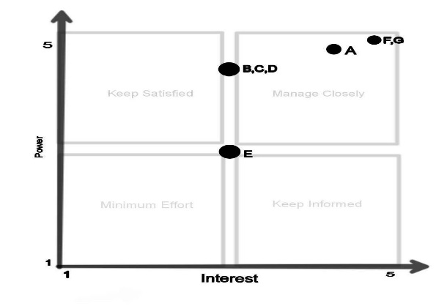*Table 15: Stakeholder Analysis*

*Figure 1: Power/Interest*

The power and interest graph for the stakeholder of Anaa Hotel and Restaurant Housekeeping, Maintenance and Inventory Management is shown below. Each letter represents a stakeholder interested in the key in the box above.

**REQUIREMENTS GATHERING TECHNIQUES**

**Interview:**

Use interviews as a valuable resource to collect information from various stakeholders, including hotel management, housekeeping staff, maintenance staff, guests, and vendors. Inquire about the system's features, functionality, and usability during these sessions.

**Observation:**

Gaining valuable insights into staff needs and identifying potential areas for automation can be achieved by observing their current practices in housekeeping, maintenance, and inventory management tasks. Take note of their daily routines, interactions with systems, tools, and guests during these observations. Pay particular attention to:

* Time spent on different tasks and the efficiency of their workflow
* Use of existing tools and software
* Communication patterns between staff and guests
* Potential areas for automation and digital integration

**Document Analysis:**

Examining available documentation, such as hotel policies, procedures, and training materials, can enhance comprehension of the current status of housekeeping, maintenance, and inventory management practices. Scrutinize the documents to pinpoint:

* Standard operating procedures for housekeeping and maintenance tasks
* Inventory tracking methods and stock levels
* Guest feedback and complaints related to housekeeping and maintenance issues
* Areas where documentation is lacking or outdated

**RFID Technology Assessment:**

Perform a comprehensive evaluation of RFID (Radio Frequency

Identification) technology to ascertain its appropriateness for the hotel's needs. Assess factors like:

* Range and accuracy of RFID tags and sensors
* Integration with door lock systems and inventory management software
* Security protocols for RFID data transmission and storage
* Cost-effectiveness and scalability of RFID implementation

Utilizing a blend of these techniques for gathering requirements enables you to efficiently capture stakeholders' needs and expectations, pinpoint areas for enhancement, and guarantee that the new hotel management system aligns with the specific requirements of both the hotel and its staff.

**USER STORIES AND USE CASES**

**User stories**

o **As a hotel guest,**

I want to be able to submit digital requests for housekeeping

services through a user-friendly digital web portal

o **As a housekeeping staff member,**

I want to receive real-time notifications of guest requests on my device. So that I can promptly address guest needs and ensure a high level of customer satisfaction

o **As a maintenance staff member,**

I want to receive automated alerts for any reported issues in guest rooms or common areas. So that I can efficiently respond to and resolve maintenance requests, minimizing downtime.

* **As a hotel staff member responsible for inventory management,**

I want to receive automatic alerts when inventory levels for cleaning supplies or other items are running low. So that I can proactively restock and ensure that essential items are always available.

o **As a hotel manager,**

I want to have centralized control over the door lock system to manage access permissions. So that I can ensure the security of guest rooms and restrict access as needed.

**Use cases**

* The guest reports a maintenance issue to housekeeping
* A guest discovers that one of the lights in their accommodation is broken.
* To file a maintenance request, the guest uses the door lock system with RFID sensor or the in-room digital interface.
* The hotel's administration system instantly forwards the request to the maintenance division. o After receiving the request, a maintenance technician looks over the information.
* To find out whether the required parts are available, the technician logs into the inventory management system.
* To fix the problem, the technician goes to the visitor's room. o When the repair is finished, the technician gives the guest comments and updates the request's status in the digital system.

**Housekeeping Staff Requests Replenishment of Cleaning Supplies**

* A housekeeping staff member realizes that the cleaning cloths are running
  + - * out.
* The staff member uses the online system to request more cleaning cloths.
* The request is automatically sent to the housekeeping manager through the hotel's computer system. o The manager looks at the request and checks how many cleaning cloths
  + - * are left in stock.
* The manager starts the process of ordering more cleaning cloths. Once the cleaning cloths are delivered, the computer system is updated and the manager is told.
* The manager lets the housekeeping staff know that the cleaning cloths have been restocked.

**Automated Inventory Replenishment**

* The inventory management system keeps track of how much of each
  + - * cleaning supply, maintenance part, and other item is in stock.
      * When the amount of an item gets too low, the system sends a warning to the manager of the department that uses that item. o The manager looks at the warnings and starts the process of ordering more of the items that are needed. o When the new items are delivered, the inventory management system is updated to show the new amounts in stock, and the manager is told.

## FUNCTIONAL REQUIREMENTS FOR INTEGRATION

1. **Centralized User Interface:**

The system shall provide a centralized user interface accessible to both hotel staff and guests.

* + Display tabs or sections for Housekeeping, Maintenance, Digital

Requests, Door Lock System, and Inventory Management.

* + Enable seamless navigation between modules.

1. **Digital Request Integration:**

The system shall facilitate thew integration of digital requests with housekeeping and maintenance modules.

* Enable guests to submit digital requests through a unified interface. • Automatically update housekeeping and maintenance modules with incoming requests.
* Provide real-time notifications to relevant staff members.

1. **Housekeeping and Maintenance Integration:**

The system shall streamline housekeeping and maintenance processes, ensuring efficient task management.

* + Link housekeeping and maintenance modules to the centralized dashboard.
  + Automatically update task statuses based on digital requests.
  + Provide real-time status updates and notifications.

1. **Automated Inventory Management Integration:**

The system shall automate inventory tracking and restocking processes, integrating with other relevant modules.

* + Connect the automated inventory management system with the

centralized interface.

* + Trigger updates to inventory levels based on housekeeping and restaurant usage.
  + Generate alerts for low stock levels and integrate with the procurement process.

1. **Door Lock System Integration:**

The system shall integrate the door lock system with the centralized user interface using RFID sensors.

* + Establish a connection between the door lock system and the user interface.
  + Associate RFID access data with guest profiles for keyless entry.
  + Implement real-time updates for door access permissions and logs.

1. **User Authentication and Access Control:**

The system shall ensure secure access to different modules based on user roles.

* + Implement robust user authentication mechanisms.
  + Define user roles with specific access permissions for staff and guests.
  + Integrate access control settings with each module to maintain data security.

**5. BUSINESS PROCESS ARCHITECTURE**

**IDENTIFICATION OF BUSINESS PROCESSES**

In order to provide stakeholders with a better understanding of our system's operation, data security, and project security assurance. We need to create a business process in order to map key assets, analyze data flow, interview stakeholders, identify critical assets, and account for regulatory compliance needs. For each process, carry out a risk assessment and a potential analysis.

## BUSINESS PROCESS DIAGRAMS

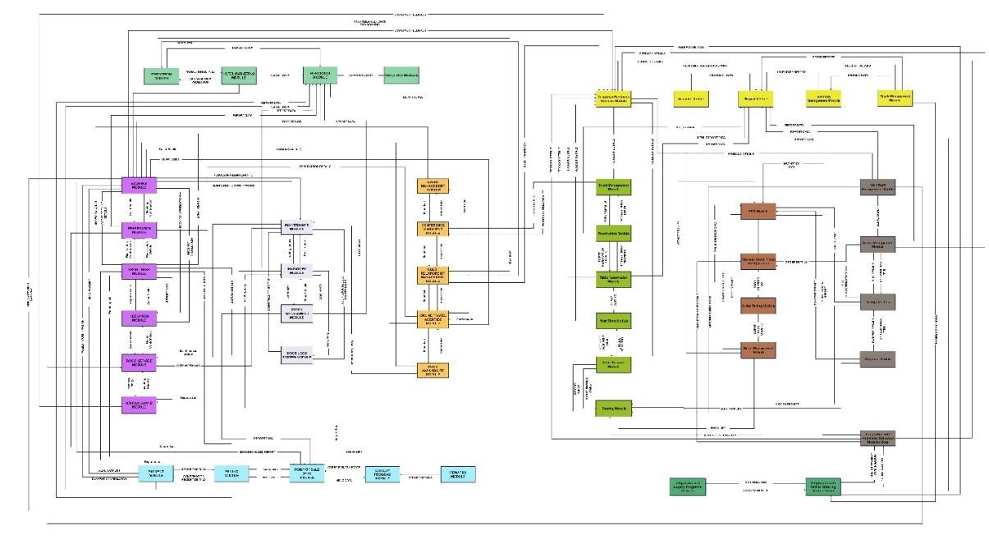

*Figure 2: BPA Top Level 1*

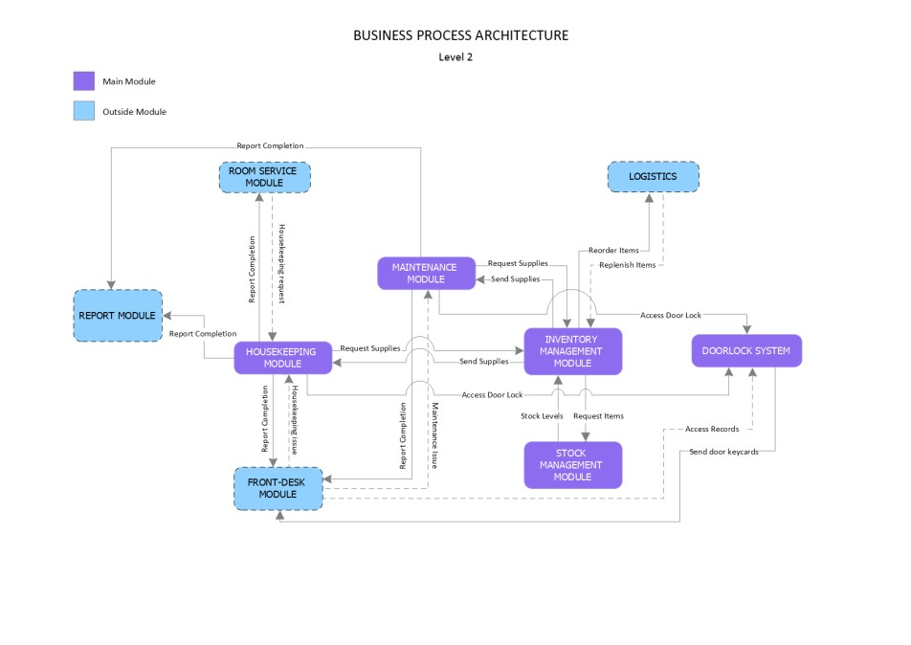

*Figure 3: BPA Top Level 2*

**ALIGNMENT OF INTEGRATED SYSTEM WITH BUSINESS PROCESSES**

1. **Guest Room Maintenance**

Traditional Approach: Guests report issues manually, and staff enter requests into a maintenance system.

Integrated Approach: Guests use a mobile app to digitally submit maintenance requests, which are automatically logged into the maintenance system.

1. **Housekeeping**

Traditional Approach: Housekeeping staff follow manual checklists for room cleaning and inventory replenishment.

Integrated Approach: RFID sensors in rooms detect occupancy and trigger real-time updates to the housekeeping system. Digital checklists on staff devices are automatically updated based on room status.

1. **Door Lock System**

-Traditional Approach: Physical keys or key cards are issued to guests.

- Integrated Approach: RFID key cards are linked to the digital request system. When a guest submits a housekeeping and maintenance request, the RFID sensor in the key card activates a notification for maintenance staff and updates the door lock system to prioritize the request.

**4. Automated Inventory Management**

Traditional Approach: Manual tracking of inventory levels, leading to occasional shortages or overstock.

Integrated Approach: RFID tags on cleaning supplies and inventory items communicate with the automated inventory management system. Reorder requests are automatically generated when supplies are low, ensuring optimal stock levels.

**Alignment:**

**Real-time Data Synchronization:** The integrated system ensures that data across maintenance, housekeeping, door lock, and inventory systems are synchronized in real time, reducing delays and enhancing efficiency.

**Improved Guest Experience:** Guests experience quicker response times to maintenance requests, and housekeeping is more proactive due to realtime updates on room occupancy.

**Resource Optimization:** The system optimizes staff allocation based on the occupancy detected by RFID sensors, preventing unnecessary room checks and reducing workload during low occupancy periods.

**Cost Savings:** Automated inventory management prevents overstocking or shortages, minimizing waste and reducing overall operational costs.

**Enhanced Security:** Integration with the door lock system ensures that maintenance staff access rooms only when necessary, improving security and guest trust.

**Analytics for Continuous Improvement:** The integrated system generates analytics on maintenance response times, housekeeping efficiency, and inventory usage. This data can be used to identify areas for improvement and enhance overall operational effectiveness.

**BUSINESS PROCESS IMPROVEMENTS**

Our objective is to enhance current procedures in addition to automating them. Through the use of the university system's resources, we hope to:

1. **Digital Request System:** 
   * Current State: Guests currently submit maintenance requests manually at the front desk.
   * Improvement: Implement a mobile app that allows guests to submit maintenance requests digitally. Requests are automatically logged into the system, providing real-time visibility to maintenance staff.
2. **RFID- Integrated Door Lock System:** 
   * Current State: Maintenance staff use physical keys to access rooms for repairs, resulting in potential security concerns.
   * Improvement: Integrate RFID sensors with the door lock system. When a maintenance request is submitted digitally, the RFID sensor on the guest's key card triggers a notification for maintenance staff and grants temporary access to the designated room.
3. **Automated Inventory Management:** 
   * Current State: Inventory levels are manually monitored, leading to inefficiencies and potential shortages.
   * Improvement: Implement an automated inventory management system with RFID tags on cleaning supplies. The system automatically tracks inventory levels, generates reorder requests when necessary, and provides real-time insights into stock levels.
4. **Real-time Occupancy Monitoring:** 
   * Current State: Housekeeping staff rely on manual checklists, resulting in unnecessary room checks.
   * Improvement: Install RFID sensors in each room to detect occupancy. Housekeeping staff receive real-time updates on room status, allowing them to prioritize cleaning based on actual occupancy.

**Benefits of Business Process Improvements:**

1. **Enhanced Guest Satisfaction:** 
   * Guests experience faster response times to maintenance requests, leading to improved satisfaction.
   * Digital requests and efficient room turnover contribute to a positive guest experience.
2. **Operational Efficiency:** 
   * Real-time occupancy monitoring optimizes housekeeping schedules, reducing unnecessary room checks and improving staff

efficiency.

1. **Improved Security:** 
   * Integration with the door lock system enhances security by ensuring that only authorized personnel access guest rooms.

1. **Cost Savings:** 
   * Automated inventory management minimizes overstocking and shortages, leading to cost savings and reduced waste.
2. **Data-Driven Decision Making:** 
   * The integrated system generates valuable data on maintenance response times, inventory usage, and room turnover, facilitating data-driven decision-making for continuous improvement.

By implementing these business process improvements, the hotel can significantly enhance the efficiency of housekeeping and maintenance operations, leading to improved guest satisfaction, streamlined processes, and cost savings.

1. **APPLICATION ARCHITECTURE**

**COMPONENTS OF APPLICATION ARCHITECTURE**

A digital request system, an RFID sensor-based door lock system, automated inventory management, and other components are often incorporated into the application architecture for housekeeping and maintenance. First, there's an interface that staff members or residents may utilize to digitally request maintenance or housekeeping services. It should be easy to use and offer a smooth experience for making service requests and monitoring.

Second, a backend system is used by the application to handle and handle these requests. A computerized inventory management system that tracks supplies and equipment is linked to this backend. Secure access control is ensured by the RFID sensor-based door lock system, which is another essential element. Together, these systems help to simplify operations. Upon receiving a maintenance request, the system may automatically allocate jobs, verify inventories, and provide access permissions to the appropriate staff members via the door lock system. In the housekeeping and maintenance area, this integrated design improves total service delivery, lowers human labor requirements, and increases efficiency.

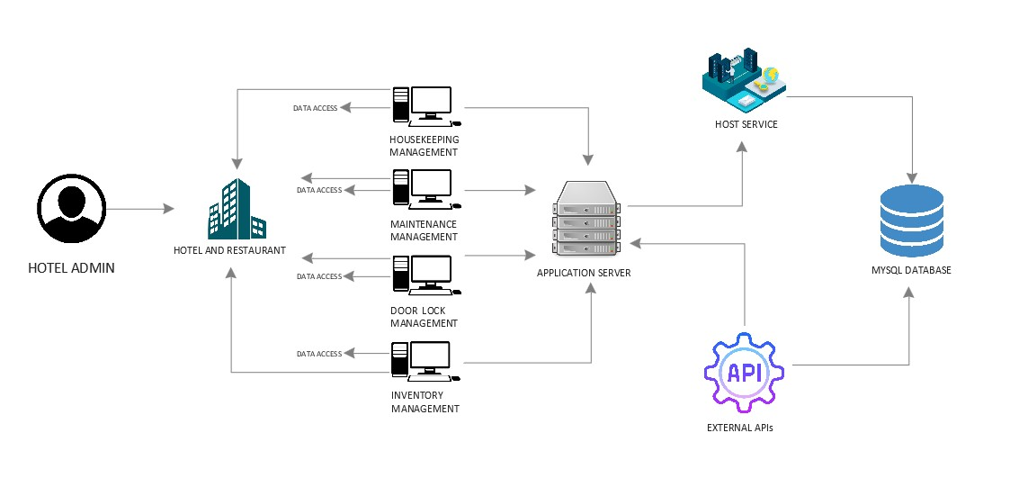

*Figure 4: Components of Application Architecture*

**APPLICATION ARCHITECTURE DIAGRAMS**

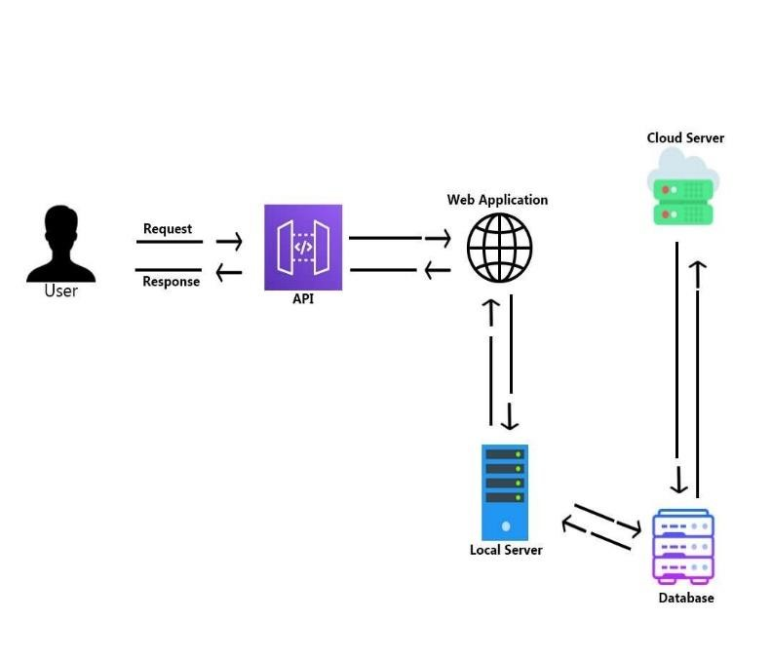

*Figure 5: High Level Architecture*

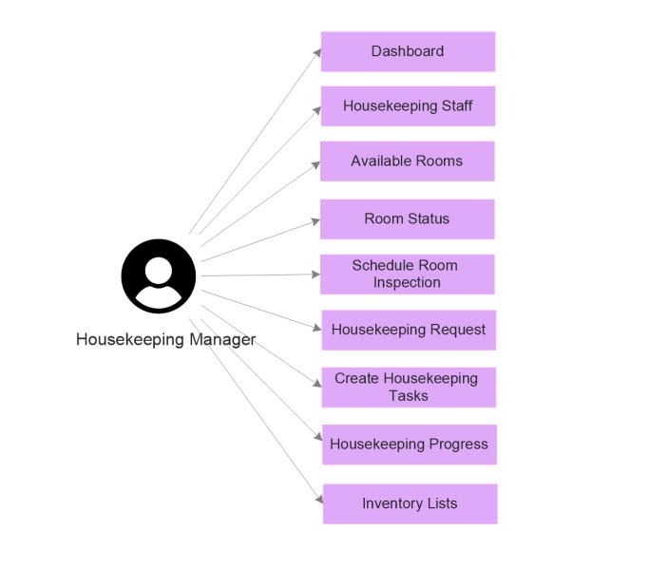

*Figure 6: Housekeeping Management Application Architecture*

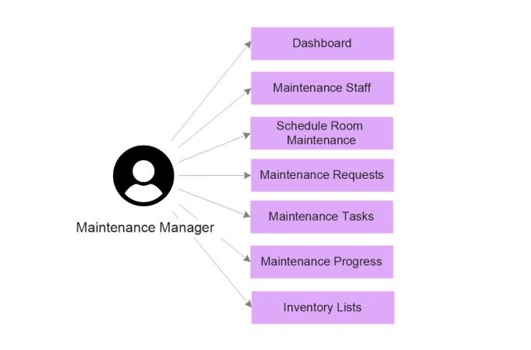

*Figure 7: Maintenance Management Application Architecture*

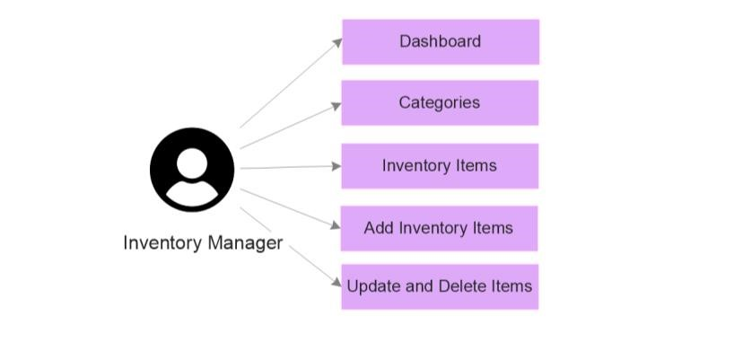

*Figure 8: Inventory Management Application Architecture*

**INTEGRATION OF SOFTWARE MODULES**

Integrating software modules for a comprehensive Hotel and Restaurant Management System with a focus on housekeeping,

maintenance, digital requests, and door lock system using RFID sensors, and automated inventory management involves coordinating various functionalities. Below is an outline of how these modules can be integrated:

**1. Centralized User Interface:**

Provide a unified user interface for seamless navigation and

interaction with different modules.

* Develop a centralized dashboard accessible to both hotel staff and guests.
* Include tabs or sections for Housekeeping and Maintenance

Digital Requests, Door Lock System, and Inventory Management.

1. **Digital Request Integration:**

Enable guests to submit digital requests seamlessly, integrating with housekeeping and maintenance modules.

* + Link the request form to the respective modules, ensuring real-time updates.
  + Housekeeping and maintenance staff receive requests directly from the centralized system.

1. **Housekeeping and Maintenance Integration:**

Streamline housekeeping and maintenance processes, ensuring

efficient task management.

* + Ensure tasks assigned through digital requests are automatically reflected in the respective modules.
  + Provide status updates and notifications for completed tasks.

1. **Door Lock System Integration:**

Enable secure access control using RFID sensors and integrate with the main system.

* + Connect the Door Lock System with the centralized user interface.
  + Associate RFID access data for keyless entry.
  + Implement real-time updates for door access activities and logs.

1. **Automated Inventory Management Integration:**

Automate inventory tracking and restocking processes, integrating with other relevant modules.

* + Connect the automated inventory management system with the

centralized interface.

* + Implement triggers to update inventory levels based on housekeeping and restaurant usage.
  + Generate alerts for low stock levels and integrate with the procurement process.

**COMMUNICATION AND INTERACTION PATTERNS**

An efficient interaction between team members, stakeholders, and the system itself is ensured by the communication and interaction patterns that are integral to a capstone project. An overview of patterns of communication and interaction for a capstone project on hotel and restaurant management systems is provided below:

1. **Daily Stand-Up Meetings:**

Facilitate quick updates and issue resolution among team members.

* + Conduct brief daily stand-up meetings (15 minutes or less) for the entire project team.
  + Each team member shares progress, challenges, and plans for the day.

1. **Weekly Status Reports:**

Keep stakeholders informed about project progress.

* + Send weekly status reports to stakeholders.
  + Highlight key accomplishments, upcoming milestones, and any challenges.
  + Include a summary of sprint progress and overall project status.

1. **Sprint Review Meetings:**

Demonstrate completed work and gather feedback.

* + - Conduct sprint review meetings at the end of each sprint.
    - Development team showcases completed features.
    - Stakeholders, including the Product Owner, provide feedback.

**7. DATA ARCHITECTURE**

**DATA SOURCES AND TYPES**

The specific types and structures of these data sources would depend on the design and requirements of the Hotel and Restaurant:

Housekeeping, Maintenance, RFID Door Lock System and Automated Inventory Management System. Proper data normalization and

organization are essential for efficient querying and system performance. Below are the specific data sources and types that will be stored in the system’s database

**Housekeeping Management**

|  |  |
| --- | --- |
| **Data Sources** | **Data Types** |
| Housekeeping  Staff Data | Id (int) Primary Key, Staff Name (varchar),  Email (varchar), Position (varchar) |
| Room Status Data | Id (int) Primary Key, Room Number (int), Room Status  (varchar) |
| Available Rooms  Data | Id (int) Primary Key, Room Number (int), Room Status  (int) |
| Schedule  Inspection Data | Id (int) Primary Key, Inspection Date (date), Room  Number (int), Inspector Name (varchar) |
| Housekeeping  Requests Data | Request ID (int) Primary Key, Room Number (int),  Request Type (varchar), Request Description (Text), Request Status (varchar), Request Date (timestamp) |
| Housekeeping  Tasks Data | Task Data ID (int) Primary Key, Room Number (int), Task  Name (varchar), Scheduled Date (date), Housekeeper  Name (varchar), Supplies Needed (varchar) |
| Housekeeping  Progress Data | Id (int) Primary Key, Housekeeping Task ID number (int),  Room Number (int), Task Name (varchar), Scheduled  Date (date), Housekeeper Name (varchar), Progress  Status (varchar) |
| Inventory Lists  Data | Id (int) Primary Key, Category (varchar), Item Name  (varchar), Quantity (int), Stock Left (int) |

*Table 16: Housekeeping Management Data Source and Types*

**Maintenance Management**

|  |  |
| --- | --- |
| **Data Sources** | **Data Types** |
| Maintenance Staff  Data | Id (int) Primary Key, Staff Name (varchar),  Email (varchar), Position (varchar) |
| Schedule  Maintenance Data | Id (int) Primary Key, Room Number (Int), Maintenance  Type (varchar), Scheduled Date (date), Maintenance  Staff (varchar), Description or Notes (TEXT) |
| Maintenance  Request Data | Request ID (int) Primary Key, Room Number (int),  Request Type (varchar), Request Description (TEXT),  Request Status (varchar), Request Date (date) |
| Maintenance  Tasks Data | Task ID (int) Primary Key, Room Number (int), Task Name (varchar), Scheduled Date (date),  Maintenance Staff Name (varchar), Equipment and Parts needs (varchar) |
| Maintenance  Progress Data | Id (int) Primary Key, Room Number (int), Task Name  (varchar), Scheduled Date (date),  Maintenance Staff Name (varchar), Progress Status  (varchar) |
| Inventory Lists  Data | Id (int) Primary Key, Category (varchar), Item Name  (varchar), Quantity (int), Stock Left (int) |

*Table 17: Maintenance Management Data Source and Types*

**Inventory Management**

|  |  |
| --- | --- |
| **Data Sources** | **Data Types** |
| Categories | Id (int) Primary Key, Category Name (varchar) |
| Inventory Items  Data | Id (int) Primary Key, Category Name (varchar), Item  Name (varchar), Item Quantity (int) |

*Table 18: Inventory Management Data Source and Types*

**Door Lock Management**

|  |  |
| --- | --- |
| **Data Sources** | **Data Types** |
|  |  |
| Room Number | Id (int) Primary Key, Room Number (int) |
| Door Activity Logs  Data | Id (int) Primary Key, Room Number (int), Door Lock RFID  UID (varchar), Access Status (varchar), Access Date  (timestamp) |

*Table 19: Door Lock Management Data Source and Types*

**DATA FLOW DIAGRAMS**

In the landscape of systems development and analysis,

understanding the intricate pathways of data is paramount. A Data Flow Diagram serves as a compass, guiding our exploration of how information moves within the capstone project we are embarking upon.

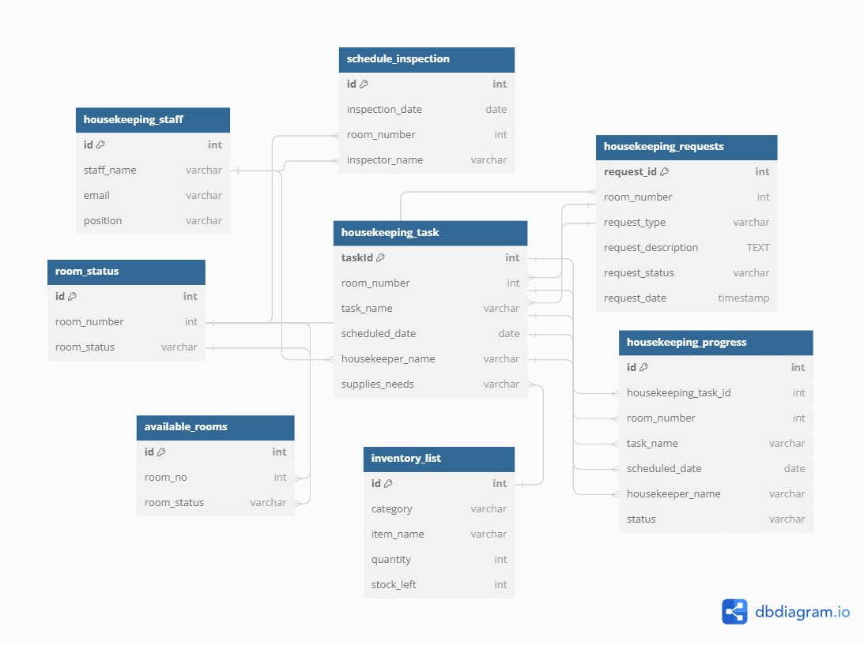

*Figure 9: Housekeeping Management Data Flow Diagram*

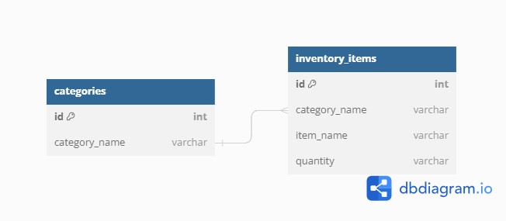

*Figure 10: Inventory Management Data Flow Diagram*

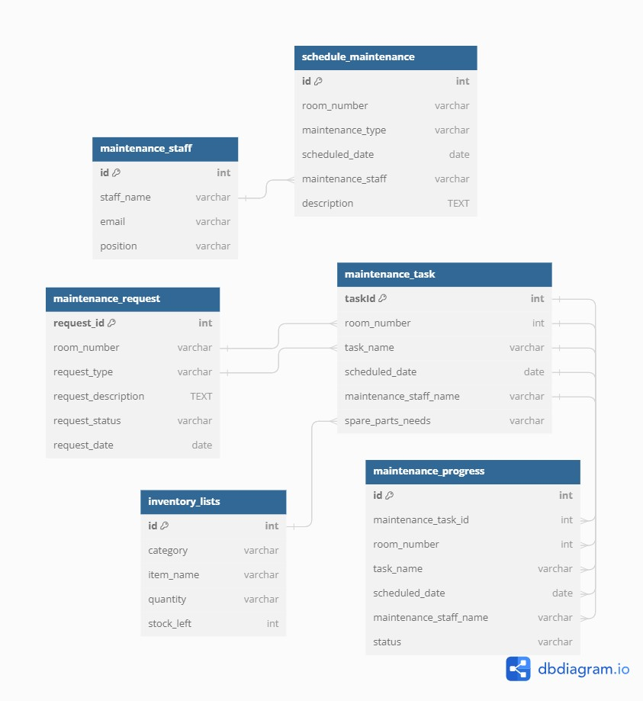

*Figure 11: Maintenance Management Data Flow Diagram*

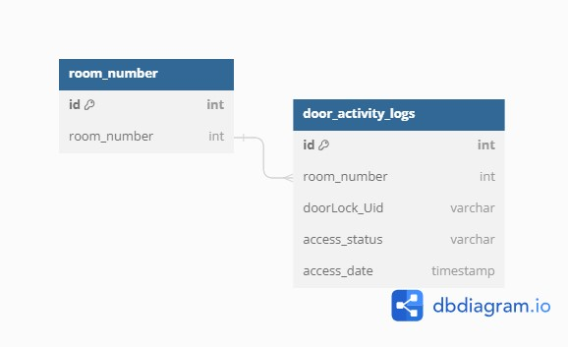

*Figure 12: Door Lock Management Data Flow Diagram*

**DATA STORAGE AND MANAGEMENT**

The System Data are stored and manage through specialized databases, a relational database management system or RDBMS for structured information on digital housekeeping and maintenance requests, including request details and request status. A dedicated activity log for door lock system, recording access granted and access denied, and an inventory database managing item details, categories and quantities, ensuring streamlined operations and efficient retrieval for these essential components of the Hotel and Restaurant: Housekeeping, Maintenance, Door Lock System and Inventory Management System.

**DATA SYNCHRONIZATION ACROSS SYSTEM**

The System provide real-time synchronization to ensure seamless communication between different system modules such as Digital

Maintenance and Housekeeping Requests, Door Lock Activity Logs, and Automated Inventory Management. This involves constant updates between databases, ensuring that the information on requests, door activity logs, and inventory levels is consistently and accurate reflected across the entire Hotel and Restaurant Management System, promoting operational efficiency and providing a unified view of data.

**8. TECHNOLOGY ARCHITECTURE**

**TECHNOLOGY STACK AND INFRASTRUCTURE**

Specifically, list the programming languages, frameworks, and tools used in the Hotel and Restaurant Booking and Reservation System. Describe the necessary cloud services, servers, and hosting platforms for the infrastructure this includes:

* **Operating System:** We deployed the system on Windows-based, and also we ensure that stability and security is highly implemented.
* **Programming Languages:** The project team will use PHP programming language for backend development and also JavaScript for Frontend Development of our Hotel and Restaurant Management System.
* **Frameworks:** The project team will use Laravel Framework for developing the system for built in authentication and easing common tasks used in the majority of web projects.
* **Database Management:** MySQL will be use by the project team, since MySQL is an open source relational database.

**NETWORK TOPOLOGY AND CONFIGURATION**

Explain the network structure designed to sustain the system, outlining the arrangement of servers, load balancers, and additional networking elements to guarantee dependable communication and

efficient data transfer**.**

In the Star Topology, each device operates as an individual connecting to a central hub or switch, which serves as the network's focal point. Similar to accommodating a variety of interests in a social situation, this arrangement enables for flexible design, allowing us to adjust and respond to specific preferences and requirements.

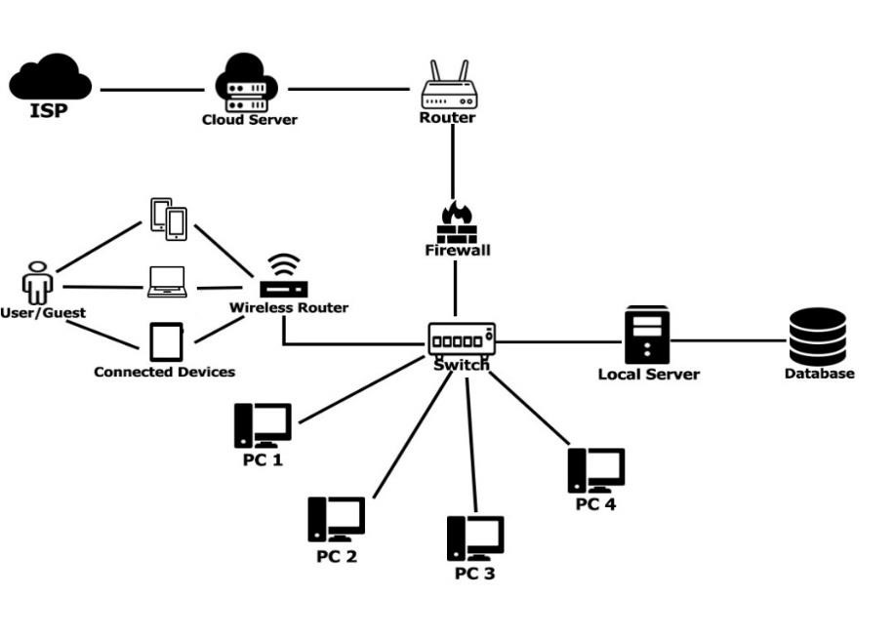

*Figure 13: Network Topology*

**Implementation Framework**

**Step 1**

Make sure that the computer room is set up with everything the system needs to operate at its most efficient. Configuring switches that allow connection to the server is necessary for this. Design the star topology out of wires and power lines, linking them to multiple management points that are depending on the equipment demands of each subsystem.

**Step 2**

Inform staff of the duration and schedule for each step. There are also occasions when we need to interrupt operations while installing new equipment. Everyone can more effectively arrange their activities by being aware of when things will cease to occur.

**Step 3**

In this step all the necessary things should be done and implemented and the network should be tested to check the connections of the devices

**Step 4**

Schedule a meeting to the necessary staff, as well as help from the IT department and anyone else who will help with the implementation.

**SOFTWARE TECHNOLOGIES**

To improve the university system's usability and functionality, we used a variety of software technologies, including:

|  |  |
| --- | --- |
| **Title** | **Description** |
|  | XAMPP is a free and opensource cross-platform web server solution stack package built by Apache  Friends that includes the Apache HTTP Server, the MariaDB database, and  interpreters for PHP and Perl scripts. |
|  | Visual Studio is an integrated development environment  (IDE) created by Microsoft for software development. It provides a comprehensive set of tools and features that make it easier for developers to build a wide range of applications, including web |

|  |  |
| --- | --- |
|  | PHP, which stands for  "PHP: Hypertext  Preprocessor," is a widely used, open-source, server side scripting language designed for web development. It is known for its simplicity and effectiveness in creating dynamic web pages and web applications. PHP is embedded within HTML code and executed on a web server, generating dynamic content that can be served to web browsers. |
|  | Laravel is a popular opensource PHP web application framework known for its elegant syntax, develop user friendly tools, and robust features. It is designed to simplify and streamline the process of building web applications, making it a top choice for web developers.  Laravel follows the Model View-Controller (MVC) architectural pattern and offers a range of features that aid in tasks like routing, |

|  |  |
| --- | --- |
|  | authentication, database interaction, and more. |
|  | A free and open-source administration tool for MySQL and MariaDB is called phpMyAdmin. It has become one of the most well liked MySQL administration tools, notably for web hosting providers, as a portable online program created primarily in PHP. |

|  |  |
| --- | --- |
|  | The Arduino Integrated Development Environment (IDE) is an open-source software platform designed for programming Arduino microcontroller boards.  Arduino is a popular platform for building electronic projects and prototyping, and the Arduino IDE provides an accessible and user-friendly environment for writing, uploading, and testing code on Arduino hardware. |
|  | NodeMCU is an open- source electronics platform and firmware based on the widely used ESP8266 microcontroller. It is designed for Internet of Things (IoT) and embedded applications, providing a convenient and cost-  effective way to build IoT devices that can connect to Wi-Fi networks and interact with other devices and services on the internet. |
|  | An RFID (Radio-Frequency  Identification) card reader is a device that can read and process data from RFID cards or tags. RFID technology uses radio waves to identify and track objects or individuals, and RFID cards are equipped with small RFID chips and antennas that transmit information when brought into proximity with an RFID card reader. |

*Table 20: Software Technologies*

**SCALABILITY AND PERFORMANCE CONSIDERATION**

In order to guarantee the system's scalability and performance, we have incorporated the subsequent factors:

1. **Service-Oriented Architecture:** 
   * Each service should handle a specific functionality such as housekeeping, maintenance, inventory management and door lock

integration to ensure modular scalability.

1. **Load Balancing:** 
   * Consider horizontal scaling for web servers and microservices to handle increased loads during peak times.
2. **RFID Sensor Integration:** 
   * Optimize the RFID sensor data processing to handle a large number of door access activities efficiently.
3. **Housekeeping and Maintenance Digital Request System:** 
   * Ensure the digital request system is capable of handling a high volume of concurrent requests.
4. **Automated Inventory Management:** 
   * Design the inventory management system to scale with the growing volume of items.
   * Implement batch processing for inventory updates to efficiently handle large datasets.
5. **Testing and Optimization:** 
   * Continuously optimize codes, database queries, and system

configuration to improve efficiency.

**9. DEVELOPMENT PROCESS**

**AGILE SCRUM ROLES AND RESPONSIBILITIES**

Roles and duties are well-defined in Agile Scrum to facilitate efficient development processes and productive teamwork. The following are the main jobs in Agile Scrum along with their corresponding duties:

* + 1. **Product Owner:** 
       - Responsible for defining and prioritizing features for the housekeeping and maintenance system.
       - Represents the interests of stakeholders.
       - Prioritizes tasks based on business value.
    2. **Scrum Master:** 
       - Facilitates Scrum events and ensures the team adheres to Scrum

principles.

* + - * Helps the team overcome obstacles and continuously improve.
      * Ensures the team follows Agile practices.
    1. **Development Team:**
  + Cross-functional team responsible for designing, implementing, and testing features.
  + Includes roles such as developers, RFID specialists, software engineers, and system integrators.
  + Collaborates to deliver a potentially shippable product increment in each sprint.

1. **Stakeholders:** 
   * Those who have an interest in the housekeeping and maintenance system, including hotel management and staff.
   * Provide input and feedback to the Product Owner.
   * Considering the digital request integrated with the door lock system,

RFID sensor, and automated inventory management system:

1. **Door Lock System Specialist:** 
   * Expertise in integrating and maintaining the digital door lock system.
   * Collaborates with the development team to ensure seamless

integration.

1. **RFID Sensor Specialist:** 
   * Specialized in RFID technology and sensors.
   * Works closely with the team to implement RFID-based features and ensure their proper functioning.
2. **Inventory Management Specialist:** 
   * Expertise in automated inventory management systems.
   * Collaborates with the team to integrate and optimize inventoryrelated features.

**SPRINT PLANNING AND BACKLOG MANAGEMENT**

1. **Sprint Planning:**

Sprint Planning is a collaborative event where the housekeeping and maintenance team, along with relevant stakeholders, come together to plan and prioritize tasks for the upcoming iteration or sprint.

**Objective:**

* + Define and agree on the tasks, features, or improvements to be accomplished in the next sprint.
  + Participants: Housekeeping and maintenance team members, system administrators, and any other stakeholders involved.

**Agenda:**

* + Review the backlog of tasks and prioritize them based on importance and user needs.
  + Break down tasks into manageable units with clear objectives.
  + Estimate the effort required for each task.
  + Select tasks to be included in the sprint based on priorities and team capacity.
  + Define a sprint goal that aligns with the overall objectives of housekeeping and maintenance, considering the integration of the digital request system, RFID sensor, door lock system, and automated inventory management.

1. **Backlog Management:**

Backlog Management involves maintaining a prioritized list of tasks, features, and improvements that need to be addressed in future sprints.

**Backlog Items:**

* + Digital Request System Enhancements
  + RFID Sensor Integration for Access Control
  + Door Lock System Upgrades and Maintenance
  + Automated Inventory Management System Improvements

**Prioritization Criteria:**

* + Criticality of maintenance tasks.
  + Urgency of digital request system enhancements.
  + Security considerations for RFID sensor integration.
  + User feedback and requirements for the door lock system.
  + Efficiency and accuracy improvements for the automated inventory management system.

**Documentation:**

* + Each backlog item should have clear user stories, acceptance criteria, and any relevant documentation.
  + Regularly update the backlog based on changing priorities and feedback.

**Collaboration:**

* + Regularly communicate with stakeholders to ensure alignment with organizational goals.
  + Gather feedback from end-users to refine and adjust backlog items as needed.

By implementing effective Sprint Planning and Backlog Management, the housekeeping and maintenance team can enhance

efficiency, prioritize tasks strategically, and ensure that the integration of digital systems meets user needs and organizational objectives.

**SPRINT EXECUTION AND DELIVERABLES**

Teams working on the integrated housekeeping and maintenance project will concentrate on providing the system's essential components in brief development cycles during the sprint execution phase. Usually, sprint cycles consist of two weeks where development, testing, and integration activities are conducted. The digital request management system interface may be set up as the first sprint's top priority, and the door lock system's RFID sensor integration may be the focus of later sprints. Concrete deliverables will be produced by each sprint, including the digital request platform's functional modules, the door lock system's API connections, and the automated inventory management system's first setups. Because of this stepwise approach, feedback and modifications can be made continuously, guaranteeing that the integrated solution closely matches changing business needs.

The end result of the sprint deliverables will be an automated inventory management system, an RFID sensor-equipped door lock system, and a fully integrated housekeeping and maintenance system with digital request management. Stakeholders may anticipate an easy-to-use digital interface for housekeeping and maintenance service requests, RFID-enabled secure door entry, and improved inventory monitoring by the conclusion of the sprint cycles. Frequent sprint reviews will enable iterative modifications to increase the overall efficacy and efficiency of the integrated system by facilitating end-user input. With this agile methodology, the project is guaranteed to be flexible enough to adjust to evolving requirements and to continuously provide benefits at every development stage.

**CHALLENGES FACED IN THE DEVELOPMENT PROCESS**

There are several obstacles to overcome while putting in place an integrated housekeeping and maintenance system, digital request system, RFID-enabled door locks, and automated inventory management. The difficulty of system integration itself comes first and foremost. It might be technically challenging to coordinate the several parts and guarantee smooth communication between the door lock system, inventory management, and digital request management. The development process may be hampered by problems with compatibility between the recently introduced technology and the current systems, as well as possible disruptions during the migration phase. Furthermore, the requirement for specific training to help employees adjust to the new processes and technology may cause implementation to lag, which might reduce overall productivity.

**10. IMPLEMENTATION**

**TECHNICAL IMPLEMENTATION DETAILS**

In today's fast-paced hotel industry, ensuring smooth operations in hotels and restaurants is vital for delivering exceptional experiences to guests.

The Hotel and Restaurant Management System: Housekeeping and Maintenance, with its RFID door lock system and digital request

integration, functions like a reliable assistant, simplifying tasks for everyone involved.

This innovative approach leverages advanced technology to automate key tasks. It helps monitor cleaning schedules, manages supplies automatically, and enables guests to submit requests online to ensure everything runs smoothly and guests are happy.

The RFID door locks provide added security, acting like vigilant guards that monitor inventory to save costs and resources, while also controlling access to authorized personnel in specific areas.

The Hotel and Restaurant Management System helps hotels and

restaurants keep their rooms and facilities clean and working well. It also makes it easy for guests to ask for things digitally. This system makes sure everything runs smoothly and guests are happy.

**TOOLS AND TECHNOLOGY USED**

**Programming Languages:**  A mix of programming languages is employed in the system to ensure its effectiveness and flexibility. For backend development, PHP takes the lead, providing a sturdy and scalable framework for managing data and implementing essential functions. On the frontend side, JavaScript steps in, enabling the creation of user-friendly interfaces that enhance interaction and usability. This combination of languages allows the system to operate smoothly while also being adaptable to changes and updates as needed.

**Frameworks:** Laravel framework is famous for its elegance, simplicity, and user-friendliness when it comes to building strong web applications. It’s clear and concise syntax enables developers to write neat and efficient code. It simplifies various common tasks like routing, authentication, caching, and sessions, thereby streamlining

**Database:** the development process. Alongside its extensive documentation and vibrant community, Laravel offers handy features like the Blade templating engine and Eloquent ORM, further enhancing its appeal to developers. In summary, Laravel empowers developers to swiftly create top-notch web applications with ease.

**RFID Technology:** The system uses RFID (Radio Frequency Identification) technology to work with door lock systems seamlessly. RFID sensors check guests and staff, letting them enter without keys and keeping the place safe. This makes it easier for guests and helps staff manage things better.

**Security Measures:** The system takes several steps to protect important information and prevent potential risks. It uses encryption methods like SSL/TLS for secure data transfer and hashing algorithms to securely store passwords, ensuring data remains confidential and unaltered. Access to sensitive features is controlled through role-based permissions, limiting access to authorized users and reducing the risk of unauthorized entry and data breaches.

**CODE INTEGRATION AND INTEROPERABILITY**

The Hotel and Restaurant Management System is a comprehensive solution that integrates housekeeping, maintenance, digital requests, and RFID door lock systems, ensuring smooth communication and

collaboration among its components. It achieves this through carefully crafted RESTful APIs and JSON data formats, seamlessly connecting with external systems such as payment gateways and property management systems. By leveraging RabbitMQ as a message broker and adopting a microservices architecture, the system facilitates asynchronous messaging and dynamic routing, which improves scalability and reliability. Moreover, adapters and data transformation processes are employed to bridge the gap between modern and legacy systems, guaranteeing seamless interoperability. Rigorous testing and robust error handling mechanisms ensure the reliability of these integrations, supported by extensive documentation and dedicated support channels to assist with utilization and troubleshooting effectively.

**INTEGRATION TESTING AND DEBUGGING**

In our Hotel and Restaurant Management System, making sure everything works smoothly is our main goal. We do this by carefully testing and fixing any issues that pop up. We use tools like pytest and Postman to check how different parts of the system work together, just like in real situations. We have separate testing areas that look like the real thing, so we know our tests are accurate. Tools like Docker and Kubernetes help us keep our testing data consistent for reliable results. If something goes wrong, we use logs and monitoring tools to find and fix the problem fast. We focus on handling errors well and keeping track of what's happening in the system. We also have a process where tests run automatically to catch any problems early, and we make sure the system works well in different situations. Keeping good records helps us keep track of what we've tested and improved. This way, we make sure our system is always dependable and meets the needs of our users smoothly.

**11. TESTING AND QUALITY ASSURANCE**

**TESTING STRATEGIES AND METHODOLOGIES**

Our testing team for the system employs a comprehensive approach to ensure the functionality, security, and reliability of the system. We follow a combination of manual and automated testing methodologies to cover all aspects of the system. Our testing strategies include unit testing, integration testing, system testing, and acceptance testing. We prioritize user experience and system performance, conducting load testing and stress testing to ensure the system can handle peak loads. Additionally, we implement security testing to identify and mitigate potential vulnerabilities, ensuring the system is secure against unauthorized access and data breaches. Our team is committed to delivering a high-quality, reliable system that meets the needs of our users.

**TEST CASES AND TEST DATA**

To guarantee our system's dependability, security, and functionality, our team has created an extensive collection of test cases. These test cases encompass a range of scenarios, such as digital request submission, door lock system integration with RFID

sensors, automated inventory management, and user

identification. Sample user credentials, request information, RFID

tag data, and inventory records are all examples of test data. We want to create a reliable and easy-to-use solution that satisfies the demands of our housekeeping and maintenance industry clients by carefully testing every part and situation

**TEST RESULTS AND BUG REPORTS**

When it comes to reporting bugs and test findings inside the system, we take a thorough approach. We do unit, integration, and system tests as part of an organized testing procedure. Standardized templates are used to document test results, including test case ID, description, expected and actual results, and pass/fail status. If any problems are found during testing, we quickly record them in our bug tracking system. Every bug report comprises an easy-to-read explanation of the issue, replication instructions, a severity rating, and the team member assigned to handle it. Frequent bug triage sessions are organized to effectively prioritize and handle reported bugs. Our team is dedicated to making sure the system is functional and reliable by using strict bug reporting procedures and extensive testing.

**QUALITY ASSURANCE MEASURES**

Our Quality Assurance team is essential to our system's smooth operation and dependability of our services. Our complete approach to quality assurance includes frequent audits of the performance of the RFID sensor, testing to ensure accuracy and efficiency of the automated inventory management system, and a detailed assessment of the digital request system to make sure it satisfies user needs. To guarantee peak performance and client happiness, our staff also periodically examines maintenance logs and service records in order to spot possible problems early on and take proactive measures to resolve them.

**12. RESULTS AND EVALUATION**

**PROJECT OUTCOMES AND DELIVERABLES**

With the fulfillment of housekeeping and maintenance with digital request integrated with door lock system RFID sensor and automated inventory management system the project seeks to optimize Housekeeping and Maintenance in digital form request, RFID's Door locking system and automated inventory management. Here are some project outcomes and deliverables that the client may anticipate to accomplish while adopting housekeeping and maintenance with digital request integrated with door lock system, RFID sensor, and automated inventory management system:

**Improve Customer Service:** By developing a user-friendly system, guest’s maintenance and housekeeping digital form request can be access through mobile device or can be accessible through website.

**Real-Time Tracking and Reporting:** By giving the hotel a privilege to access real-time tracking of Inventory Management system, the reports are on time, stocks in the hotel’s inventory are tracked and recorded so that re-stocking are monitored.

**Cost Reduction:** through the integration of RFID DOORLOCK SYSTEM, housekeeping and maintenance request through digital form, and digital Inventory Management system. ANAA anticipates a more

efficient, cost-effective approach

**Increased Efficiency:** By implementing the Digital request form through requesting in ANAA system, these solutions improve each guest's request, reducing delays and improving overall efficiency because requests can now be made online, time-efficient and causing less difficulty.

**On-time**

**INTVENTORY:** By creating an INVENTORY

MANAGEMENT SYSTEM, the company might comply with every stock, records, concerns, in their inventory. Tracked stocks, need to re-stocks, used stocks, stocks that needed to be dispose and replace are being reported and monitored.

**ALIGNMENT WITH PROJECT OBJECTIVES**

This project is clearly focused on achieving important goals that complement our broader goal of giving our stakeholders a flawless, secure, and effective implementation of the system. Our strategic efforts to optimize housekeeping and maintenance request, inventory management system, and RFID door lock system reflects to the outcome of our project.

**Efficiency**: The housekeeping and maintenance workflow is improved by the implementation of digital request system, which enables stakeholders, hotel guests, to submit and monitor requests with ease. RFID door lock system improves and monitors guest's tap in time and date, which helps to manage areas safely and effectively.

**Transparency**: Real-time visibility into housekeeping and maintenance requests is made possible by the digital request system, which also ensures quick responses and transparent communication. The door lock system's RFID sensors improve security procedures and provide a transparent record of date and time, tap in and out access by providing information about employee, guest's movements.

**Maintenance**: By integrating RFID door lock systems, it is possible access to designated rooms and its guest resident, which promotes proactive and scheduled maintenance and lowers the possibility of unforeseen problems. Restocking supplies on schedule is guaranteed by the inventory management system, which helps with preventative

maintenance, and timely notification to avoid delays.

**Inventory’s Resource Utilization:** The automated inventory management system reduces waste, improves overall efficiency in purchasing, and avoids overstocking or stock-outs to maximize resource use.

**STAKEHOLDER AND USER FEEDBACK**

Stakeholders and end users have responded positively to the implementation of our integrated housekeeping and maintenance with digital request integrated with door lock system RFID sensor and automated inventory management system, working together and being in constant contact with users and stakeholders has been essential to developing and improving the system's functionality.

**STAKEHOLDERS FEEDBACK:**

Stakeholders that have been involved in the integration process, such as facility managers, hotel employees, and administrative staff, are satisfied with how well the HOUSEKEEPING AND MAINTENANCE WITH DIGITAL REQUEST INTEGRATED WITH DOOR LOCK SYSTEM RFID SENSOR AND AUTOMATED INVENTORY MANAGEMENT SYSTEM

work together. Access control has been greatly enhanced by the RFID door lock system, which makes sure that only authorized individuals such as the administrative stuff are able to monitor every guest's tap in/out movements.

Positive comment has been received on this improved security feature, especially in terms of protecting sensitive areas such as the guest's personal date and time room information, and the guest's safeness in their designated rooms. Real-time visibility into housekeeping and maintenance requests provides more accurate selection and resource allocation. The accuracy with which the automated inventory management system tracks supplies, avoids shortages, and simplifies purchasing processes has received recognition. One advantage that stakeholders have emphasized is the cost-effectiveness that comes from reduced workflows and preventive delayed maintenance requesting attempts. Overstocking in the inventory are prevented because it is well-monitored in the Inventory

Management System Integration

**USER FEEDBACK:**

Hotel guests, including employees, housekeepers, and maintenance personnel, have provided important feedback on the integrated system's usability and usefulness on a daily basis. The Housekeeping and Maintenance digital request platform has received praise for having a simple to use user interface that makes it easier to submit and follow up on maintenance and housekeeping needs. The efficiency improvements from doing away with paper-based workloads are valued by users, who can now concentrate on their main duties

Users expressed their praised on the RFID door lock system because of the increased in their security, the ease of use. The automated inventory management system has also received recognition for its contribution to decreasing downtime, avoiding stock lapses, guaranteeing the availability of essential supplies, and improving overall operating

efficiency.

Because our user engagement is progressive, we can continuously improve the system to meet the demands of each user and make sure they have a positive and efficient experience.

**LESSON LEARNED**

Integrating a smooth housekeeping and maintenance digital request system with features like automated inventory management system and RFID based door locking system. The most important takeaways from this project's execution include the requirement for precise project objectives and a comprehensive needs analysis. To make sure that different points of view are taken into account, cooperation between the project team, stakeholders, scrum master, and end users is essential. Effective adoption is aided by staff training, continuous feedback loops, and user participation. It is also essential to prioritize cybersecurity measures, address integration challenges, and put in place comprehensive data accuracy checks. The adaptability and long-term efficacy of the system are guaranteed by scalability, securing, and frequent system reviews. Lastly, creating a mobile

and web-based HOUSEKEEPING AND MAINTENANCE WITH DIGITAL

REQUEST INTEGRATED WITH DOOR LOCK SYSTEM RFID SENSOR AND AUTOMATED INVENTORY MANAGEMENT SYSTEM help creates

an is easy to use, safe, and effective, and that smoothly optimizes cleaning and maintenance procedures.

1. **CONCLUSION**

**KEY TAKEWAYS AND SUMMARY**

The ANAA Hotel and Restaurant Management System

successfully addresses challenges in the hospitality industry by introducing innovative solutions. The system optimizes housekeeping and maintenance through digital requests, integrates RFID door lock technology, and implements an automated inventory management system.

**PROJECT ACHIEVEMENTS AND CONTRIBUTIONS**

* + **Improved Customer Service:** The user-friendly digital request system enhances guest experiences by providing easy access through mobile devices or websites.
  + **Real-Time Tracking and Reporting:** The system allows hotels to access real-time inventory tracking, ensuring timely reports and efficient stock monitoring.
  + **Cost Reduction:** Integration of RFID door lock, digital requests, and automated inventory management results in a more efficient and cost-effective approach.

* + **Increased Efficiency:** Digital request forms streamline guest requests, reducing delays and enhancing overall efficiency.
  + **On-time Inventory Management:** The automated inventory system ensures accurate tracking, restocking, and disposal of supplies, maintaining a well-managed inventory.

**FUTURE WORK AND ENHANCEMENTS**

* + **Continuous User Engagement:** Ongoing user engagement ensures the system meets evolving user demands, leading to positive and efficient experiences.
  + **Security Measures:** Prioritizing cybersecurity measures, addressing integration challenges, and implementing comprehensive data accuracy checks for enhanced system security.
  + **Scalability:** Ensuring the system remains adaptable and effective in the long term by prioritizing scalability, security, and frequent system reviews.
  + **Mobile and Web Accessibility:** Continuously improving the mobile and web-based interfaces of the system for ease of use, safety, and effectiveness.

**CLOSING REMARKS**

The ANAA Hotel and Restaurant Management System not only meets but exceeds the project objectives. It revolutionizes traditional practices, enhancing guest security, streamlining operations, and providing a reliable, efficient, and user-friendly solution for the hospitality sector. The lessons learned underscore the importance of precise project objectives, collaboration, cybersecurity, adaptability, and user engagement in achieving successful implementations.

1. **REFERENCES**

**LIST OF CITED SOURCES AND REFERENCES**

**Intellect**

[**https://www.linkedin.com/pulse/hotel-housekeepingmanagement-software-market-1c/**](https://www.linkedin.com/pulse/hotel-housekeeping-management-software-market-1c/) **Alexis Janmarie Diaz**

[**https://ejournals.ph/article.php?id=16026**](https://ejournals.ph/article.php?id=16026)

1. **APPENDICES**

**Appendix A** Process Diagram

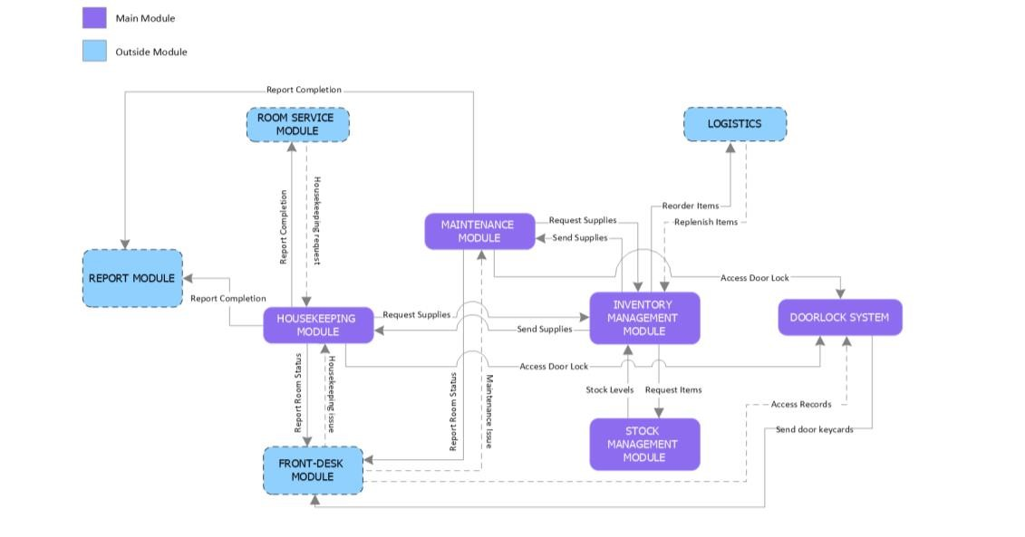

*Figure 14: Appendix A Process Diagram*

**Appendix B** User Surveys

Thank you for being a valued user of the Anaa Hotel and Restaurant Management System (AHARMS). Your feedback is important to us as we strive to continuously improve our system to better meet your needs. Please take a few minutes to complete this survey.

1. **General Information**
   * Name: [Optional]
   * Position/Role: [e.g., Front Desk Manager, Housekeeping Staff, IT Administrator]
   * Department/Location: [e.g., Front Office, Housekeeping, Restaurant]
2. **System Usability**
   * How would you rate the overall usability of AHARMS?
     + Excellent
     + Good
     + Fair
     + Poor
   * Which features of AHARMS do you find most useful?
     + [Open-ended response]
3. **Functionality**
   * Are there any specific features or functionalities you find lacking in AHARMS? If yes, please specify.
     + [Open-ended response]
   * How satisfied are you with the performance and reliability of AHARMS?
     + Very satisfied
     + Satisfied
     + Neutral
     + Dissatisfied
     + Very dissatisfied
4. **User Experience**
   * How intuitive do you find the user interface of AHARMS?
     + Very intuitive
     + Somewhat intuitive
     + Neutral
     + Not very intuitive
     + Not intuitive at all
   * Do you feel adequately trained to use AHARMS effectively?
     + Yes, fully trained
     + Somewhat trained
     + No, not trained enough
5. **Support and Training**
   * How would you rate the support provided by the AHARMS support team?
     + Excellent
     + Good
     + Fair
     + Poor
   * Have you received sufficient training and resources to use AHARMS effectively?
     + Yes
     + No
     + Not sure
6. **Data Security**
   * How confident are you in the security measures implemented in AHARMS to protect sensitive data?
     + Very confident
     + Somewhat confident
     + Neutral
     + Not very confident
     + Not confident at all
7. **Suggestions and Comments**
   * Do you have any suggestions or comments for improving AHARMS?
     + [Open-ended response]
8. **Overall Satisfaction**
   * How satisfied are you overall with AHARMS?
     + Very satisfied
     + Satisfied
     + Neutral
     + Dissatisfied
     + Very dissatisfied

**Appendix C** User Stories and Use Cases

**User stories**

o **As a hotel guest,**

I want to be able to submit digital requests for housekeeping

services through a user-friendly digital web portal

o **As a housekeeping staff member,**

I want to receive real-time notifications of guest requests on my device. So that I can promptly address guest needs and ensure a high level of customer satisfaction

o **As a maintenance staff member,**

I want to receive automated alerts for any reported issues in guest rooms or common areas. So that I can efficiently respond to and resolve maintenance requests, minimizing downtime.

* **As a hotel staff member responsible for inventory management,**

I want to receive automatic alerts when inventory levels for cleaning supplies or other items are running low. So that I can proactively restock and ensure that essential items are always available.

o **As a hotel manager,**

I want to have centralized control over the door lock system to manage access permissions. So that I can ensure the security of guest rooms and restrict access as needed.

**Use cases**

* The guest reports a maintenance issue to housekeeping
* A guest discovers that one of the lights in their accommodation is broken.
* To file a maintenance request, the guest uses the door lock system with RFID sensor or the in-room digital interface.
* The hotel's administration system instantly forwards the request to the maintenance division. o After receiving the request, a maintenance technician looks over the information.
* To find out whether the required parts are available, the technician logs into the inventory management system.
* To fix the problem, the technician goes to the visitor's room. o When the repair is finished, the technician gives the guest comments and updates the request's status in the digital system.

**Housekeeping Staff Requests Replenishment of Cleaning Supplies**

* A housekeeping staff member realizes that the cleaning cloths are running
  + - * out.
* The staff member uses the online system to request more cleaning cloths.
* The request is automatically sent to the housekeeping manager through the hotel's computer system. o The manager looks at the request and checks how many cleaning cloths
  + - * are left in stock.
* The manager starts the process of ordering more cleaning cloths. Once the cleaning cloths are delivered, the computer system is updated and the manager is told.
* The manager lets the housekeeping staff know that the cleaning cloths have been restocked.

**Automated Inventory Replenishment**

* The inventory management system keeps track of how much of each
  + - * cleaning supply, maintenance part, and other item is in stock.
      * When the amount of an item gets too low, the system sends a warning to the manager of the department that uses that item.
      * The manager looks at the warnings and starts the process of ordering more of the items that are needed. o When the new items are delivered, the inventory management system is updated to show the new amounts in stock, and the manager is told.

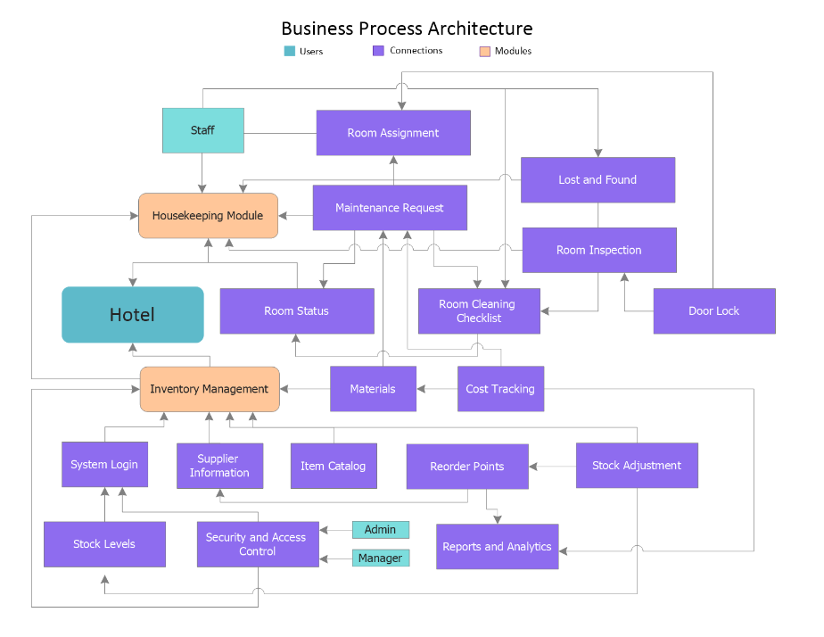**Appendix D** Sample Data

*Figure 15: Appendix D Sample Data*

**Appendix E** Stakeholder Interview Transcripts

General Questions:

1. What are the primary goals and objectives of the hotel and restaurant in terms of housekeeping, inventory management, and door lock systems?
2. What specific challenges or pain points are you currently experiencing with the existing systems, if any?
3. Are there any regulatory or compliance requirements that the systems must adhere to (e.g., safety regulations, data privacy laws)?

Housekeeping System:

1. What are the key features and functionalities you expect from the housekeeping system?
2. How would you like to handle room assignments and cleaning task assignments for housekeeping staff?
3. Are there any specific room status updates or cleaning checklists you'd like to incorporate into the system?
4. Do you need a lost and found management feature within the housekeeping system?
5. What are your expectations for room inspection scheduling and reporting?

Inventory Management System:

1. What types of inventory items do you need to manage (e.g., consumables, non-consumables)?
2. How would you like to track inventory levels and set reorder points for supplies?
3. Are there specific suppliers and procurement processes that should be integrated into the inventory management system?
4. What reports and analytics are essential for managing inventory efficiently?
5. Do you have any specific requirements for waste and disposal management of inventory items?

Door Lock System:

1. What type of door lock system is currently in use, and what are its limitations or requirements for improvement?
2. Are there any security or access control features you'd like to implement in the new door lock system?
3. Do you need integration with other hotel systems, such as the property management system (PMS), for seamless guest access?
4. Are there any preferences for keyless entry or smart lock technologies?

Budget and Timeline:

1. Do you have a budget allocated for the development or improvement of these systems, and are there any budget constraints?
2. What is the desired timeline or deadlines for implementing these systems?

**Appendix F** System Performance Test Results

The System Performance Test Results for Anaa Hotel and Restaurant Management System demonstrate robust functionality across key areas. In housekeeping, the system efficiently tracks room status updates and service requests, ensuring timely responses and improved guest satisfaction. Maintenance tasks are seamlessly integrated, facilitating proactive upkeep and minimizing downtime through automated alerts and scheduling. The digital request system, coupled with the door lock system using RFID sensors, enhances security and convenience, allowing guests to securely access their rooms while enabling staff to monitor entry in real-time. Moreover, the automated inventory management system optimizes stock levels and streamlines procurement processes, reducing wastage and enhancing operational efficiency. Overall, the integration of these features underscores the system's reliability, scalability, and ability to meet the diverse needs of hospitality management effectively.

**Appendix G** Data Security Measures

The Anaa Hotel and Restaurant Management System prioritizes robust data security measures to safeguard sensitive information. The system employs advanced encryption protocols to protect guest and operational data stored within its databases. Access controls are rigorously enforced, ensuring that only authorized personnel have appropriate permissions to view or modify data. Regular security audits and vulnerability assessments are conducted to identify and address potential risks proactively. Furthermore, the system adheres to industry best practices and compliance standards such as GDPR (General Data Protection Regulation) to ensure data privacy and integrity are maintained at all times. These comprehensive data security measures underscore the system's commitment to maintaining confidentiality, integrity, and availability of information critical to hotel and restaurant operations.

**Appendix H** Mobile Application Prototype

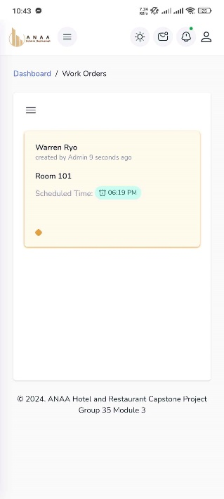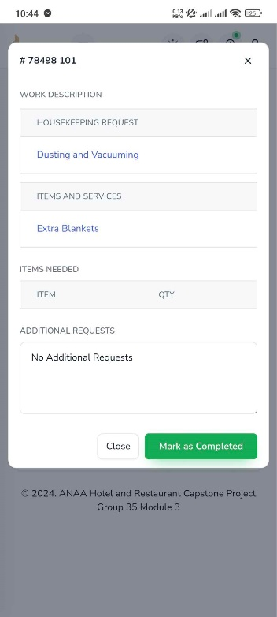

*Figure 16: Appendix H Mobile Application Prototype*

**Appendix I** Adviser Acceptance

The group's researchers attest that, to the best of their knowledge and conviction, this project study does not, without permission, integrate any content that has previously been presented for a diploma at any university. Except in cases where appropriate citation is provided within the text, it doesn't include any previously published or written works by us or anybody else. Furthermore, we hereby grant permission for our project study. If approved, to be made available for interlibrary loan, photocopying, and public distribution of the title and synopsis to other groups.

Signature of Group/ Individual: Date: May 2024

     PENA, WARREN RYO GANDAROSA, NORHANA

PATENO, LHEY JUSTINE

   OLARTE, WOWIE ATON, JUSTINE JOHN

Counter Signed By:

Mr. Gerald Dela Cruz

Project Adviser

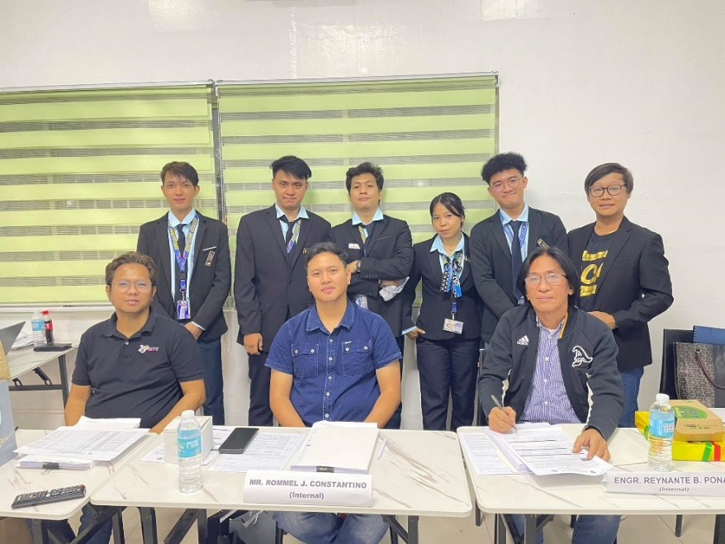**Appendix J** Panel Evaluation and Signature (plus photo ops during defense)

*Figure 17: Appendix J Panel Evaluation and Signature*

**Appendix K** Capacity Planning (Estimates on Storage Consumption – 5 years)

For storage consumption over a five-year period involves estimating the amount of storage space required to accommodate data growth and system expansion. Here's a general approach to estimate storage consumption for ANAA Hotel's management system:

**Current Data Size:** Determine the current size of the data stored in the system, including databases, media files, logs, and other data sources. This can be obtained by analyzing existing storage usage metrics or by conducting a storage audit.

**Data Growth Rate:** Estimate the expected growth rate of data over the next five years. This can be based on historical data growth trends, business projections, or industry benchmarks.

**Appendix L** Pilot Companies’ Background with proofs of

interviews

**Appendix M** Cloud Copy of the Codes (1 year validity)

<https://github.com/warrenryo/Anaa-HRMS-H3-Housekeeping>

**Appendix N** IMRAD Format Summary

**INTRODUCTION**

Technological innovations are driving the highly competitive hotel and restaurant businesses to a better services and as well to attract and gain guest's interest. Including a Digitalize

Inventory management, the Hotel and Restaurant Management System (HRMS) provides integrated features targeted to the industry's unique requirements. Some hotels continue to use outdated methods and techniques in spite of technology advancements, which creates inefficiencies and security hazards. With the use of an RFID sensor for door locking to increase security, an automated inventory management system for effective tracking of hotel supplies, and digital housekeeping and maintenance requests for guests, this project seeks to establish an integrated system that addresses these problems. The objective is to provide an improved, new, and digitalize solution that will benefit both employees and visitors.

**METHODOLOGY**

With the use of AGILE SCRUM METHODOLOGY, Agile

methodology will rely on trusting teams and individual to create a collaboration in directly to customers so teams and individuals can understand the needs and give solutions in a timely and progressive approach. Each sprint of the development process will concentrate on a different feature. Frequent scrum meetings will help with adaptability and communication. A project manager oversees the daily operations of the project's scope, in addition to the project team and sponsor. The project manager is prepared to help the project team generate leads for the company. The project manager oversees the Hotel and Restaurant

Management System Project.

**RESULT**

With the fulfillment of housekeeping and maintenance with digital request integrated with door lock system RFID sensor and automated inventory management system the project seeks to optimize Housekeeping and Maintenance in digital form request, RFID's Door locking system and automated inventory management. It improves guest's customer service by giving them digitalize housekeeping and maintenance request, and accessible through mobile

device. Giving the hotel a privilege tracking their Inventory reports access in real-time, supplies in the hotel's inventory are monitored through inventory management system. Stakeholders are happily satisfied of the system's Cost reduction because it is more efficient and cost-effective. By the implementation of Digital request form through ANAA's system, it improved guest's request, avoided delays, and improved overall efficiency while causing less difficulty

**DISCUSSION**

Integrating technologies like an automated inventory management system and an RFID-based door locking system into a seamless digital request system for

housekeeping and repair. Also, the need for specific project objectives and a thorough needs analysis are the two most crucial lessons learned from the implementation of this project. To ensure that all points of view are taken into consideration, collaboration is necessary between the project team, stakeholders, scrum master, and end users. User involvement, ongoing feedback loops, and staff

training all contribute to effective adoption. A user-friendly, easy to use secure, and efficient system that seamlessly optimizes cleaning and maintenance procedures is created by developing a mobile and web-based Housekeeping and maintenance with digital request integrated with door lock system using rfid sensor and automated inventory management system.

Lastly, it is also essential to prioritize cybersecurity measures, address integration challenges, and put in place comprehensive data accuracy checks. The adaptability and long-term efficacy of the system are guaranteed by scalability, securing, and frequent system reviews.

**Appendix O** Comparison of the EIS to existing EIS’s (5 pages)

When comparing the Anaa Hotel and Restaurant Management System's (AHARMS) EIS (Enterprise Information System) to existing EIS solutions in the hospitality industry, several key aspects highlight its advantages:

1. **Integration and Functionality**: AHARMS integrates housekeeping, maintenance, digital requests with RFID door lock systems, and automated inventory management seamlessly into a unified platform. Existing EISs may offer similar functionalities but often require multiple systems or modules, leading to complex integrations and potential inefficiencies.
2. **User Interface and Accessibility**: AHARMS prioritizes user-friendly interfaces tailored for hospitality staff, enhancing usability and reducing training time. Some existing EIS solutions may have interfaces that are less intuitive or require extensive customization to meet specific hospitality needs.
3. **Scalability and Customization**: AHARMS is designed to scale efficiently with hotel and restaurant operations, accommodating growth and adapting to changing needs through modular customization. In contrast, some existing EISs may be less flexible, requiring significant redevelopment or additional costs to expand functionality.
4. **Data Security and Compliance**: AHARMS emphasizes robust data security measures, including encryption, access controls, and compliance with data protection regulations like GDPR. While existing EIS solutions also prioritize security, AHARMS' integrated approach ensures comprehensive protection across all modules.
5. **Performance and Reliability**: AHARMS undergoes rigorous performance testing to ensure reliability in managing real-time operations such as room status updates, service requests, and inventory management. Existing EISs may vary in performance depending on the complexity of their integrations and scalability.

**SUPPLEMENTARY MATERIAL**

**User Stories**

|  |  |  |  |  |
| --- | --- | --- | --- | --- |
| **User**  **Story**  **Number** | **User Stories** | **Tasks** | **User**  **Story**  **Point s(Hours)** | **Responsib**  **le**  **Team**  **Member** |
| **Sprint 1** | | | | |
| **Housekeeping Management** | | | | |
| 1 | As a Housekeeping  Admin, I want to create a Dashboard        To create a  Dashboard | Planning | 2 | Warren  Pena |
| Designing | 2 | Warren  Pena,  Wowie  Olarte |
| Coding | 5 | Warren  Pena |
| Testing | 1 | Justine  Ejorcada  s |
| Documenting | 3 | Norhana  Gandaro sa, Lhey  Pateno |
| 2 | As a Housekeeping  Admin, I want to create Housekeepers  Lists        To create a table for  Housekeepers | Planning | 2 | Warren  Pena |
| Designing | 2 | Warren  Pena,  Wowie  Olarte |
| Coding | 5 | Warren  Pena |
| Testing | 1 | Justine  Ejorcada  s |
| Documenting | 3 | Norhana  Gandarosa,  Lhey  Pateno |

|  |  |  |  |  |
| --- | --- | --- | --- | --- |
| 3 | As a Housekeeping  Admin, I want to create Available Rooms | Planning | 2 | Warren  Pena |
| Designing | 2 | Warren  Pena,  Wowie  Olarte |
| Coding | 5 | Warren  Pena |
| Testing | 1 | Justine  Ejorcada  s |
|  | To create a table for Available Rooms Lists | Documenting | 3 | Norhana  Gandaro sa, Lhey  Pateno |
| 4 | As a Housekeeping  Admin, I want to create Housekeeping  Requests to show the  list of guest’s  housekeeping request      To create a table for  Housekeeping  Requests Lists | Planning | 2 | Warren  Pena |
| Designing | 6 | Warren  Pena,  Wowie  Olarte |
| Coding | 6 | Warren  Pena |
| Testing | 1 | Justine  Ejorcada  s |
| Documenting | 3 | Norhana  Gandaro sa, Lhey  Pateno |
| 5 | As a Housekeeping Admin, I want to create Schedule Room  Inspection | Planning | 2 | Warren  Pena |
| Designing | 3 | Warren  Pena,  Wowie  Olarte |

|  |  |  |  |  |
| --- | --- | --- | --- | --- |
|  | To create a table for  Schedule Room  Inspection | Coding | 5 | Warren  Pena |
| Testing | 1 | Justine  Ejorcada  s |
| Documenting | 3 | Norhana  Gandaro sa, Lhey  Pateno |
| 6 | As a Housekeeping  Admin, I want to create Room Status Lists      To create a table for  Room Status  lists | Planning | 2 | Warren  Pena |
| Designing |  | Warren  Pena,  Wowie  Olarte |
| Coding | 6 | Warren  Pena |
| Testing | 1 | Justine  Ejorcada  s |

|  |  |  |  |  |
| --- | --- | --- | --- | --- |
|  |  | Documenting | 3 | Norhana  Gandaro sa, Lhey  Pateno |
| **Sprint 2** | | | | |
| **Housekeeping Management** | | | | |
| 7 | As a Housekeeping  Admin, I want to create  Housekeeping Task      To create a table for  Housekeeping Task  Lists | Planning | 2 | Warren  Pena |
| Designing | 3 | Warren  Pena,  Wowie  Olarte |
| Coding | 7 | Warren  Pena |
| Testing | 1 | Justine  Ejorcada  s |
| Documenting | 3 | Norhana  Gandaros a, Lhey Pateno |

|  |  |  |  |  |
| --- | --- | --- | --- | --- |
| 8 | As a Housekeeping  Admin, I want to create  Housekeeping Progress      To create a table for  Housekeeping Progress  Lists | Planning | 2 | Warren  Pena |
| Designing | 3 | Warren  Pena,  Wowie  Olarte |
| Coding | 7 | Warren  Pena |
| Testing | 1 | Justine  Ejorcada  s |
| Documenting | 3 | Norhana  Gandaro sa, Lhey  Pateno |
| 9 | As a Housekeeping  Admin, I want to create  Housekeeping Inventory  Lists      To create a table for | Planning | 2 | Warren  Pena |
| Designing | 3 | Warren  Pena,  Wowie  Olarte |
| Coding | 5 | Warren  Pena |
| Testing | 1 | Justine  Ejorcada  s |
|  | Housekeeping Inventory  Lists | Documenting | 3 | Norhana  Gandaro sa, Lhey  Pateno |
| **Sprint 2** | | |  |  |
| **Maintenance Management** | | |  |  |
|  |  | Planning | 3 | Warren  Pena |

|  |  |  |  |  |
| --- | --- | --- | --- | --- |
| 10 | As a Maintenance  Admin, I want to create Dashboard    To create an admin  Dashboard | Designing | 3 | Warren  Pena,  Wowie  Olarte |
| Coding | 5 | Warren  Pena |
| Testing | 1 | Justine  Ejorcada  s |
| Documenting | 3 | Norhana  Gandaro sa, Lhey  Pateno |
| 11 |  | Planning | 3 | Warren  Pena |
| Designing | 3 | Warren  Pena,  Wowie |
|  | As a Maintenance  Admin, I want to create Maintenance Staff    To create a table for  Maintenance staff Lists |  |  | Olarte |
| Coding | 5 | Warren  Pena |
| Testing | 1 | Justine  Ejorcada  s |
| Documenting | 3 | Norhana  Gandaro sa, Lhey  Pateno |
| 12 | As a Maintenance  Admin, I want to create  Maintenance Requests      To create a table for  Maintenance Requests  Lists | Planning | 3 | Warren  Pena |
| Designing | 3 | Warren  Pena,  Wowie  Olarte |
| Coding | 3 | Warren  Pena |
| Testing | 1 | Justine  Ejorcada  s |
| Documenting | 3 | Norhana  Gandaro sa, Lhey  Pateno |

|  |  |  |  |  |
| --- | --- | --- | --- | --- |
| 13 | As a Maintenance  Admin, I want to create  Schedule Room Maintenance    To create a table for  Schedule  Maintenance Lists | Planning | 3 | Warren  Pena |
| Designing | 3 | Warren  Pena,  Wowie  Olarte |
| Coding | 5 | Warren  Pena |
| Testing | 1 | Justine  Ejorcada  s |
| Documenting | 3 | Norhana  Gandaro sa, Lhey  Pateno |
| 14 | As a Maintenance  Admin, I want to create Maintenance Task    To create a table for  Maintenance Task Lists | Planning | 3 | Warren  Pena |
| Designing | 3 | Warren  Pena,  Wowie  Olarte |
| Coding | 6 | Warren  Pena |
| Testing | 1 | Justine  Ejorcada  s |
|  |  | Documenting | 3 | Norhana  Gandaro sa, Lhey  Pateno |
|  |  | Planning | 3 | Warren  Pena |

|  |  |  |  |  |
| --- | --- | --- | --- | --- |
| 15 | As a Maintenance  Admin, I want to create  Maintenance Progress    To create a table for  Maintenance Progress  Lists | Designing | 3 | Warren  Pena,  Wowie  Olarte |
| Coding | 5 | Warren  Pena |
| Testing | 1 | Justine  Ejorcada  s |
| Documenting | 3 | Norhana  Gandaro sa, Lhey  Pateno |
| 16 | As a Maintenance  Admin, I want to create  Maintenance Inventory | Planning | 3 | Warren  Pena |
| Designing | 3 | Warren  Pena,  Wowie  Olarte |
|  | Lists    To create a table for  Maintenance Inventory  Lists | Coding | 5 | Warren  Pena |
| Testing | 1 | Justine  Ejorcada  s |
| Documenting | 3 | Norhana  Gandaro sa, Lhey  Pateno |
|  | **Sprint 3** | | |  |
|  | **Inventory and Stock Management** | | |  |
| 17 | As a Inventory Admin, I want to create Dashboard    To create an Inventory  Dashboard | Planning | 3 | Warren  Pena |
| Designing | 3 | Warren  Pena,  Wowie  Olarte |
| Coding | 3 | Warren  Pena |

|  |  |  |  |  |
| --- | --- | --- | --- | --- |
|  |  | Testing | 1 | Justine  Ejorcada  s |
| Documenting | 3 | Norhana  Gandaro sa, Lhey  Pateno |

|  |  |  |  |  |
| --- | --- | --- | --- | --- |
| 18 | As a Inventory Admin, I want to create Categories    To create a Category  Lists | Planning | 3 | Warren  Pena |
| Designing | 3 | Warren  Pena,  Wowie  Olarte |
| Coding | 3 | Warren  Pena |
| Testing | 1 | Justine  Ejorcada  s |
| Documenting | 3 | Norhana  Gandaro sa, Lhey  Pateno |
| 19 | As a Inventory Admin, I want to create Inventory Items    To create a table for  Inventory Items Lists | Planning | 3 | Warren  Pena |
| Designing | 3 | Warren  Pena,  Wowie  Olarte |
| Coding | 5 | Warren  Pena |
| Testing | 1 | Justine  Ejorcada  s |
|  |  | Documenting | 3 | Norhana  Gandaro sa, Lhey  Pateno |

|  |  |  |  |  |
| --- | --- | --- | --- | --- |
| 20 | As a Inventory Admin, I want to create add items on inventory    To add an items to inventory | Planning | 3 | Warren  Pena |
| Designing | 3 | Warren  Pena,  Wowie  Olarte |
| Coding | 5 | Warren  Pena |
| Testing | 1 | Justine  Ejorcada  s |
| Documenting | 3 | Norhana  Gandaro sa, Lhey  Pateno |
| 21 | As a Inventory Admin, I want to update and | Planning | 3 | Warren  Pena |
| Designing | 3 | Warren  Pena,  Wowie  Olarte |
|  | delete items on inventory    To update and delete items on inventory | Coding | 5 | Warren  Pena |
| Testing | 1 | Justine  Ejorcada  s |
| Documenting | 3 | Norhana  Gandaro sa, Lhey  Pateno |
| 22 | As a Inventory Admin, I want to create  notifications for low stock items | Planning | 3 | Warren  Pena |
| Designing | 3 | Warren  Pena,  Wowie  Olarte |
| Coding | 5 | Warren  Pena |

|  |  |  |  |  |
| --- | --- | --- | --- | --- |
|  | To create a notification when item quantity is running low | Testing | 1 | Justine  Ejorcada  s |
| Documenting | 3 | Norhana  Gandaro sa, Lhey  Pateno |
|  |  | Planning | 3 | Warren  Pena |

|  |  |  |  |  |
| --- | --- | --- | --- | --- |
| 23 | As a Inventory Admin, I want to update items  quantity on inventory    To update stock levels on inventory | Designing | 3 | Warren  Pena,  Wowie  Olarte |
| Coding | 5 | Warren  Pena |
| Testing | 1 | Justine  Ejorcada  s |
| Documenting | 3 | Norhana  Gandaro sa, Lhey  Pateno |
| **Sprint 4** | | | | |
| **Door Lock Management** | | | | |
| 24 | As a Door Lock  Manager, I want to | Planning | 3 | Warren  Pena |
| Designing | 3 | Warren  Pena,  Wowie  Olarte |
|  | create access records for door access.    To create a table for  Door Access | Coding | 5 | Warren  Pena |
| Testing | 1 | Justine  Ejorcada  s |
| Documenting | 3 | Norhana  Gandaro sa, Lhey  Pateno |

*Table 21: Supplementary Material User Stories*

**16.1 SYSTEM ARCHITECTURE**

**OVERVIEW OF THE OVERALL SYSTEM ARCHITECTURE**

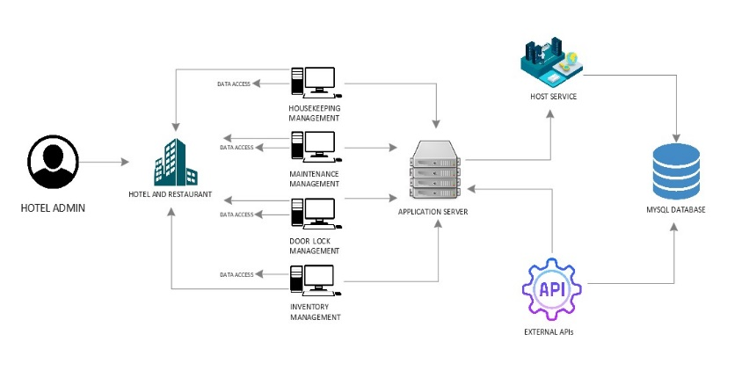The ANAA Hotel and Restaurant Management System (HRMS) is an integrated system that includes the following modules:

*Figure 18: System Architecture*

**DETAILED DIAGRAMS ILLUSTRATING SYSTEM COMPONENTS AND THEIR INTERACTIONS**

A detailed diagram of the system architecture is provided in the document, but it is described as follows:

* The Digital Housekeeping and Maintenance Request System interacts with the backend system, which in turn interacts with the Door Lock System and the Inventory Management System.
* The Door Lock System uses RFID sensors to communicate with the backend system.
* The Inventory Management System tracks inventory levels and can send alerts when supplies are running low.



*Figure 19: Detailed Diagrams Illustrating System Components and Their Interactions*

**EXPLANATION OF COMPONENT RESPONSIBILITIES AND RELATIONSHIPS**

* **Digital Housekeeping and Maintenance Request System:**

This module is responsible for capturing guest requests, routing them to the appropriate staff, and providing status updates to guests.

* **Backend System:** This module is responsible for processing data from all of the other modules, storing data in a database, and managing user accounts.
* **RFID Door Lock System:** This module is responsible for granting access to authorized personnel and guests using RFID sensors.
* **Automated Inventory Management System**: This module is

responsible for tracking inventory levels, generating reports, and sending alerts when supplies are running low.

**16.2 INFORMATION SYSTEMS INTEGRATION:**

**DESCRIPTION OF HOW THE CLASS'S INFORMATION SYSTEMS WERE INTEGRATED**

The ANAA Hotel and Restaurant Management System integrates different systems using the following methods:

* **API integration:** The system uses APIs to allow different modules to communicate with each other.
* **Database integration:** All of the system's data is stored in a central database, which allows different modules to access the same data.
* **Message queue:** A message queue is used to

asynchronously transfer data between different modules.

**DIAGRAMS SHOWING THE INTEGRATION POINTS AND DATA FLOWS**

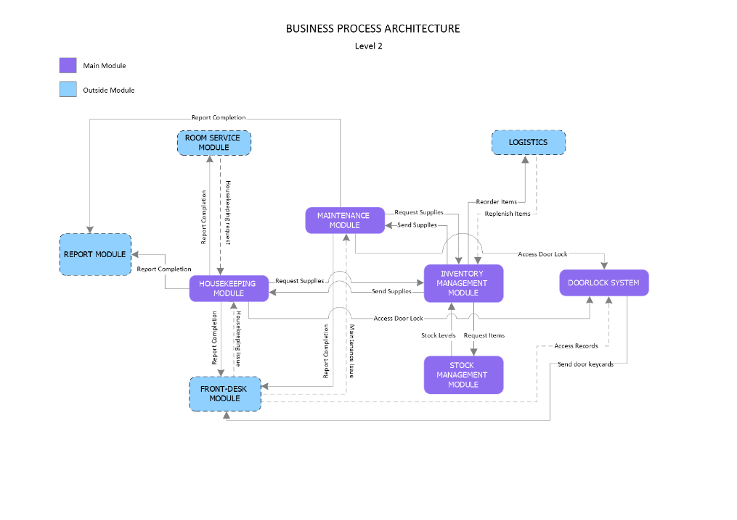

*Figure 20: Diagrams Showing Integration Points and Data Flows*

**DATA TRANSFORMATION AND MAPPING PROCESSES**

Data Collection and Acquisition:

Gather data from various sources such as:

* Housekeeping and maintenance logs
* Digital requests from guests
* Door lock system RFID sensor
* Inventory management system

Data Extraction:

Extract relevant data elements including:

* Guest information (name, room number, contact details)
* Maintenance requests (issue description, room location)
* Housekeeping logs (cleaning schedules, tasks completed)
* Inventory levels (consumables, equipment)
* Door access logs (activity logs, room number, housekeeper name)

Data Cleaning and Standardization:

Remove duplicates and inconsistencies in data.

Standardize formats for:

* Date and time stamps
* Room numbers
* Maintenance request categories
* Inventory item names and codes

Data Transformation:

Integrate data from various sources into a unified format.

Transform data for analysis and reporting:

* Aggregate housekeeping logs to track performance metrics (e.g., average time per room cleaning).
* Categorize maintenance requests by urgency and type for prioritization.
* Combine door access logs with housekeeper information for security monitoring.
* Update inventory levels based on usage and replenishment.

Data Mapping and Integration:

Establish mappings between different datasets:

* Link maintenance requests with corresponding guest rooms and housekeeping schedules.
* Connect door access logs with housekeeper in and out records for security and access control.

Data Storage and Management:

Store transformed data in a centralized database or data warehouse.

Implement appropriate data management practices:

* Regular backups to prevent data loss.
* Access controls to ensure data security and privacy compliance.
* Versioning to track changes and updates to datasets.

Data Analysis and Reporting:

Utilize integrated data for analysis and reporting purposes:

* Generate housekeeping performance reports for management review.
* Identify trends in maintenance requests to improve service efficiency.
* Analyze inventory usage patterns to optimize stock levels and reduce waste.
* Monitor door access logs for security incidents or anomalies.

**16.3 APPLICATION DESIGN AND DEVELOPMENT**

**DETAILED INFORMATION ABOUT THE SOFTWARE MODULES**

**AND COMPONENTS**

The system is composed of the following software modules:

**Digital Housekeeping and Maintenance Request System:**

This module is a web application that allows guests to submit requests.

* + **Backend System:** This module is a web application that processes data from all of the other modules.
  + **Mobile App (optional):** An optional mobile app can be used by guests to submit requests.
  + **RFID Door Lock System:** This module consists of RFID sensors and a control panel.
  + **Inventory Management System:** This module is a web

application that allows staff to track inventory levels.

**CODE SNIPPETS AND CODE STRUCTURE**

Below are code snippets and a basic structure for implementing the described functionalities using Laravel Breeze and MySQL database:

**Data Migration**

* php artisan make:migration create_activity_logs_table
* php artisan make:migration create_h3_door_lock_logs_table
* php artisan make:migration create_h3_door_key_table
* php artisan make:migration create_h3_housekeeping_staff_table
* php artisan make:migration create_h3_housekeeping_request_table
* php artisan make:migration create_h3_cart_items_work_order_table
* php artisan make:migration create_h3_work_order_task_table
* php artisan make:migration create_h3_work_order_task_item_table
* php artisan make:migration create_h3_h_inventory_category_table
* php artisan make:migration create_h3_h_inventory_items _table
* php artisan make:migration create_h3_m_inventory_category _table
* php artisan make:migration create_h3_m_inventory_table
* php artisan make:migration create_h3_reorder_points_table
* php artisan make:migration create_h3_maintenance_staff_table
* php artisan make:migration create_h3_maintenance_request_table
* php artisan make:migration create_h3_maintenance_work_order_cart_table
* php artisan make:migration create_h3_maintenance_work_order_table
* php artisan make:migration create_h3_maintenance_work_order_item_table

**Define Models**

* php artisan make:model Activities
* php artisan make:model HousekeepingDoorKeys
* php artisan make:model HousekeepingDoorLockLogs
* php artisan make:model HousekeepingRequests
* php artisan make:model HousekeepingWorkOrder
* php artisan make:model HousekeepingWorkOrderItem
* php artisan make:model HousekeepingCategory
* php artisan make:model MaintenanceCategory
* php artisan make:model HousekeepingInventory
* php artisan make:model MaintenanceInventory
* php artisan make:model MaintenanceRequest
* php artisan make:model MaintenanceStaff
* php artisan make:model MaintenanceWorkOrder
* php artisan make:model MaintenanceWorkOrderCart
* php artisan make:model MaintenanceWorkOrderItem
* php artisan make:model User

**Implement Controllers**

* php artisan make:controller DashboardController
* php artisan make:controller DoorLockController
* php artisan make:controller HousekeepingItemsController
* php artisan make:controller HousekeepingProgressController
* php artisan make:controller HousekeepingRequestController
* php artisan make:controller HousekeepingStaffController
* php artisan make:controller HousekeepingWorkOrdersController
* php artisan make:controller RoomDetailsController
* php artisan make:controller HousekeepingInventoryController
* php artisan make:controller InventoryCategoryController
* php artisan make:controller InventoryDashboardController
* php artisan make:controller MaintenanceInventoryController
* php artisan make:controller ReorderPointsController
* php artisan make:controller MaintenanceProgressController
* php artisan make:controller MaintenanceRequestController
* php artisan make:controller MaintenanceStaffController
* php artisan make:controller MaintenanceWorkOrderController

**Routes**

<?php

use App\Http\Controllers\DoorLock\DoorKeyController;

use App\Http\Controllers\DoorLock\DoorLogsController;

use App\Http\Controllers\Housekeeping\HousekeepingItemsController;

use App\Http\Controllers\Housekeeping\HousekeepingProgress;

use App\Http\Controllers\Housekeeping\HousekeepingProgressController;

use App\Http\Controllers\Housekeeping\HousekeepingWorkOrdersController;

use App\Http\Controllers\Maintenance\MaintenanceStaffController;

use App\Models\InventoryModel\InventoryItems\HousekeepingInventory;

use Illuminate\Support\Facades\Auth;

use Illuminate\Support\Facades\Route;

use App\Http\Controllers\UserController;

use App\Http\Controllers\ProfileController;

use App\Http\Controllers\DigitalRequestController;

use App\Http\Controllers\Housekeeping\DashboardController;

use App\Http\Controllers\Housekeeping\DoorLockController;

use App\Http\Controllers\Inventory\InventoryCategoryController;

use App\Http\Controllers\Housekeeping\HousekeepingStaffController;

use App\Http\Controllers\Inventory\HousekeepingInventoryController;

use App\Http\Controllers\Housekeeping\HousekeepingRequestController;

use App\Http\Controllers\Housekeeping\RoomDetailsController;

use App\Http\Controllers\Inventory\InventoryDashboardController;

use App\Http\Controllers\Inventory\MaintenanceInventoryController;

use App\Http\Controllers\Inventory\ReorderPointsController;

use App\Http\Controllers\Logistics\LogisticsControlller;

use App\Http\Controllers\Maintenance\InventoryController;

use App\Http\Controllers\Maintenance\MaintenanceInventoryController as MaintenanceMaintenanceInventoryController;

use App\Http\Controllers\Maintenance\MaintenanceProgressController;

use App\Http\Controllers\Maintenance\MaintenanceRequestController;

use App\Http\Controllers\Maintenance\MaintenanceWorkOrderController;

use App\Http\Controllers\MobileApp\AppDashboardController;

use App\Http\Controllers\MobileApp\AppWorkOrderController;

use App\Http\Controllers\MobileApp\Maintenance\MaintenanceWorkOrderAppController;

use App\Models\HousekeepingModel\HousekeepingRequest;

use App\Models\MaintenanceModel\MaintenanceRequest;

use App\Models\MaintenanceModel\MaintenanceWorkOrder;

/*

|--------------------------------------------------------------------------

| Web Routes

|--------------------------------------------------------------------------

|

| Here is where you can register web routes for your application. These

| routes are loaded by the RouteServiceProvider and all of them will

| be assigned to the "web" middleware group. Make something great!

|

*/

Route::get('/', function () {

    return view('auth.login');

});

Route::get('/modules', function () {

    return view('modules');

});

//NOTIFICATION

Route::get('markUnread{id}', function ($id) {

    $notification = Auth::user()->notifications()->find($id);

    if ($notification) {

        $notification->markAsRead();

    }

    return redirect('HousekeepingAdmin/housekeeping-request-list');

});

Route::get('markAsAllRead', function () {

    Auth::user()->unreadNotifications->markAsRead();

    return redirect()->back();

});

//NOTIFICATION FOR STAFF WORK ORDERS

Route::get('housekeeper/markUnread{id}', function ($id) {

    $notification = Auth::user()->notifications()->find($id);

    if ($notification) {

        $notification->markAsRead();

    }

    return redirect('housekeeper/work-order');

});

//Users

Route::middleware(['auth', 'isAdmin'])->group(function () {

    Route::get('users', [UserController::class, 'allUsers'])->middleware('auth', 'password.confirm');

    Route::get('register-user', [UserController::class, 'registerUser']);

    Route::post('add-user', [UserController::class, 'addUser']);

    Route::get('edit-user/id={id}', [UserController::class, 'editUser']);

    Route::put('update-user/id={id}', [UserController::class, 'updateUser']);

    Route::delete('delete-user', [UserController::class, 'deleteUser']);

});

//HOUSEKEEPER MOBILE APP ROUTE

Route::prefix('housekeeper')->middleware(['auth', 'verified'])->group(function () {

    Route::get('dashboard', [AppDashboardController::class, 'index']);

    //work order

    Route::get('work-order', [AppWorkOrderController::class, 'index']);

    Route::get('accept-update-status/{id}', [AppWorkOrderController::class, 'updateStatus']);

    Route::get('mark-as-completed/{id}', [AppWorkOrderController::class, 'markAsCompleted']);

    Route::get('completed-task', [AppWorkOrderController::class, 'completedTaskIndex']);

});

//MAINTENANCE MOBILE APP ROUTE

Route::prefix('maintenance')->middleware(['auth', 'verified'])->group(function(){

    Route::get('dashboard', [AppDashboardController::class, 'indexMaintenance']);

    //work order

    Route::get('work-order-maintenance', [MaintenanceWorkOrderAppController::class, 'index']);

    Route::get('accept-update-status-m/{id}', [MaintenanceWorkOrderAppController:: class, 'updateStatus']);

    Route::get('mark-as-completed-m/{id}', [MaintenanceWorkOrderAppController::class, 'markAsCompleted']);

    Route::get('completed-task-m', [MaintenanceWorkOrderAppController::class, 'completedTaskIndex']);

});

//HOUSEKEEPING MODULE ROUTE

Route::middleware(['auth', 'housekeeping'])->group(function () {

    Route::prefix('HousekeepingAdmin')->middleware(['auth', 'verified'])->group(function () {

        Route::get('/dashboard', [DashboardController::class, 'dashboardIndex'])->name('admin.dashboard');

        //housekeeping Staff

        Route::get('/housekeepingStaff', [HousekeepingStaffController::class, 'index']);

        Route::post('/add-staff', [HousekeepingStaffController::class, 'addStaff']);

        Route::get('/staff-edit/id={id}', [HousekeepingStaffController::class, 'staffEdit']);

        Route::put('/update-staff/id={id}', [HousekeepingStaffController::class, 'updateStaff']);

        Route::delete('/delete-staff/id={id}', [HousekeepingStaffController::class, 'deleteStaff']);

        //housekeeping request

        Route::get('housekeeping-request-list', [HousekeepingRequestController::class, 'index']);

        Route::get('delete-all-exceeded', [HousekeepingRequestController::class, 'deleteExceeded']);

        //work orders

        Route::get('create-work-orders/request-code={code}', [HousekeepingWorkOrdersController::class, 'getRequestData']);

        Route::post('add-items-cart/{id}/{code}', [HousekeepingWorkOrdersController::class, 'addItemsToCart']);

        Route::post('submit-work-order/id={code}', [HousekeepingWorkOrdersController::class, 'submitWorkOrder']);

        Route::get('delete-item-cart/id={id}', [HousekeepingWorkOrdersController::class, 'deleteItemCart']);

        //Housekeeping Progress

        Route::get('housekeeping-progress', [HousekeepingProgressController::class, 'index']);

        Route::get('cancel-task/id={id}', [HousekeepingProgressController::class, 'cancelTask']);

        Route::get('delete-completed-task/id={id}', [HousekeepingProgressController::class, 'deleteCompletedTask']);

        //Inventory Items Lists

        Route::get('items-lists', [HousekeepingItemsController::class, 'index']);

        //Room Details

        Route::get('roomDetails', [RoomDetailsController::class, 'index']);

        //Door lock system

        Route::get('door-keys', [DoorLockController::class, 'index']);

        Route::put('assign-key/{id}', [DoorLockController::class, 'assignKey']);

        Route::get('door-logs', [DoorLockController::class, 'doorlogsIndex']);

        Route::get('view-logs/{room_no}', [DoorLockController::class, 'viewLogs']);

        Route::get('remove-doorkey/id={id}', [DoorLockController::class, 'removeDoorKey']);

        //ADMIN WORK ORDER

        Route::post('submit-work-order-admin', [HousekeepingWorkOrdersController::class, 'adminWorkOrder']);

    });

});

//MAINTENANCE MODULE ROUTE

Route::middleware(['auth', 'maintenance'])->group(function () {

    Route::prefix('maintenance-admin')->middleware(['auth', 'verified'])->group(function () {

        Route::get('/dashboard', function () {

            return view('MaintenanceAdmin.dashboard');

        });

        Route::get('maintenance-staff', [MaintenanceStaffController::class, 'index']);

        Route::post('add-maintenance-staff', [MaintenanceStaffController::class, 'addStaff']);

        Route::get('edit-maintenance-staff/id={id}', [MaintenanceStaffController::class, 'editMaintenanceStaff']);

        Route::put('update-maintenance-staff/id={id}', [MaintenanceStaffController::class, 'updateMaintenanceStaff']);

        Route::delete('delete-maintenance-staff', [MaintenanceStaffController::class, 'deleteMaintenanceStaff']);

        //maintenance request

        Route::get('maintenance-request-lists', [MaintenanceRequestController::class, 'maintenanceListsIndex']);

        Route::get('delete-all-exceeded', [MaintenanceRequestController::class, 'deleteAllExceeded']);

        //maintenance work orders

        Route::get('create-maintenance-order/request-code={code}', [MaintenanceWorkOrderController::class, 'createMaintenanceOrder']);

        Route::post('add-items/{id}/{code}', [MaintenanceWorkOrderController::class, 'addItemsToCart']);

        Route::post('submit-maintenance-work-order/id={code}', [MaintenanceWorkOrderController::class, 'submitMaintenanceWorkOrder']);

        //maintenance progress

        Route::get('maintenance-task-progress', [MaintenanceProgressController::class, 'index']);

        //maintenance Inventory

        Route::get('inventory-items', [InventoryController::class, 'index']);

    });

});

//INVENTORY MODULE ROUTE

Route::middleware(['auth', 'inventory'])->group(function () {

    Route::prefix('inventory-admin')->middleware(['auth', 'verified'])->group(function () {

        Route::get('/dashboard', [InventoryDashboardController::class, 'index']);

        //inventory housekeeping category

        Route::get('housekeeping-category', [InventoryCategoryController::class, 'housekeepingIndex']);

        Route::post('add-h-category', [InventoryCategoryController::class, 'addHousekeepingCategory']);

        Route::get('h-category-edit/id={id}', [InventoryCategoryController::class, 'hCategoryEdit']);

        Route::put('update-h-category/id={id}', [InventoryCategoryController::class, 'updateHCategory']);

        Route::get('delete-category/id={id}', [InventoryCategoryController::class, 'deleteCategory']);

        //inventory maintenance category

        Route::get('maintenance-category', [InventoryCategoryController::class, 'maintenanceIndex']);

        Route::post('submit-maintenance-category', [InventoryCategoryController::class, 'addMaintenanceCategory']);

        Route::put('update-category/id={id}', [InventoryCategoryController::class, 'updateMaintenaceCategory']);

        Route::get('delete-maintenance-category/id={id}', [InventoryCategoryController::class, 'deleteMaintenanceCategory']);

        //HOUSEKEEPING INVENTORY

        Route::get('housekeeping-inventory', [HousekeepingInventoryController::class, 'hInventoryIndex']);

        Route::post('add-h-item', [HousekeepingInventoryController::class, 'addItems']);

        Route::get('h-item-edit/id={id}', [HousekeepingInventoryController::class, 'itemEdit']);

        Route::put('update-h-item/id={id}', [HousekeepingInventoryController::class, 'updateItem']);

        Route::get('delete-housekeeping-category/id={id}', [HousekeepingInventoryController::class, 'deleteItem']);

        //MAINTENANCE INVENTORY

        Route::get('maintenance-inventory', [MaintenanceInventoryController::class, 'mInventoryIndex']);

        Route::post('submit-maintenance-inventory', [MaintenanceInventoryController::class, 'addMaintenanceItem']);

        Route::put('update-maintenance-inventory/id={id}', [MaintenanceInventoryController::class, 'updateMaintenance']);

        Route::delete('delete-inventory-item/id={id}', [MaintenanceInventoryController::class, 'deleteItem']);

        //REORDER POINTS

        Route::get('reorder-points', [ReorderPointsController::class, 'index']);

        Route::get('reorder-item/id={id}', [ReorderPointsController::class, 'reorderView']);

        Route::post('submit-reorder/id={id}', [ReorderPointsController::class, 'submitReorder']);

        Route::get('pending-reorder', [ReorderPointsController::class, 'pendingIndex']);

        Route::get('cancel-order/id={id}', [ReorderPointsController::class, 'cancelOrder']);

    });

});

//LOGISTICS

Route::get('logistics', [LogisticsControlller::class, 'index']);

Route::get('approve/id={id}', [LogisticsControlller::class, 'approve']);

Route::get('approved', [LogisticsControlller::class, 'approveLists']);

Route::get('on-delivery/id={id}', [LogisticsControlller::class, 'onDelivery']);

Route::get('on-delivery-index', [LogisticsControlller::class, 'ondeliveryIndex']);

Route::get('complete-request/id={id}', [LogisticsControlller::class, 'requestingComplete']);

Route::get('received/id={id}', [LogisticsControlller::class, 'received']);

Route::get('claim-now/id={id}', [LogisticsControlller::class, 'claim']);

//DOOR LOCK MODULE

Route::middleware(['auth', 'doorLock'])->group(function () {

    Route::prefix('doorLock-admin')->middleware(['auth', 'verified'])->group(function () {

        Route::get('/dashboard', function () {

            return view('DoorLockAdmin.dashboard');

        });

        //door key lists

        Route::get('door-key-lists', [DoorKeyController::class, 'doorKeyLists']);

        Route::put('assign-room-for-keys/id={id}', [DoorKeyController::class, 'assignRoomKeys']);

        Route::put('edit-door-key/id={id}', [DoorKeyController::class, 'editDoorKey']);

        Route::delete('delete-door-key/id={id}', [DoorKeyController::class, 'deleteDoorKey']);

        //Door logs

        Route::get('door-logs', [DoorLogsController::class, 'doorLogsIndex']);

    });

});

Route::middleware(['auth', 'verified'])->group(function () {

    //DIGITAL REQUEST CLIENT SIDE

    Route::get('digital-requests', [DigitalRequestController::class, 'index']);

    //housekeeping request

    Route::get('housekeeping-request', [DigitalRequestController::class, 'housekeepingRequest']);

    Route::post('submit-housekeeping-request', [DigitalRequestController::class, 'submitHrequest']);

    //maintenance request

    Route::get('maintenance-request', [DigitalRequestController::class, 'maintenanceRequest']);

    Route::post('submit-maintenance-request', [DigitalRequestController::class, 'submitMrequest']);

});

Route::middleware('auth')->group(function () {

    Route::get('/profile', [ProfileController::class, 'edit'])->name('profile.edit');

    Route::patch('/profile', [ProfileController::class, 'update'])->name('profile.update');

    Route::delete('/profile', [ProfileController::class, 'destroy'])->name('profile.destroy');

});

require __DIR__ . '/auth.php';

**Authentication**

* composer require laravel/breeze –dev
* php artisan breeze:install
* npm install & npm run dev

**ALGORITHMS AND DATA STRUCTURES USED**

**Queue**: Used for managing tasks such as housekeeping schedules, maintenance requests, and digital service requests. Laravel provides Queue services out-of-the-box, allowing tasks to be queued and processed in the background using various drivers such as Redis or database.

**Priority Queue:** Prioritizes tasks within queues based on urgency or importance. Custom implementation can be done using arrays or collections with sorting algorithms like heapsort.

**Hash Table:** Efficiently stores and retrieves data like guest information, inventory items, and room assignments. Utilize Laravel's Eloquent ORM for database interactions, which internally handles hashing and indexing for efficient data retrieval.

**Binary Search Tree (BST):** Manages sorted data structures, such as sorting inventory items alphabetically or by category. Custom implementation can be done using PHP's data structures or leveraging Laravel's Collection methods for sorting and searching.

**Graph Algorithms:** Models relationships between entities like rooms, guests, and staff members. Utilize graph traversal algorithms like Depth-First Search (DFS) or Breadth-First Search (BFS) to navigate relationships within the application, for example, finding the shortest path between rooms for housekeeping tasks.

**Encryption Algorithms:** Secures sensitive data such as guest information and access credentials. Laravel provides encryption mechanisms through its built-in encryption library. Utilize Laravel's encryption and decryption methods to secure and manage sensitive data.

**Cache**: Improves performance by storing frequently accessed data in memory. Laravel provides a powerful caching system with support for multiple cache drivers such as Redis and Memcached. Utilize Laravel's caching features to cache frequently accessed data, reducing database load and improving application responsiveness.

**Dynamic Programming:** Optimizes complex tasks such as resource allocation, scheduling, and inventory management. Implement custom algorithms using dynamic programming techniques to optimize resource allocation and scheduling processes within the application.

**LIBRARIES AND FRAMEWORKS UTILIZED**

The following libraries and frameworks are used in the system:

**Programming languages:** PHP (backend), JavaScript (frontend)

**Framework:** Laravel (backend)

**Database:** MySQL

**16.4 DATABASE SCHEMA AND DATA MANAGEMENT**

**Housekeeping Management**

|  |  |
| --- | --- |
| **Data Sources** | **Data Types** |
| Housekeeping  Staff Data | Id (int) Primary Key, Staff Name (varchar),  Email (varchar), Position (varchar) |
| Room Status Data | Id (int) Primary Key, Room Number (int), Room Status  (varchar) |
| Available Rooms  Data | Id (int) Primary Key, Room Number (int), Room Status  (int) |
| Schedule  Inspection Data | Id (int) Primary Key, Inspection Date (date), Room  Number (int), Inspector Name (varchar) |
| Housekeeping  Requests Data | Request ID (int) Primary Key, Room Number (int),  Request Type (varchar), Request Description (Text), Request Status (varchar), Request Date (timestamp) |
| Housekeeping  Tasks Data | Task Data ID (int) Primary Key, Room Number (int), Task  Name (varchar), Scheduled Date (date), Housekeeper  Name (varchar), Supplies Needed (varchar) |
| Housekeeping  Progress Data | Id (int) Primary Key, Housekeeping Task ID number (int),  Room Number (int), Task Name (varchar), Scheduled  Date (date), Housekeeper Name (varchar), Progress  Status (varchar) |
| Inventory Lists  Data | Id (int) Primary Key, Category (varchar), Item Name  (varchar), Quantity (int), Stock Left (int) |

*Table 22: Housekeeping Database Schema and Database Management*

**Maintenance Management**

|  |  |
| --- | --- |
| **Data Sources** | **Data Types** |
| Maintenance Staff  Data | Id (int) Primary Key, Staff Name (varchar),  Email (varchar), Position (varchar) |
| Schedule  Maintenance Data | Id (int) Primary Key, Room Number (Int), Maintenance  Type (varchar), Scheduled Date (date), Maintenance  Staff (varchar), Description or Notes (TEXT) |
| Maintenance  Request Data | Request ID (int) Primary Key, Room Number (int),  Request Type (varchar), Request Description (TEXT),  Request Status (varchar), Request Date (date) |
| Maintenance  Tasks Data | Task ID (int) Primary Key, Room Number (int), Task Name (varchar), Scheduled Date (date),  Maintenance Staff Name (varchar), Equipment and Parts needs (varchar) |
| Maintenance  Progress Data | Id (int) Primary Key, Room Number (int), Task Name  (varchar), Scheduled Date (date),  Maintenance Staff Name (varchar), Progress Status  (varchar) |
| Inventory Lists  Data | Id (int) Primary Key, Category (varchar), Item Name  (varchar), Quantity (int), Stock Left (int) |

*Table 23: Maintenance Database Schema and Database Management*

**Inventory Management**

|  |  |
| --- | --- |
| **Data Sources** | **Data Types** |
| Categories | Id (int) Primary Key, Category Name (varchar) |
| Inventory Items  Data | Id (int) Primary Key, Category Name (varchar), Item  Name (varchar), Item Quantity (int) |

*Table 24: Housekeeping Database Schema and Database Management*

**Door Lock Management**

|  |  |
| --- | --- |
| **Data Sources** | **Data Types** |
|  |  |
| Room Number | Id (int) Primary Key, Room Number (int) |
| Door Activity Logs  Data | Id (int) Primary Key, Room Number (int), Door Lock RFID  UID (varchar), Access Status (varchar), Access Date  (timestamp) |

*Table 25: Door Lock Database Schema and Database Management*

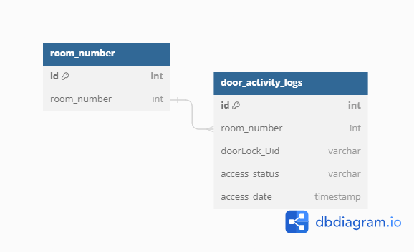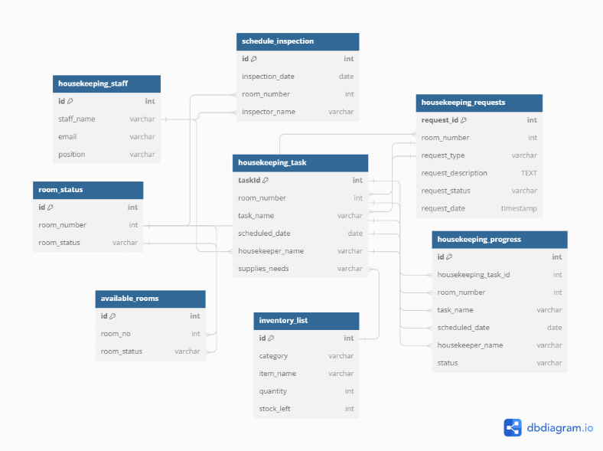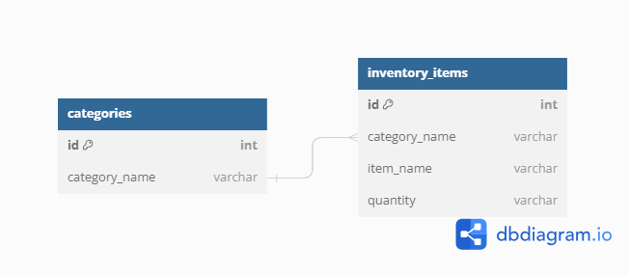**ENTITY-RELATIONSHIP DIAGRAMS (ERDS)**

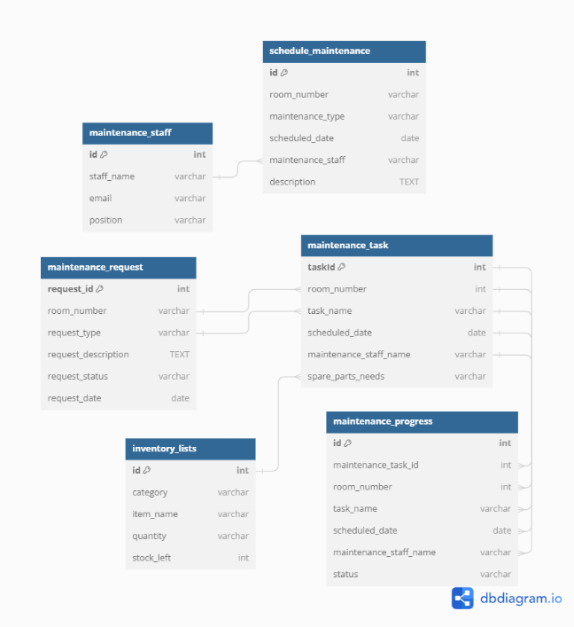

*Figure 21: Entity Relation Diagrams*

**CRUD (CREATE, READ, UPDATE, DELETE) OPERATIONS**

The system supports all CRUD operations for managing data in the database.

**16.5 NETWORK CONFIGURATION**

**NETWORK TOPOLOGY AND CONFIGURATION DETAILS**

Explain the network structure designed to sustain the system, outlining the arrangement of servers, load balancers, and additional networking elements to guarantee dependable communication and

efficient data transfer**.**

In the Star Topology, each device operates as an individual connecting to a central hub or switch, which serves as the network's focal point. Similar to accommodating a variety of interests in a social situation, this arrangement enables for flexible design, allowing us to adjust and respond to specific preferences and requirements.



*Figure 22: Network Topology**and Configuration Details*

**SECURITY MEASURES (E.G., FIREWALLS, ENCRYPTION)**

|  |  |  |
| --- | --- | --- |
| **LOGO** | **NAME** | **DESCRIPTION** |
|  | **Firewall** | **A firewall is a network security device that monitors and controls incoming and outgoing**  **network traffic to protect**  **your network from**  **unauthorized access and**  **potential threats.** |
|  | **Access**  **Control** | **Access control is a security system that regulates who can access specific resources, enhancing overall**  **security.** |

|  |  |  |
| --- | --- | --- |
|  | **Password**  **Policy** | **A password policy is a set of rules that dictate how passwords should**  **be created and**  **managed to improve**  **security** |
|  | **Encryption** | **Encryption security protects data by turning it into**  **unreadable code that can only be understood with the right key, enhancing data privacy and confidentiality.** |
|  | **Data**  **Backup and**  **Recovery** | **safeguards your data by creating secure copies, ensuring you**  **can recover it in case of cyberattacks, hardware failures, or disasters.** |

*Table 26: Security Measures*

**PROTOCOLS AND COMMUNICATION METHODS USED**

* **RESTful APIs:** for communication between the system and external systems
* **JSON data formats**: for data exchange

**LOAD BALANCING AND FAILOVER MECHANISMS**

Service Segmentation:

* Identify different services within the HRMS that can be load balanced separately, such as:
* Housekeeping requests handling
* Maintenance requests handling
* Digital requests for services (e.g., room service, maintenance requests)

Load Balancer Configuration:

* Round Robin: Distributes incoming requests evenly across a set of servers.
* Least Connections: Directs traffic to the server with the fewest active connections.
* Weighted Round Robin: Assigns different weights to servers based on their capacities.
* IP Hashing: Uses client’s IP address to determine which server receives the request.

Database Load Balancing:

* Use database clustering or sharding techniques to distribute database load across multiple servers.
* Implement read replicas for read-heavy operations to offload the primary database server.

Session Management:

* Utilize sticky sessions or session replication mechanisms to ensure user sessions are maintained across server switches.

**16.6 DEPLOYMENT AND INFRASTRUCTURE**

**DEPLOYMENT STRATEGIES (E.G., CLOUD, ON-PREMISES)**

**On-Premises Deployment:**

Self-Hosted Servers or Data Centers: If the ANAA Hotel choose to manage their own servers or data center infrastructure, they can install their system on-site. With complete control over data and technology, this method is appropriate for businesses with stringent legal requirements or worries about data sovereignty.  
Advantages include total control, data sovereignty, and possible long-term cost savings.

Infrastructure investment up front, continuing maintenance and upgrade expenses, scalability constraints, and disaster recovery planning are all factors to take into account.

**HARDWARE SPECIFICATIONS AND SERVER CONFIGURATIONS**

|  |  |  |
| --- | --- | --- |
| **LOGO** | **NAME** | **DESCRIPTION** |
|  | **ROUTER** | combines the  networking capabilities of a wireless access point with a router, creates networks, and controls data flow both  inside and between  those networks. |
|  | **SWITCH** | allows devices within a network to communicate with one another by sending and receiving data packets. |
|  | **LAPTOP** | Users will be able to interact with the computer through a  visual interface and view  text and graphics produced by software  with this laptop display. |
|  | **SERVER** | Large amounts of data  are stored on this server, which also facilitates resource sharing and communication. |

*Table 27: Hardware Specification*

**CONFIGURATION MANAGEMENT (E.G., SCRIPTS, AUTOMATION TOOLS)**

**Environment Configuration:**

* Laravel provides the .env file for environment-specific configurations. You can define environment variables for database connections, application settings, and other configurations.
* Use different .env files for development, staging, and production environments to customize settings as per the environment.

**Database Migrations and Seeds:**

* Laravel's migration and seeding feature allows you to manage database schema changes and seed initial data consistently across environments.
* Write migration scripts to define the database schema and use seeds to populate initial data.

**Automated Deployment:**

* Use deployment automation tools like Laravel Envoyer, Deployer, or even CI/CD pipelines with services like GitHub Actions.
* Automate deployment tasks such as code deployment, database migration, dependency

**SCALABILITY AND RESOURCE OPTIMIZATION**

The system optimizes staff allocation based on the occupancy detected by RFID sensors, preventing unnecessary room checks and reducing workload during low occupancy periods.

**16.7 SECURITY MEASURES**

**SECURITY PROTOCOLS AND MEASURES IMPLEMENTED**

SSL/TLS, role-based access control

**AUTHENTICATION AND AUTHORIZATION MECHANISMS**

Usernames and passwords, role-based access control

**ENCRYPTION AND DATA PROTECTION**

SSL/TLS for data transfer, hashing algorithms for password storage

**INCIDENT RESPONSE AND MITIGATION PROCEDURES**

**Identification and Detection:**

* Monitor hotel management system logs, server performance metrics, and security alerts using tools such as Laravel Telescope, server monitoring tools, and intrusion detection systems.
* Train hotel staff to recognize signs of potential incidents, such as unusual system behavior, unauthorized access attempts, or suspicious activities reported by guests.

**Initial Response:**

* Upon detection of an incident, the designated incident response team should be notified immediately.
* The incident manager should assess the situation, gather initial information about the incident, and determine its severity and potential impact on hotel operations.
* Activate communication channels for internal coordination and notify relevant stakeholders, including hotel management, IT staff, and external partners if necessary.

**16.8 TESTING AND QUALITY ASSURANCE**

**DETAILED TEST CASES AND SCENARIOS**

To guarantee our system's dependability, security, and functionality, our team has created an extensive collection of test cases. These test cases encompass a range of scenarios, such as digital request submission, door lock system integration with RFID sensors, automated inventory management, and user identification.

**TEST DATA AND EXPECTED OUTCOMES**

We want to create a reliable and easy-to-use solution that satisfies the demands of our housekeeping and maintenance industry clients by carefully testing every part and situation. Sample user credentials, request information, RFID tag data, and inventory records are all examples of test data.

**TEST RESULTS AND VALIDATION AGAINST REQUIREMENTS**

When it comes to reporting bugs and test findings inside the system, we take a thorough approach. We do unit, integration, and system tests as part of an organized testing procedure. Standardized templates are used to document test results, including test case ID, description, expected and actual results, and pass/fail status. If any problems are found during testing, we quickly record them in our bug tracking system. Every bug report comprises an easy-to-read explanation of the issue, replication instructions, a severity rating, and the team member assigned to handle it. Frequent bug triage sessions are organized to effectively prioritize and handle reported bugs. Our team is dedicated to making sure the system is functional and reliable by using strict bug reporting procedures and extensive testing.

**PERFORMANCE TESTING AND OPTIMIZATION EFFORTS**

1. Service-Oriented Architecture:

* Each service should handle a specific functionality such as housekeeping, maintenance, inventory management and door lock integration to ensure modular scalability.

1. Load Balancing:

* Consider horizontal scaling for web servers and microservices to handle increased loads during peak times.

1. RFID Sensor Integration:

* Optimize the RFID sensor data processing to handle a large number of door access activities efficiently.

1. Housekeeping and Maintenance Digital Request System:

* Ensure the digital request system is capable of handling a high volume of concurrent requests.

1. Automated Inventory Management:
   * + Design the inventory management system to scale with the growing volume of items.
     + Implement batch processing for inventory updates to efficiently handle large datasets.
2. Testing and Optimization:

* Continuously optimize codes, database queries, and system configuration to improve efficiency.
  1. **SYSTEM MONITORING AND MAINTENANCE**

**TOOLS AND TECHNIQUES FOR MONITORING SYSTEM HEALTH**

**Laravel Telescope:**

* Laravel Telescope is a powerful debug assistant for Laravel applications. It provides insight into the requests coming into your application, exceptions, log entries, database queries, queued jobs, mail, notifications, cache operations, scheduled tasks, and more. It's an excellent tool for real-time monitoring and debugging of your Laravel application.

**Logging and Log Management:**

* Utilize Laravel's built-in logging functionality to log important events, errors, warnings, and informational messages. You can configure log channels to write log entries to various destinations, such as files, databases, or external services.

**LOGGING AND ERROR HANDLING MECHANISMS**

Effective logging involves capturing relevant information about system events, user interactions, and errors in a structured format. This includes logging critical events such as housekeeping and maintenance requests, digital service interactions, RFID door lock system activities, and inventory management updates. Error handling mechanisms complement logging by systematically identifying, reporting, and responding to errors encountered during system operation. This involves categorizing errors by severity, logging detailed error messages, and implementing appropriate error recovery strategies to minimize service disruptions and ensure data integrity. Comprehensive logging and error handling not only facilitate troubleshooting and system maintenance but also enhance overall system reliability and user experience by promptly addressing issues and maintaining operational continuity.

**SCHEDULED MAINTENANCE AND UPDATES**

Regularly scheduled maintenance allows for the proactive upkeep of system performance, security, and functionality. This includes tasks such as database optimizations, server software updates, and hardware inspections to ensure optimal operation and minimize the risk of downtime or performance degradation. Updates encompass applying patches for security vulnerabilities, integrating new features, and improving system stability based on user feedback and industry advancements. To minimize disruption to hotel and restaurant operations, scheduled maintenance and updates are typically planned during off-peak hours, with clear communication to stakeholders regarding expected downtime and any changes to system functionality. These practices not only enhance system reliability but also ensure compliance with evolving industry standards and regulatory requirements, contributing to a seamless and secure guest experience.

**LOGGING AND ERROR HANDLING MECHANISMS**

**Laravel Logging:**

* Make use of Laravel's integrated logging features to document significant occurrences, mistakes, and alerts in the program.   
  Set up log channels to indicate the locations of files, databases, and external services where log entries are to be written.

**Custom Error Handling:**

* To handle exceptions and errors that the program encounters gracefully, provide bespoke error handling techniques.   
  Define error handlers to show readable error messages, gracefully handle unforeseen situations, and catch and log exceptions.

**Exception Logging and Notification:**

* Set up Laravel so that faults and exceptions are logged to certain log files or databases.   
  Establish notification systems to notify developers or administrators of serious mistakes using Slack, email, or other channels of contact.

**Scheduled Maintenance and Updates:**

**Regular Maintenance Schedule:**

* Establish a regular maintenance schedule to perform routine tasks such as database backups, system updates, and performance optimizations.
* Schedule maintenance windows during off-peak hours to minimize disruption to hotel operations and guest experiences.

**Database Backups**:

* Implement automated database backup procedures to regularly backup MySQL databases.
* Store backups securely in off-site locations or cloud storage providers to ensure data integrity and availability in case of system failures or disasters.

**Application Updates:**

* Stay up-to-date with Laravel framework releases and security patches to ensure the application remains secure and stable.
* Schedule periodic updates to install bug fixes, security updates, and new features while minimizing downtime and impact on users.

**Disaster Recovery and Backup Procedures:**

**Backup Strategy:**

* Develop a comprehensive backup strategy that includes regular backups of both application data and system configurations.
* Implement automated backup procedures to create full and incremental backups of critical data and files.

**Off-Site Backup Storage:**

* Store backup copies of data and system configurations in secure, off-site locations to protect against data loss due to disasters such as hardware failures, fires, or natural disasters.

**Disaster Recovery Plan:**

* Create a disaster recovery plan outlining procedures for restoring the system to a functional state in the event of a catastrophic failure.
* Define roles and responsibilities for team members involved in the recovery process and establish communication channels for coordinating response efforts.

**Backup Testing and Verification:**

* Regularly test backup procedures to ensure data integrity and verify that backups can be successfully restored in the event of a disaster.
* Conduct periodic drills or simulations to practice disaster recovery procedures and identify areas for improvement.

**DISASTER RECOVERY AND BACKUP PROCEDURES**

Disaster recovery involves planning and implementing strategies to recover data, applications, and IT infrastructure in the event of a major disruption, such as natural disasters, cyberattacks, or hardware failures. This includes maintaining off-site backups of critical data and systems, utilizing redundant servers or cloud-based storage solutions for data redundancy, and establishing clear protocols for restoring operations swiftly and securely. Regular backups are conducted to capture changes in data and configurations, typically using automated tools to ensure consistency and reliability. Testing these procedures periodically ensures their effectiveness and readiness in real-world scenarios, safeguarding against potential risks and disruptions that could impact hotel and restaurant operations.

* 1. **APIS AND INTEGRATION POINTS:**

**DOCUMENTATION OF APIS USED FOR INTEGRATION**

A RESTful API (Representational State Transfer) is an architectural style designed for networked applications, emphasizing simplicity, scalability, and performance. It operates over HTTP using standard HTTP methods (GET, POST, PUT, DELETE) to perform CRUD (Create, Read, Update, Delete) operations on resources identified by URLs. Key principles include statelessness, where each request from a client contains all necessary information to be understood by the server, and uniform interfaces for consistent interactions. Resources are represented in multiple formats such as JSON, XML, or others, offering flexibility to clients. RESTful APIs enable interoperability between systems, making them widely adopted for web services due to their clarity, reliability, and ease of integration.

**API ENDPOINTS, METHODS, AND DATA FORMATS**

<?php

use Illuminate\Http\Request;

use Illuminate\Support\Facades\Route;

use App\Http\Controllers\API\APIController;

use App\Http\Controllers\API\TaskController;

use App\Http\Controllers\API\HOTEL1APIController;

use App\Http\Controllers\API\MobileAPIController;

use App\Http\Controllers\API\APILogisticsController;

use App\Http\Controllers\API\HousekeepingDoorLockController;

use App\Http\Controllers\SuperAdminController;

/*

|--------------------------------------------------------------------------

| API Routes

|--------------------------------------------------------------------------

|

| Here is where you can register API routes for your application. These

| routes are loaded by the RouteServiceProvider and all of them will

| be assigned to the "api" middleware group. Make something great!

|

*/

Route::middleware('auth:sanctum')->get('/user', function (Request $request) {

    return $request->user();

});

Route::get('/api', [APIController::class, 'example']);

Route::get('work-order', [APIController::class, 'workOrder']);

Route::post('order', [APIController::class,'takeOrder']);

//DOOR LOCK UID API'S

Route::post('/add-door-key', [APIController::class, 'apiUID']);

Route::post('/door-logs', [APIController::class, 'doorLogs']);

//SHARE DOOR LOCK API

Route::get('key-id', [APIController::class, 'keys']);

Route::post('inventory', [APIController::class, 'items']);

//ANDROID APP API

Route::post('loginMobile', [MobileAPIController::class, 'loginMobile']);

Route::middleware(['auth:api_token'])->group(function(){

    Route::get('task-assigned', [TaskController::class, 'displayTask']);

    Route::get('in-progress', [TaskController::class, 'inProgress']);

    //UPDATING STATUS

    Route::post('accept-task', [TaskController::class, 'acceptTask']);

    Route::post('complete-task', [TaskController::class, 'completeTask']);

    Route::get('user', [MobileAPIController::class, 'index']);

    Route::post('logout', [MobileAPIController::class, 'logout']);

});

//HOTEL 1 API

Route::post('add-room-details', [HOTEL1APIController::class, 'addRoomDetails']);

Route::post('update-room-details', [HOTEL1APIController::class, 'updateRoomDetails']);

Route::post('update-status', [HOTEL1APIController::class, 'updateStatus']);

Route::post('delete-room-details', [HOTEL1APIController::class, 'deleteRoom']);

//GET THE HOTEL 1 USERS

Route::post('get-h1-users', [HOTEL1APIController::class, 'getUsers']);

//DOOR LOCK FOR HOUSEKEEPING

Route::post('housekeeping-add-doorkey', [HousekeepingDoorLockController::class, 'addDoorKey']);

Route::post('housekeeping-door-logs', [HousekeepingDoorLockController::class, 'doorLogs']);

//SHARE DOOR LOCK KEYS

Route::get('door-keys', [HousekeepingDoorLockController::class, 'doorKeys']);

//LOGISTICS

Route::post('logistics', [APILogisticsController::class, 'logistics']);

//FROM SUPER ADMIN

Route::post('super-add-user', [SuperAdminController::class, 'addUsers']);

Route::post('super-edit-user', [SuperAdminController::class, 'editUsers']);

Route::post('super-delete-user', [SuperAdminController::class, 'deleteUsers']);

**HOW EXTERNAL SYSTEMS INTERACT WITH YOUR PROJECT**

External systems interact with your project through its RESTful API by sending HTTP requests to the specified endpoints. These requests typically use standard methods like GET for retrieving data, POST for creating resources, PUT for updating existing resources, and DELETE for removing them. Each request includes necessary parameters and headers as defined by the API documentation. Responses from your project are returned in a structured format such as JSON or XML, providing the requested data or confirming the action taken. Security measures like authentication tokens or API keys may be required to access certain endpoints, ensuring proper authorization and protecting sensitive data. This standardized approach allows seamless integration with various external systems, enabling them to leverage your project’s functionalities in a controlled and efficient manner.

* 1. **USER DOCUMENTATION**

**USER MANUALS AND GUIDES (IF APPLICABLE)**

**INSTRUCTIONS FOR SYSTEM USERS**

**TROUBLESHOOTING AND FAQS**

* + 1. **Login to system**

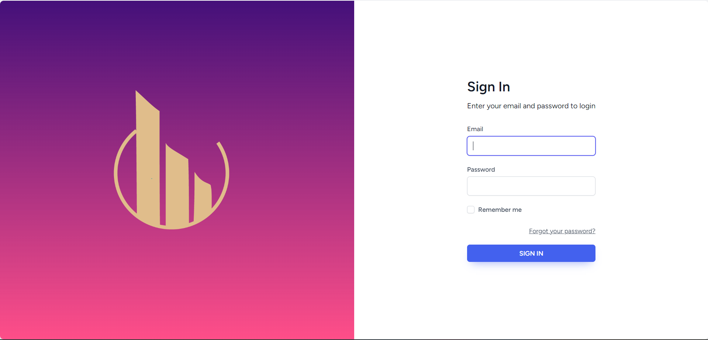

*Figure 23: Login System*

* + 1. **Select system modules**

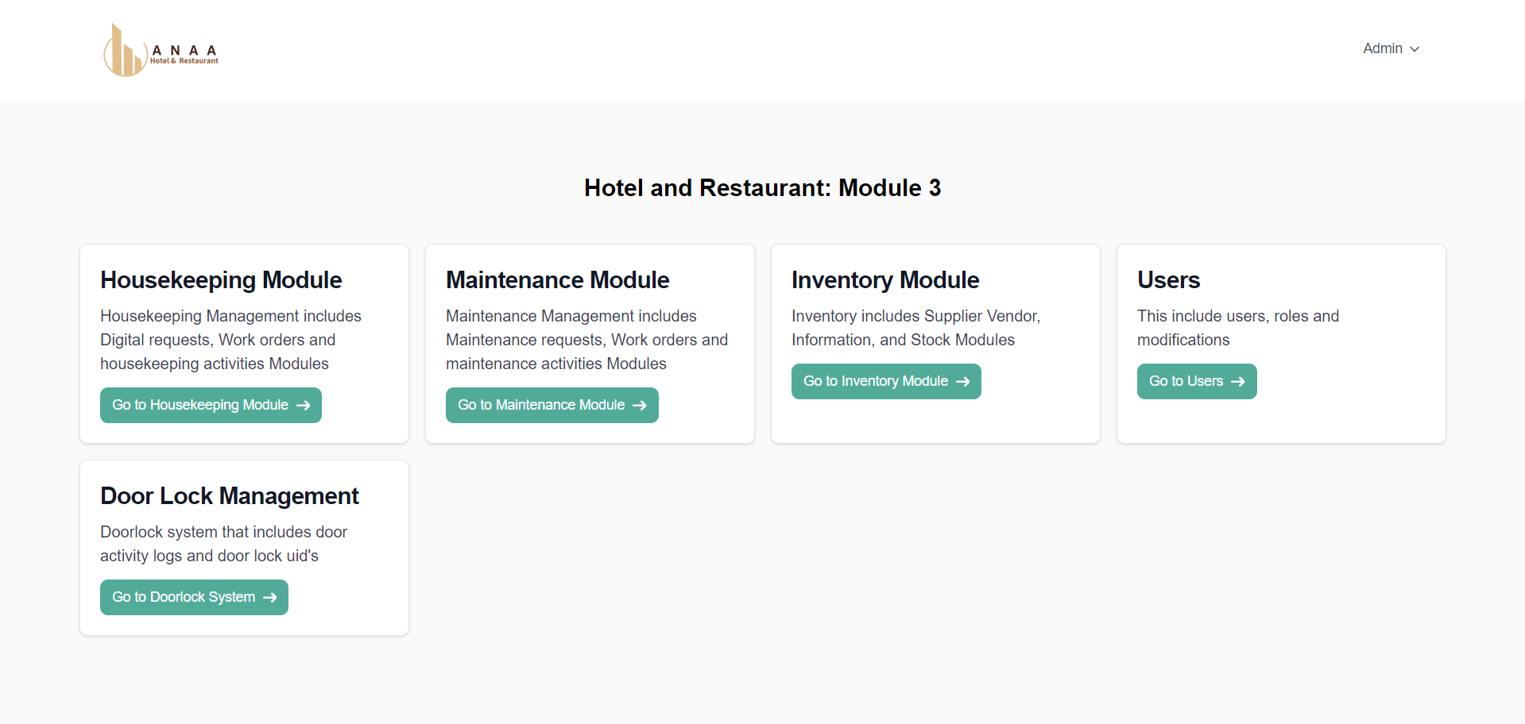

*Figure 24: System Modules*

* + 1. **Housekeeping Modules**

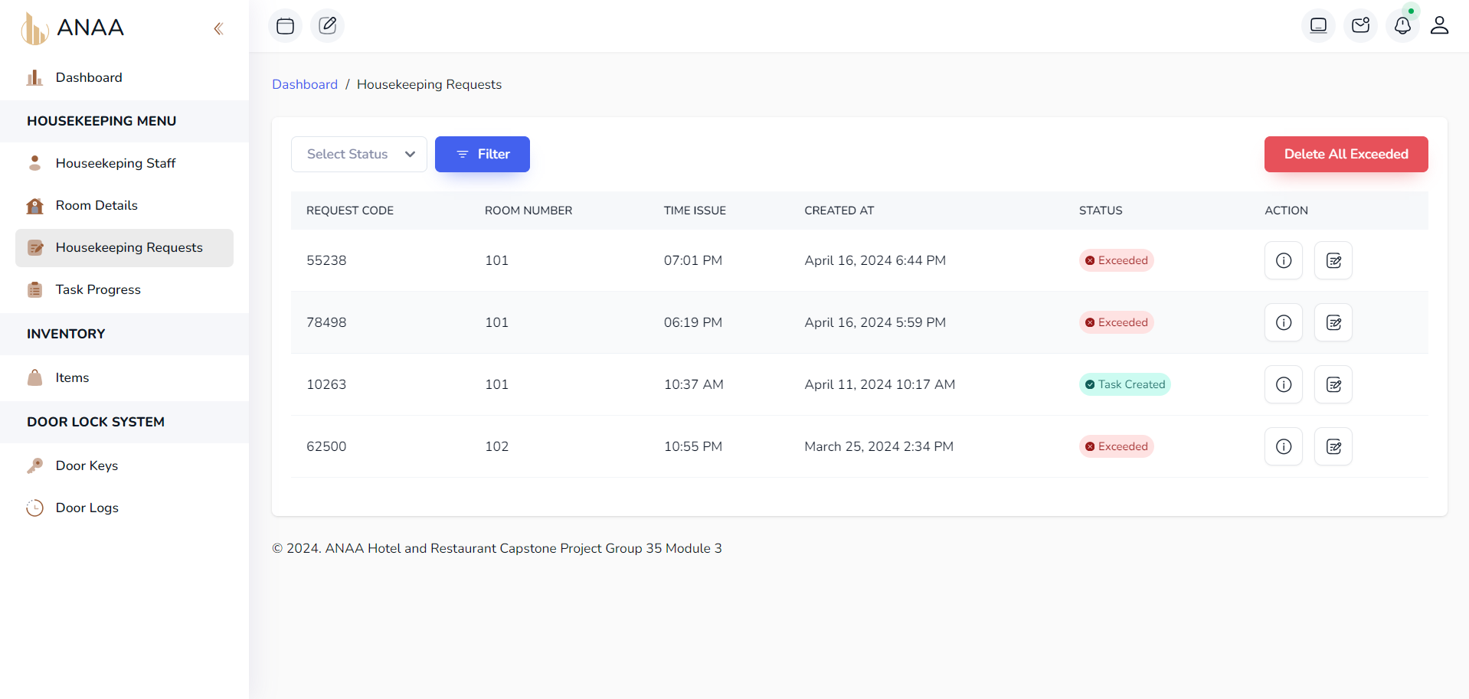

*Figure 25: Housekeeping Modules*

* You can create housekeeping task by clicking the create work orders on action column
* If the status is exceeded you don’t have to create work orders because the request is already done or exceeded from the time required.
  + 1. **Select Housekeeper and items if needed**

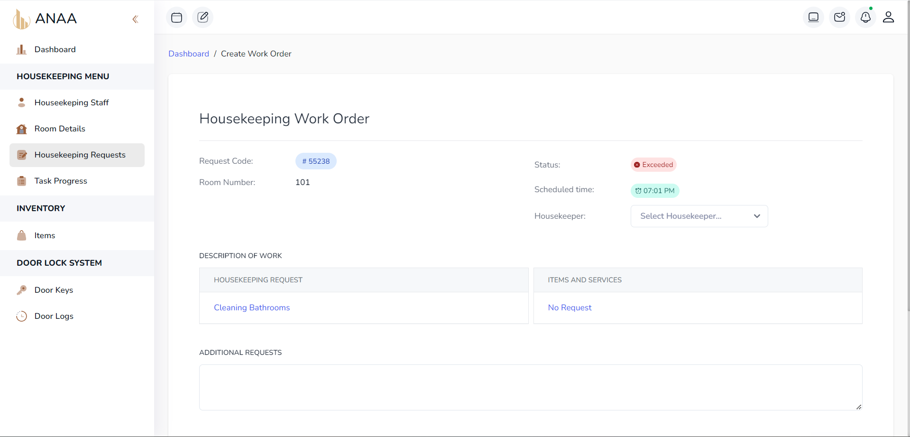

*Figure: 26 Housekeeper Selection*

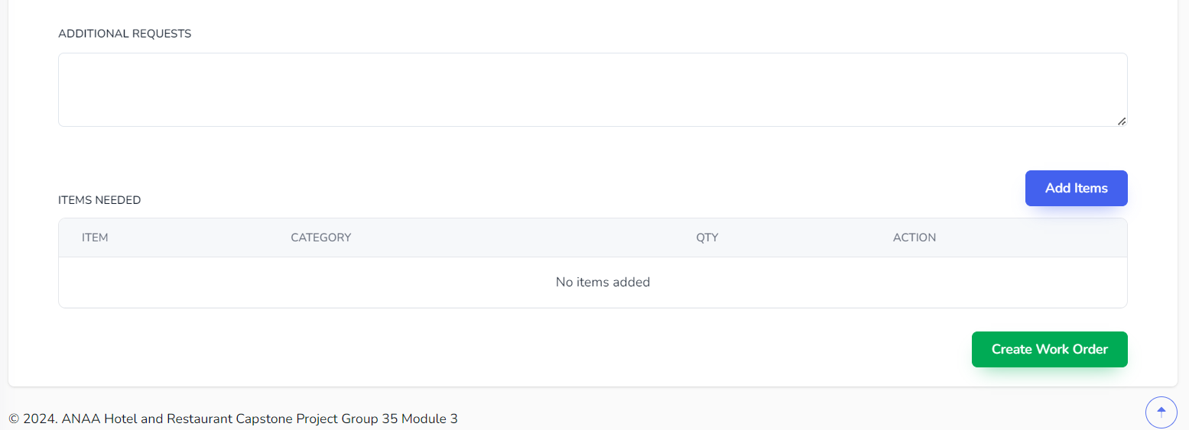

*Figure 27: Items Selection*

* + 1. 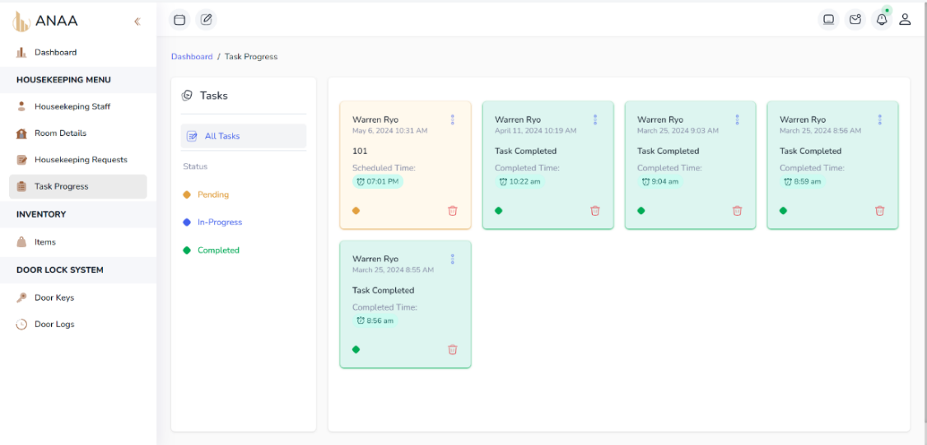**Work Orders are now displayed on Task Progress Page**

*Figure 28: Task Progress Page*

* + 1. **On Staff Mobile Application Accept the task**

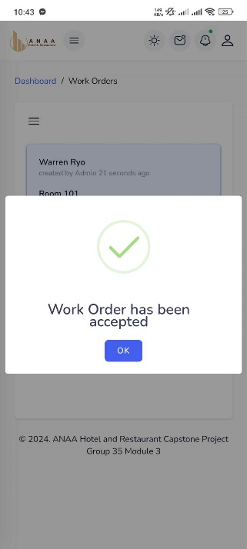

*Figure 29: Staff Mobile Application*

1. **The Work Order Background is Blue which indicate the task is in Progress**

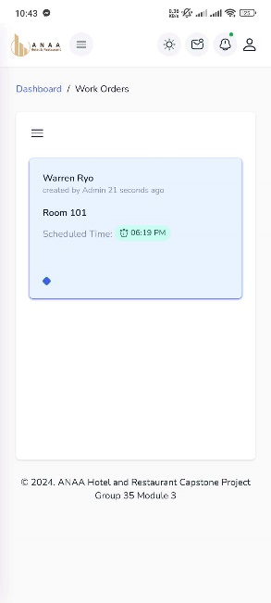

*Figure 30: Mobile Application Task Progress*

1. **Click the Mark as Completed button to mark the task as Completed and will change the background to green**

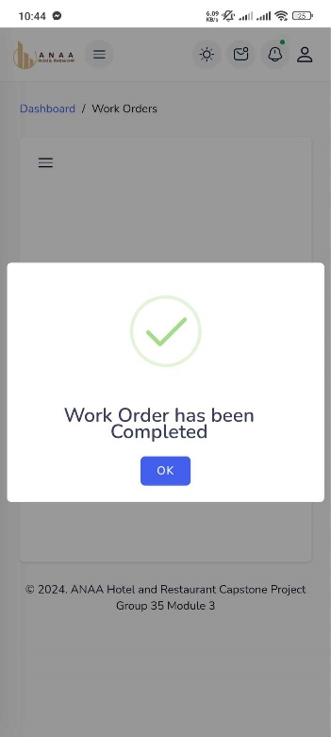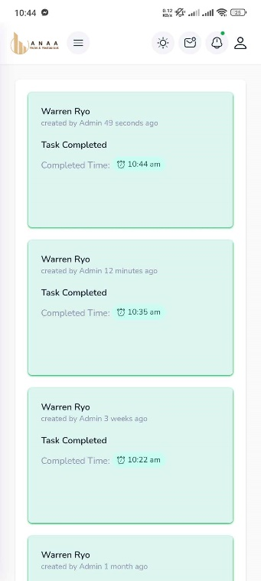

*Figure 31: Completion Alert*

1. **Now the on Admin side the Task is now indicate as Completed**

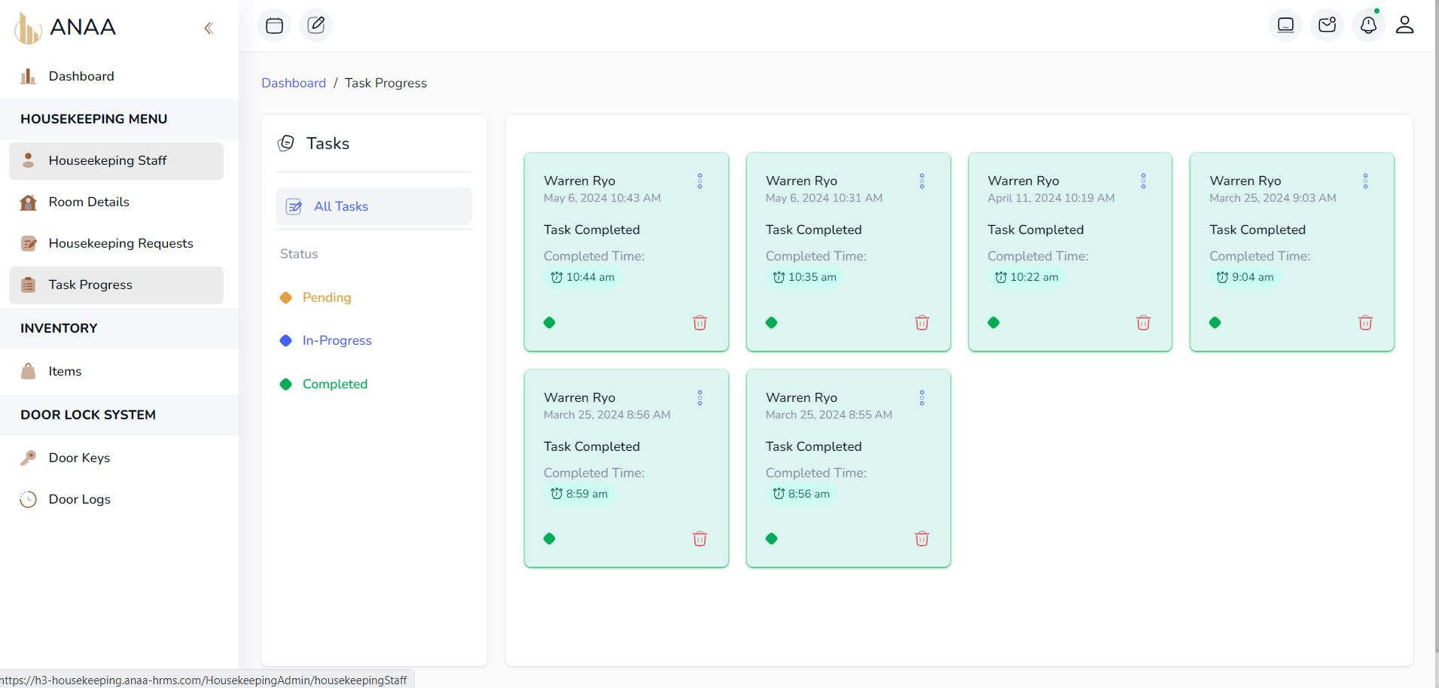

*Figure 32: Completed Task*

1. **You can see the analytics as well on Dashboard**

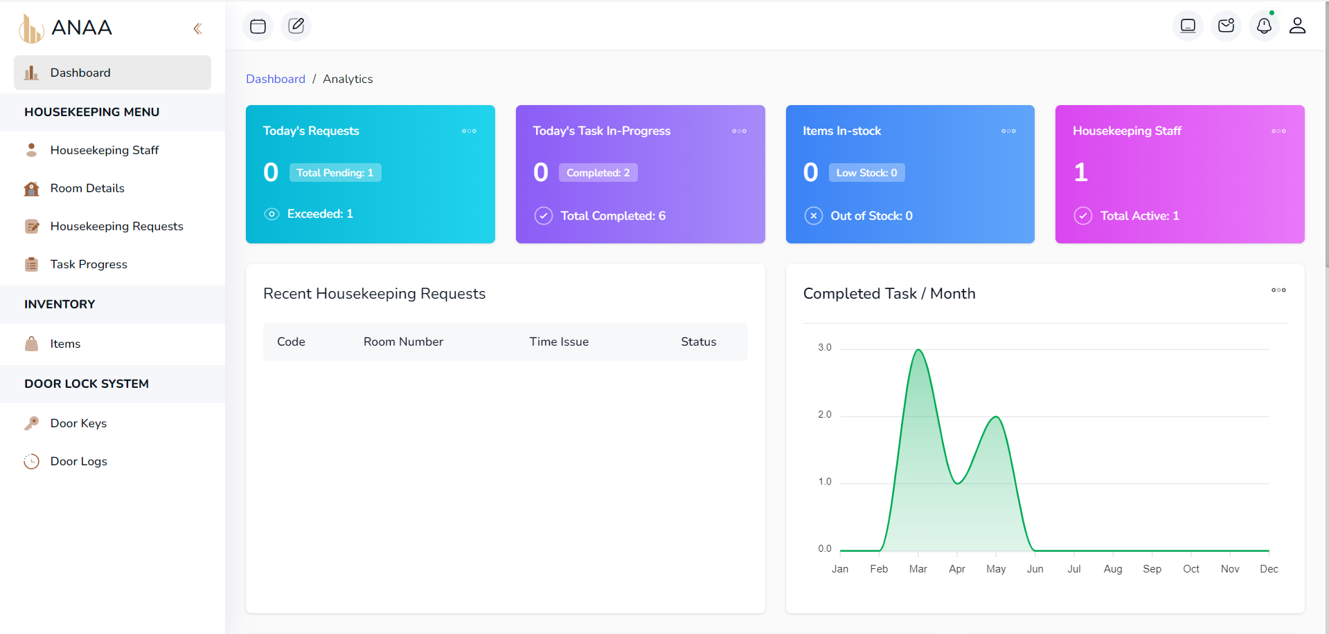

*Figure 33: Dashboard*

* 1. **KNOWN ISSUES AND TROUBLESHOOTING**

**LIST OF KNOWN ISSUES AND THEIR STATUS CONTACT**

Here are some known issues and their current status for the Anaa Hotel and Restaurant Management System with integrated housekeeping and maintenance, digital request via RFID door lock system, and automated inventory management:

**RFID Door Lock System:** Occasionally, there have been reports of delays in RFID sensor recognition, resulting in temporary access issues. Status: Under investigation by the technical team for optimization and reliability improvements.

**Automated Inventory Management:** Some discrepancies have been noted between automated inventory counts and physical stock levels, potentially due to syncing delays or data entry errors. Status: Ongoing review and refinement of data synchronization processes to enhance accuracy and real-time updates.

**Digital Request System:** Users have encountered intermittent connectivity issues when submitting digital requests for housekeeping and maintenance services via the mobile app, affecting response times. Status: Active troubleshooting and network stability improvements underway to ensure consistent service request processing.

**TROUBLESHOOTING STEPS FOR COMMON PROBLEMS**

Here are troubleshooting steps for common problems that may arise in the Anaa Hotel and Restaurant Management System with integrated housekeeping and maintenance, digital request via RFID door lock system, and automated inventory management:

**RFID Door Lock System Issues:**

**Check Power and Connectivity:** Ensure the RFID sensors and door locks have sufficient power and are properly connected to the network.

**Inspect Sensor Placement:** Verify that RFID sensors are correctly positioned for optimal signal reception and alignment with door lock mechanisms.

**Update Firmware:** Check for firmware updates for both RFID sensors and door locks to address compatibility issues and improve performance.

**Test with Different RFID Tags:** Test functionality using different RFID tags to rule out tag-specific issues.

**Review Logs:** Examine system logs for error messages or unusual activity that may indicate hardware malfunction or interference.

Automated Inventory Management Challenges:

**Verify Data Synchronization:** Confirm that automated inventory counts are synchronized correctly with physical stock levels and sales transactions.

**Check Network Connectivity:** Ensure stable internet connectivity and network access for real-time updates between inventory management software and database servers.

**Review Integration Settings:** Double-check integration settings between inventory management modules and other systems (e.g., POS system) for proper configuration.

**Reconcile Discrepancies:** If discrepancies persist, manually reconcile inventory counts against physical inventory and investigate any discrepancies thoroughly.

**Digital Request System Troubleshooting:**

**Restart Application:** Close and reopen the digital request app to refresh connections and clear temporary glitches.

**Check Internet Connection**: Verify that the device has a stable internet connection to submit and receive digital requests.

**Update App:** Ensure the app is updated to the latest version to benefit from bug fixes and performance improvements.

**Clear Cache:** Clear the app cache or temporary files that may be causing performance issues or data retrieval delays.

**Contact Support:** If issues persist, contact technical support for further assistance, providing specific details about the problem and any error messages encountered.

**CONTACT INFORMATION FOR TECHNICAL SUPPORT**

|  |  |  |
| --- | --- | --- |
| **NAME** | **ROLE** | **CONTACT INFO.** |
| Pena, Warren | Project Manager/  Programmer | 0922-940-3679 |
| Pateno, Lhey Justine | Document  Specialist | 0968-688-7582 |
| Aton, Justine John | Network  Administrator | 0995-733-5899 |
| Olarte, Wowie Nastor | Business Analyst | 0908-132-6407 |
| Gandarosa, Norhana | System Analyst |  |

*Table 28: Contact Information for Technical Support*

* 1. **VERSION CONTROL AND SOURCE CODE REPOSITORY DESCRIPTION OF VERSION CONTROL SYSTEM (E.G., GIT)**

GitHub is a web-based platform built around Git, a distributed version control system used primarily for code management in software development. It provides tools for collaboration, allowing developers to host repositories, track changes to their codebase, and manage contributions from team members or the open-source community. GitHub offers features such as issue tracking, pull requests for code review, and project management tools like wikis and boards. It facilitates transparency and coordination among developers, making it a cornerstone for modern software development workflows and fostering community-driven innovation through accessible and efficient code sharing and collaboration.

**REPOSITORY LOCATION AND ACCESS DETAILS**

<https://github.com/warrenryo/Anaa-HRMS-H3-Housekeeping>

**BRANCHING AND MERGING STRATEGIES**

The Git repository for ANAA Hotel's management system is hosted on a Git hosting platform such as GitHub, GitLab, or Bitbucket. The repository is accessible to authorized developers and team members who are granted appropriate permissions for viewing, cloning, and pushing changes to the repository. Access to the repository may be managed through user authentication and authorization mechanisms provided by the Git hosting platform.

Branching and Merging Strategies:

Branching Model:

* ANAA Hotel follows a feature branching model, where each new feature or development task is implemented on a dedicated feature branch.
* Feature branches are created off the main branch and are merged back into the main branch upon completion of development and code review.

Merging Strategy:

* Upon successful review and approval, feature branches are merged into the main branch using a merge strategy such as merge commits or rebasing.
* Merge conflicts, if any, are resolved collaboratively by the development team to ensure smooth integration of changes into the main branch.
  1. **DEVOPS AND CONTINUOUS INTEGRATION/CONTINUOUS**

**DEPLOYMENT (CI/CD) CI/CD PIPELINE SETUP AND CONFIGURATIONS**

ANAA Hotel employs a robust CI/CD pipeline to automate the build, test, and deployment processes for its management system. The CI/CD pipeline is configured to perform the following steps:

Source Code Management:

* Developers push code changes to the Git repository hosted on a platform like GitHub or GitLab.

Continuous Integration (CI):

* Upon code push, the CI server automatically triggers a build job.
* The build job fetches the latest code from the repository and compiles the Laravel Breeze application.
* Automated tests, including unit tests, integration tests, and acceptance tests, are executed to ensure code quality and functionality.

Continuous Deployment (CD):

* After successful completion of the CI phase, the CD pipeline deploys the application to staging or production environments.
* Deployment artifacts are packaged and deployed to the target environment using deployment scripts or tools like Laravel Forge.
* Automated smoke tests or health checks are performed post-deployment to verify application availability and functionality.

**AUTOMATION SCRIPTS AND TOOLS USED**

When working with the Laravel framework for a Hotel and Restaurant Management System (HRMS), several automation scripts and tools can enhance efficiency and streamline operations:

1. **Artisan Commands**: Laravel's built-in Artisan command-line interface allows for creating custom commands to automate repetitive tasks like database migrations, seeding, and clearing caches.
2. **Task Scheduling**: Laravel's task scheduler allows you to define scheduled tasks using Cron expressions, automating tasks such as sending reminders, generating reports, and updating data at specific intervals.
3. **Queue Management**: Laravel's queue system, powered by tools like Redis, Beanstalkd, or Amazon SQS, automates background tasks and processing, enhancing system responsiveness and scalability.
4. **Testing and Continuous Integration (CI)**:
   * **PHPUnit**: Laravel integrates PHPUnit for automated testing, ensuring code quality and reducing manual testing efforts.
   * **CI/CD Tools**: Tools like Jenkins, GitLab CI/CD, or Travis CI can be configured to automate testing, deployment, and integration processes.
5. **Deployment Automation**: Tools like Laravel Forge or Envoyer automate the deployment and management of Laravel applications, including server provisioning, configuration, and deployment updates.
6. **Logging and Monitoring**:
   * **Laravel Logging**: Configure Laravel's logging mechanism to record errors, events, and user activities, aiding in troubleshooting and performance monitoring.
   * **Monitoring Tools**: Use tools such as Laravel Telescope or third-party services like New Relic or Datadog for real-time monitoring of application performance, database queries, and server metrics.

**DEPLOYMENT STRATEGIES AND ROLLBACK PROCEDURES**

For deployment, employing a phased rollout approach minimizes risks and ensures smooth transitions. Initially, staging environments are used for testing updates, configurations, and new features to validate functionality and identify potential issues before production deployment. Continuous Integration/Continuous Deployment (CI/CD) pipelines, facilitated by tools like Laravel Forge or Envoyer, automate the build, testing, and deployment processes, ensuring consistency and reliability across deployments. Once ready, updates are rolled out incrementally to production servers, monitored closely for performance and stability. In case of deployment issues or unexpected errors, rollback procedures are essential. These involve reverting to the previous stable version using version control systems (e.g., Git) or snapshots taken before deployment. Rollback procedures should be well-documented and rehearsed to minimize downtime and mitigate any impact on hotel and restaurant operations, ensuring seamless service delivery to customers.

* 1. **LICENSING AND OPEN SOURCE LIBRARIES**

**INFORMATION ABOUT LICENSES FOR SOFTWARE AND LIBRARIES USED**

ANAA Hotel's management system relies on various open-source libraries and software components to enhance functionality and streamline development. Below is information about licenses for the software and libraries used, as well as credits and attributions for open-source components:

**1. Laravel Framework:**

License: Laravel framework is open-source software released under the terms of the MIT license.

**2. Laravel Breeze:**

License: Laravel Breeze is an official Laravel starter kit for building web applications. It is open-source software released under the terms of the MIT license.

**3. MySQL Database:**

License: MySQL is an open-source relational database management system released under the GNU General Public License (GPL) version

**4. Git Version Control System:**

License: Git is open-source software released under the terms of the GNU General Public License (GPL) version 2.

**5. Composer Dependency Manager:**

License: Composer is open-source software released under the terms of the MIT license.

**6. PHPUnit Testing Framework:**

License: PHPUnit is open-source software released under the terms of the BSD-3-Clause license.

**CREDITS AND ATTRIBUTIONS FOR OPEN-SOURCE**

**1. Laravel Framework:**

Credits: Developed by Taylor Otwell, Laravel is a PHP web application framework that provides elegant syntax and tools for building modern web applications.

**2. Laravel Breeze:**

Credits: Developed by Taylor Otwell and the Laravel team, Laravel Breeze provides a minimal and lightweight foundation for Laravel applications, including authentication scaffolding.

**3. MySQL Database:**

Credits: Developed by Oracle Corporation, MySQL is one of the most popular open-source databases used for storing and managing data in web applications.

**4. Git Version Control System:**

Credits: Developed by Linus Torvalds, Git is a distributed version control system widely used for tracking changes in source code during software development.

**5. Composer Dependency Manager:**

Credits: Developed by Nils Adermann and Jordi Boggiano, Composer is a dependency manager for PHP that simplifies the process of managing libraries and dependencies in PHP projects.

**6. PHPUnit Testing Framework:**

Credits: Developed by Sebastian Bergmann, PHPUnit is a unit testing framework for PHP that enables developers to write automated tests for their code.

**16.16. PERFORMANCE METRICS AND MONITORING**

**METRICS COLLECTED AND MONITORED**

**Metrics Collected and Monitored:**

**Response Time:** Monitor the average response time of web requests to ensure timely responses to user interactions.

**Throughput:** Measure the number of requests processed per unit of time to assess system capacity and scalability.

**Error Rate:** Track the percentage of requests that result in errors or failures to identify potential issues impacting user experience.

**CPU and Memory Utilization:** Monitor server resource usage to ensure sufficient capacity and identify potential bottlenecks.

**Database Performance:** Measure database query execution times, throughput, and cache hit rates to optimize database performance.

**Network Latency:** Monitor network latency to assess communication performance between servers and clients.

**Tools and Dashboard used for Performance Analysis**

Apex Chart: ApexCharts is a modern JavaScript charting library that enables developers to create interactive and visually appealing charts and graphs for web applications. It offers a wide range of chart types, including line charts, area charts, bar charts, pie charts, and more, along with various customization options and features

**TOOLS AND DASHBOARDS USED FOR PERFORMANCE ANALYSIS**

In a Hotel and Restaurant Management System (HRMS), Apex dashboards and graphs serve as indispensable tools for visualizing and analyzing critical data points. ApexCharts, known for its versatility and ease of integration with frameworks like Laravel, empowers HRMS administrators to create dynamic and interactive dashboards that provide real-time insights into operational performance. These dashboards can showcase key metrics such as room occupancy rates, restaurant reservations, service requests, and inventory levels through various chart types like line charts, bar charts, pie charts, and more. By leveraging ApexCharts, HRMS stakeholders can swiftly identify trends, monitor KPIs, and make data-driven decisions to optimize guest experiences, streamline operations, and enhance overall efficiency in hotel and restaurant management.

Top of Form

Bottom of Form

**ACTIONS TAKEN BASED ON PERFORMANCE DATA**

For instance, if occupancy rate trends indicate consistently high demand during certain periods, management can adjust pricing strategies or allocate additional staffing resources to ensure seamless guest experiences. Similarly, insights into restaurant reservation trends can prompt adjustments in seating arrangements or menu offerings to better accommodate customer preferences and maximize table turnover. Monitoring service request metrics allows for prioritizing tasks efficiently, ensuring timely responses and resolutions. Furthermore, tracking inventory levels through detailed visualizations enables proactive procurement and minimizes stockouts, ensuring uninterrupted service delivery. Overall, leveraging performance data from Apex dashboards enables HRMS stakeholders to implement strategic improvements that optimize efficiency, elevate service quality, and foster greater operational agility in response to evolving guest needs.

**16.17 CAPACITY PLANNING (ESTIMATES ON STORAGE**

**CONSUMPTION – 5 YEARS)**

Capacity planning for storage consumption over a five-year period involves estimating the amount of storage space required to accommodate data growth and system expansion. Here's a general approach to estimate storage consumption for ANAA Hotel's management system:

**Current Data Size:** Determine the current size of the data stored in the system, including databases, media files, logs, and other data sources. This can be obtained by analyzing existing storage usage metrics or by conducting a storage audit.

**Data Growth Rate:** Estimate the expected growth rate of data over the next five years. This can be based on historical data growth trends, business projections, or industry benchmarks.

**RESUME**









